

SWALLOWDALE PRIMARY SCHOOL
Geography Curriculum
2026–2027 and 2027-2028

SCHOOL VALUES, VISSION AND MISSION

Intent
At Swallowdale Primary School, we want our Geography curriculum to inspire our children to explore, enquire, explain and be empowered.
Implementation
In Geography, the aim of our teaching is to develop our pupils curiosity and understanding of the world around them and to instil a desire to find out more. As a school we want our children to understand the world they live in by extending pupils experience and awareness from the classroom to the community and to the wider world. Through carefully planned lessons, children will be able to describe, analyse, explain, understand and appreciate the world they live in. We aim to give them access to discussions about local, national and global events so that they can in turn develop their own values and understand the views of others.
Impact
Children will have developed the geographical knowledge and skills to help them explore, navigate and understand the world around them and their place in it. Children’s knowledge and skills will develop progressively as they move through the school, not only to enable them to meet the requirements of the National Curriculum but to prepare them to become competent geographers in secondary education. Most importantly our children will be empowered to think as a global citizen. They will understand that everyone is part of a worldwide community.

“You are never too small to make a difference,” Greta Thunberg “Planet Earth is our shared island, let us join forces to protect it,” Ban Ki-Moon.

National Curriculum
The Geography National Curriculum subject content is broken into 4 strands.
Locational  Knowledge | 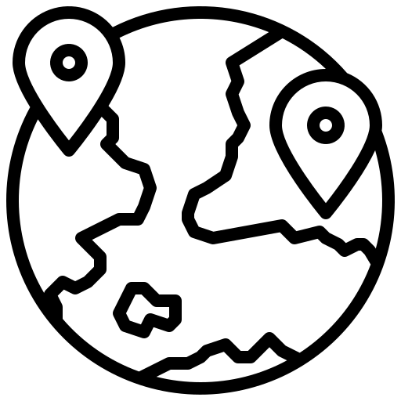 |  | Place Knowledge |  |  | Human and Physical Geography | 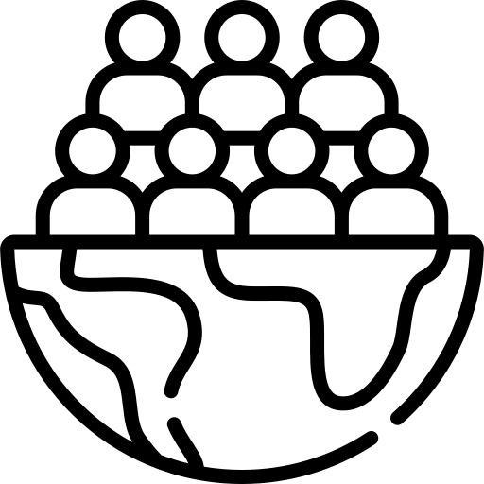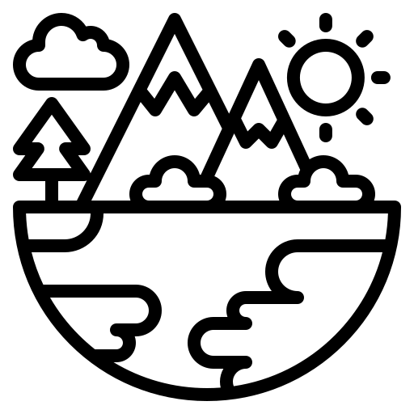 |  | Geographical Skills and Fieldwork | 

Subject content taken from the National Curriculum is sequenced into units of learning. Years 1, 2, 3, 4 and 5 teach three Geography units across the academic year. Year 6 teach two Geography units across the academic year.
 | Units of Geography learning
 | Autumn | Spring | Summer
Year 1 | My School | My Town | The UK
Year 2 | Seas and Oceans | Seven Continents | Hot and Cold Places
Year 3/4  Cycle A 2026 - 2027 | Rivers | Natural Resources | Europe
Year 3/4  Cycle B  2027 - 2028 | The UK Regions | Water Cycle | Settlements
Year 5 | Climate Zones (including biomes and vegetation belts) | North America (including time zones) | Economic Activity
Year 6 | Local Fieldwork | Earthquakes and Volcanoes (including mountains)

Long Term Plan – Units of Learning
Each unit of learning has an enquiry question. The children use the knowledge, understanding and skills they have acquired throughout the topic to answer the question at the end of the geography unit.
Cycle A 2026 - 2027
 | Autumn |  | Spring |  |  | Summer
Year R  (Development  Matters) | 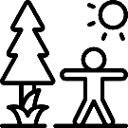  Describe what you see, hear and feel outside. | 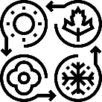  Explore how changing seasons effect the natural world. |  |   Explore and care for the environment you live in. | 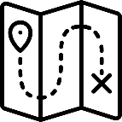  Draw information from a simple map. |  |   Recognise life in other countries may be different to ours.
Year 1  UK | My School |  | My Town |  |  | The UK
Year 1  UK | 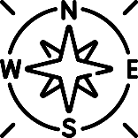  Why do we draw compass directions on a map? |  | 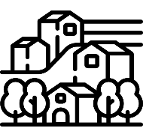  What features can we find in our town? |  |  |   Why is London the capital city of the UK and England?
Year 2  UK &  Australia | Seas and Oceans |  | Seven Continents |  |  | Hot and Cold Places
Year 2  UK &  Australia | 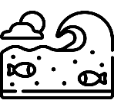  Where do we find water? |  | 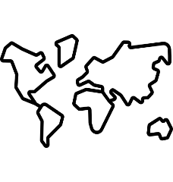  How do we locate different continents? |  |  |   Does the UK experience the same climate as Australia?
Year 3/4  Cycle A  Europe | Rivers |  | Natural Reources |  |  | Europe
Year 3/4  Cycle A  Europe | 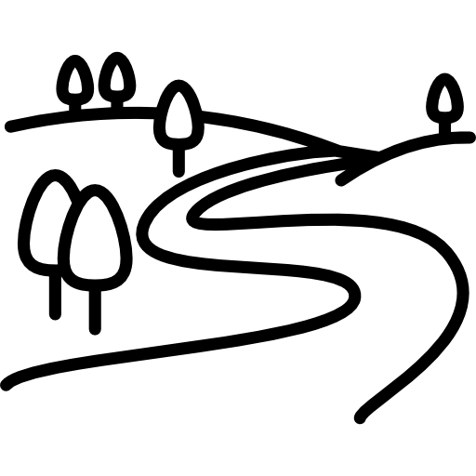  Why do rivers flow across land and end at the sea? |  | 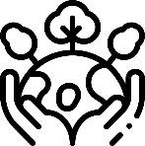  How can we use natural resources sustainably? |  |  | 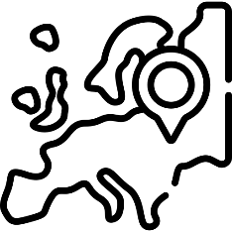  What makes a country in Europe unique?
Year 5  North America | Climate Zones |  | North America |  |  | Economic Activity
Year 5  North America |   Why do places experience different climates? |  | 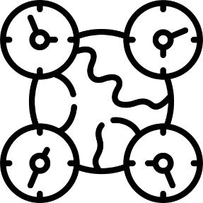  Why does North America have different time zones? |  |  | 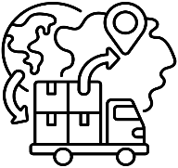  How does the UK trade with the world?
Year 6  Local Area | Local Fieldwork |  | Earthquakes and Volcanoes
Year 6  Local Area |   Why are some areas of Melton Mowbray busier than others? |  | 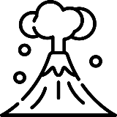  Why are some places more vulnerable to tectonic hazards?

 | Autumn |  | Spring |  |  | Summer
Year R  (Development  Matters) | Describe what you see, hear and feel outside. | Explore how changing seasons effect the natural world. |  | Explore and care for the environment you live in. | Draw information from a simple map. |  | Recognise life in other countries may be different to ours.
Year 1  UK | My School |  | My Town |  |  | The UK
Year 1  UK | Why do we draw compass directions on a map? |  | What features can we find in our town? |  |  | Why is London the capital city of the UK and England?
Year 2  UK &  Australia | Seas and Oceans |  | Seven Continents |  |  | Hot and Cold Places
Year 2  UK &  Australia | Where do we find water? |  | How do we locate different continents? |  |  | Does the UK experience the same climate as Australia?
Year 3/4  Cycle B  UK | The UK Regions |  | The Water Cycle |  |  | Settlements
Year 3/4  Cycle B  UK | 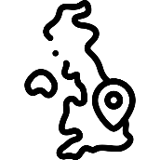  What will you find in a region? |  | 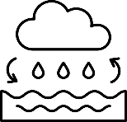  Why is the world covered in water? |  |  |   Why do people live in different settlements?
Year 5  North America | Climate Zones |  | North America |  |  | Economic Activity
Year 5  North America | Why do places experience different climates? |  | Why does North America have different time zones? |  |  | How does the UK trade with the world?
Year 6  Local Area | Local Fieldwork |  | Earthquakes and Volcanoes
Year 6  Local Area | Why are some areas of Melton Mowbray busier than others? |  | Why are some places more vulnerable to tectonic hazards?
Cycle B 2027 – 2028

Fieldtrip Opportunities
Fieldwork is the process of going outside, into the real world, and investigating a question. During fieldwork you collect information and find things out for yourself. At Swallowdale we believe that fieldwork is an important aspect of Geography. It provides a real-world opportunity for children to develop and extend their geographical thinking. It also enables critical thinking through purposeful data collection. The highlighted units of learning include a fieldwork enquiry.
Case Study
A case study is the process of researching a place to find out more information. With teacher guidance, children research a place and then compare it to their local, familiar area. This enables children to critically evaluate the place. The highlighted units of learning include a case study enquiry.
 | Units of Geography learning
 | Autumn | Spring | Summer
Year 1 | My School | My Town | The UK
Year 2 | Seas and Oceans | Seven Continents | Hot and Cold Places
Year 3/4  Cycle A | Rivers | Natural Resources | Europe
Year 3/4  Cycle B | The UK Regions | Water Cycle | Settlements
Year 5 | Climate Zones (including biomes and vegetation belts) | North America (including time zones) | Economic Activity
Year 6 | Local Fieldwork | Earthquakes and Volcanoes (including mountains)

Early Years Foundation Stage
Play underpins all development and learning for young children in Reception. Providing well-planned experiences based on children’s spontaneous play, both indoors and outdoors, is an important way in which practitioners support young children to learn with enjoyment and challenge. Due to the spontaneity of play and child interests, the curriculum is delivered through a combination of whole class activities, adult led focussed activities, child initiated activities and stories. The curriculum statements have been taken from Development Matters – Understanding the World, Children in Reception. Practitioners use these statements to inform their planning of the curriculum and provision. At the end of the year children are assessed against the Early Learning Goals.
Understanding The World
Development Matters | Children in Reception | - Talk about members of their immediate family and community.  - Name and describe people who are familiar to them.  - Comment on images of familiar situations in the past.  - Compare and contrast characters from stories, including figures from the past.  - Draw information from a simple map.  - Understand that some places are special to members of their community.  - Recognise that people have different beliefs and celebrate special times in different ways.  - Recognise some similarities and differences between life in this country and life in other countries.  - Explore the natural world around them.  - Describe what they see, hear and feel whilst outside.  - Recognise some environments that are different to the one in which they live.  - Understand the effect of changing seasons on the natural world around them.

National Curriculum – Years 1, 2, 3, 4, 5, and 6
The National Curriculum is broken into 4 strands: Locational Knowledge, Place Knowledge, Human and Physical Geography and Geographical Skills and Fieldwork. Each unit of learning has a medium term plan. This plan outlines which National Curriculum Statements will be covered throughout the unit and how learning will be sequenced to answer the enquiry question. See medium term plans for each year group below.

Climate Change and Sustainability
The DfE’s Sustainability and Climate Change Strategy for Education highlights the importance of climate education for children. Young people are increasingly worried about climate change and want to know more about the impact it is having now and how it will impact their future lives. Swallowdale has a Climate Action Plan which aligns with the DfE’s sustainability and climate change strategy. Opportunities for children to learn about climate change and sustainability have been built into our Geography Curriculum known as ‘Climate Education.’

The highlighted units of learning include opportunities for children to learn about elements of Climate Education.
 | Units of Geography learning
 | Autumn | Spring | Summer
Year 1 | My School | My Town | The UK
Year 2 | Seas and Oceans | Seven Continents | Hot and Cold Places
Year 3/4  Cycle A | Rivers | Natural Resources | Europe
Year 3/4  Cycle B | The UK Regions | Water Cycle | Settlements
Year 5 | Climate Zones (including biomes and vegetation belts) | North America (including time zones) | Economic Activity
Year 6 | Local Fieldwork | Earthquakes and Volcanoes (including mountains)

YEAR 1 – MY SCHOOL
National Curriculum Link
• use simple compass directions (N,S, E,W) and locational and directional language to describe the location of features and routes on a map
• use simple fieldwork and observational skills to study the geography of their school and its grounds and the key human and physical features of its surrounding features
• devise a simple map and use and construct basic symbols in a key
Enquiry question:
Why do we draw compass directions on a map?
Session number |  | Sequenced learning points
1. Why do we give directions? |  | ● What is a direction?  ○ In front, behind, near, far, left, right  ● Why do we give directions?  ● Respond to directions correctly
2. What are compass directions? |  | ● What is a direction?  ● What is a compass?  ● There are 4 compass directions: north, east, south and west  ● Respond to compass directions
3. How do compass directions help us locate features? |  | ● There are 4 compass directions: north, east, south and west  ● Why do we use a compass?  ● What is a feature?  ● Locate features using compass directions
4. What is a map? |  | FIELDWORK BOOKLET  ● What is a map?  ● Why do we use maps?  ● Features are represented on a map using shapes  ○ The key tells us what each shape represents  ● Why is a compass drawn on a map?
5. Create a simple map of our school. |  | FIELDWORK BOOKLET  ● What school do we attend?  ● Find our school using a satellite map  ● Why do we create maps?  ● Create a map of the KS1 area  ○ Children sit on KS1 playground facing north  ○ Draw features using shapes to represent them
6. Why do we draw compass directions on a map? |  | FIELDWORK BOOKLET  ● Look at your map of the KS1 area  ○ Children sit in same position facing north  ● Why do we need a key?  ○ Draw a key  ● Why do we need compass directions?  ○ Draw a compass on your map  ● Describe where features are located using compass directions

YEAR 1 – MY TOWN
National Curriculum Link
• study the human and physical geography of a small area of the United Kingdom
• use geographical vocabulary which relates to human and physical features
• use aerial photographs to recognise landmarks and basic human and physical features
• use simple fieldwork and observational skills to study the human and physical features of my local area
Enquiry question:
What features can we find in our town?
Session number |  | Sequenced learning points
1. What is a town? |  | ● We live in the town Melton Mowbray  ● What is a town?  ● What is located in Melton Mowbray?  ● Why do we make maps?  ● Explore Melton Mowbray using Street view Google Maps
2. What are human and physical features? |  | ● What is a human feature?  ○ Use correct geographical vocabulary for this feature  ● What is a physical feature?  ○ Use correct geographical vocabulary for this feature  ● Use aerial photographs to identify human and physical features
3. Identify different types of features in our school grounds |  | ● What is a human feature?  ● What is a physical feature?  ● Explore the school grounds and identify human and physical features you find
4. Prepare for the fieldwork |  | FIELDWORK BOOKLET  ● What is a fieldwork?  ● What are we going to find out?  ○ What is a human feature?  ○ What is a physical feature?  ● How are we going to record our findings?  ● Prepare your risk assessment
5. What features can we find in our town? |  | FIELDWORK BOOKLET  ● Engage in fieldwork adhering to risk assessment  ● Collect data  ○ Observe and record human and physical features found
6. Present findings from the fieldwork |  | ● Human and physical features can be found in our town  ○ Recap what we found  ● Present findings from fieldwork  ○ Choose a method to present findings

YEAR 1 – THE UK
National Curriculum Link
• name, locate and identify characteristics of the four countries and capital cities of the UK
• use geographical vocabulary which relates to human and physical features
• use world maps, atlas and globe to identify the UK and its countries.
• use photographs to recognise landmarks and basic human and physical features
• identify seasonal and daily weather patterns in the United Kingdom
Enquiry question:
Why is London the capital city of the UK and England?
Session number |  | Sequenced learning points
1. What country do you live in? |  | ● What town do you live in?  ● What is a country?  ○ What country do to you live in?  ● The United Kingdom (UK) is made up of 4 countries.  ○ Each country has its own flag  ● Use an atlas to identify the UK and its countries
2. What is a capital city? |  | ● The UK is made up of 4 countries  ● Locate each country on a map  ● Create a map of the UK  ● Each country has a capital city  ● Locate each capital city on map of UK
3. What weather does the UK experience? |  | ● The UK is made up of 4 countries  ● Each country is the UK experiences similar weather  ● What type of weather do we have?  ● There are 4 seasons  ● How does climate change affect our weather?  ● How does weather change throughout the day?
4. Why does the UK have lots of beaches? |  | ● What is a physical feature?  ○ Use correct geographical vocabulary for this feature  ● Learn about some famous physical features from each country  ○ Use photographs to identify physical features  ● The UK is an island, each country has a coastline
5. Why are some human features known as landmarks? |  | ● What is a human feature?  ○ What is a landmark?  ○ Use correct geographical vocabulary for this feature  ● Learn about some famous landmarks from each country  ○ Use photographs to identify landmarks
6. Why is London the capital city of the UK and England? |  | ● The UK is made up of 4 countries  ○ Locate each country on a map  ● Each country has a capital city  ● London is the capital city of England and the UK  ● What do people think of when they hear UK?

YEAR 1 – SEAS AND OCEANS
National Curriculum Link
• name and locate the United Kingdom’s surrounding seas
• name and locate the world’s five oceans
• use maps, atlases and globes to identify the UK seas and oceans
• use simple compass directions (North, East, South, West) to describe the location of features on a map
Enquiry question:
Where do we find water?
Session number |  | Sequenced learning points
1. Where do we live? |  | ● What town do we live in?  ● What country do we live in?  ● The United Kingdom (UK) is made up of 4 countries  ● Each country has a capital city  ● Use an atlas to identify the UK and its countries  ● The UK is an island nation  ○ What surrounds the UK?
2. What surrounds the UK island? |  | ● The UK is an island nation  ● What is a sea?  ● There are 3 seas that surround the British Isles  ● Use maps to locate and identify the UK seas
3. How many oceans are there? |  | ● What is an ocean?  ● How many oceans are there?  ● Use a map/atlas to identify the 5 oceans  ● The oceans are different sizes
4. Where are the 5 oceans located? |  | ● There 5 oceans  ● Create a map of the 5 oceans  ● What are compass directions?  ○ Add compass directions to your map  ● Describe the location of an ocean using compass directions
5. Where do we find water? |  | ● Our world is covered in water  ● What is the difference between a sea and an ocean?  ● What seas surrounds the British Isles?  ● What ocean borders the British Isles?  ○ Why do we travel across the water?

Year 2 – SEVEN CONTINENTS
National Curriculum Link
• name and locate the world’s seven continents
• identify the Equator, North Pole and South Pole
• identify hot and cold areas of the world in relation to the Equator and the North and South Poles
• use maps, atlases and globes to identify the UK, the continents and oceans
• devise a simple map and use and construct basic symbols in a key
Enquiry question:
How do we locate different continents?
Session number |  | Sequenced learning points
1. What is a continent? |  | ● What is land?  ● What is a country?  ○ Where do we live?  ○ What country do we live in?  ● What is a continent?  ○ How many continents are there?  ○ What continent do we live in?
2. Where are the 7 continents located? |  | ● What is a continent?  ● Using an atlas locate the seven continents  ○ What separates the continents?  ○ Continents are different sizes  ● Create a map and identify the seven continents  ○ Draw compass directions on the map
3. Which imaginary lines run across the world? |  | ● Where are the seven continents located?  ● We draw imaginary lines across the world to help people locate things  ● What is the Equator?  ○ Which hemisphere is the continent Europe located in?  ● What are the Poles?  ● What are the Tropics?
4. Where are these imaginary lines located? |  | ● We draw imaginary lines across the world to help people locate things  ● What imaginary lines do we use?  ● Create a map showing the position of these imaginary lines  ○ Create a key for your map  ○ Draw compass directions on the map
5. Describe the location of different continents. |  | ● There are seven continents  ● We draw imaginary lines across the world to help people locate things  ● We can describe the location of a continent using these imaginary lines and compass directions
6. How does a continents location affect the climate? |  | ● Continents are located in different places  ○ Continents cannot move  ● What is climate?  ○ What type of weather can we experience?  ● A place’s position relative to the Equator and Poles determines the climate it experiences  ○ Cold areas are located near to the Poles  ○ Hot areas are located near to the Equator

YEAR 2 – HOT AND COLD PLACES
National Curriculum Link
• identify seasonal patterns in the UK and the location of hot and cold areas of the world in relation to the Equator and the North and South Poles.
• use geographical vocabulary which relates to human and physical features
• understand geographical similarities and differences through studying the human and physical geography of a small area of the UK and a small area in a contrasting non-European country
• use maps, atlases and globes to identify the UK, countries, continents and oceans
• use photographs to recognise landmarks and basic human and physical features
Enquiry question:
Does the UK experience the same climate as Australia?
Session number |  | Sequenced learning points
1. What seasonal climate does the UK experience? |  | ● What country do we live in?  ● What is climate?  ● Each country in the UK experiences similar weather  ● What type of weather do we have?  ● There are 4 seasons
2. How does a country’s location affect the climate? |  | ● What is a country?  ● What is climate?  ● We draw imaginary lines across the world to help people locate things  ● A place’s position relative to the Equator and Poles determines the climate it experiences  ○ Cold areas are located near to the Poles  ○ Hot areas are located near to the Equator  ● Why are weather patterns changing?
3. Where is Australia located? |  | CASE STUDY BOOKLET  ● What is a case study?  ● Where is the UK located?  ● Where is Australia located?  ○ Locate the UK and Australia on a map  ● What continent is Australia located on?  ● What is the capital city of Australia?
4. What climate does Australia experience? |  | CASE STUDY BOOKLET  ● Australia is a country located in Oceania  ● We draw imaginary lines across the world to help people locate things  ● A place’s position relative to the Equator and Poles determines the climate it experiences  ● What is climate?  ● What type of climate does Australia experience?  ● Does the UK experience the same climate as Australia?
5. Why are beaches popular in Australia? |  | CASE STUDY BOOKLET  ● What is a physical feature?  ● What physical features can be found in Australia?  ● Use images to recognise features studied  ● Why are beaches so popular?  ● Australia is home to lots of unique wildlife
6. Why should you visit Australia? |  | CASE STUDY BOOKLET  ● What is a human feature?  ● What is a landmark?  ● What landmarks are located in Australia?  ● Use images to recognise features studied  ● Why should others visit Australia?  ○ Comparing life in Australia to your life in the UK

YEAR 3/4 Cycle A – RIVERS
National Curriculum Link
• describe and understand key aspects of rivers
• name and locate key topographical features including hills, mountains, coasts and rivers
• use symbols and keys to read a map
• use fieldwork to observe, measure, record and present physical features in the local area using a range of methods
Enquiry question:
Why do rivers flow across land and end at the sea?
Session number |  | Sequenced learning points
1. Where does water come from? |  | ● What is water?  ● Where do you find water?  ● How does water move around the Earth?  ● What happens during the water cycle?
2. How does water flow in a river? |  | ● What is a river?  ● What does a river look like?  ● Identify rivers on different types of maps  ● How do rivers flow across land?  ● What can we find inside the river channel?
3. Is the river course (for the River Eye) straight? |  | ● Prepare your risk assessment  ● Engage in fieldwork adhering to risk assessment  ● Locate the River Eye on an OS Map  ● Observe features of the river channel  ● Observe features of the river course
4. Where do rivers begin? |  | ● The river course can be broken into 3 parts.  ● Where do rivers begin?  ● Why do rivers begin on a mountain or hill?  ● What features might you find in the upper course?
5. How does the river course bend and meander? |  | ● The river course can be broken into 3 parts.  ● What happens to river as it flows into the middle course?  ○ Use maps to identify river feature  ● What do oxbow lakes form?  ● What features might you find in the middle course?
6. Why do rivers flow across land and end at the sea? |  | ● The river course can be broken into 3 parts.  ● What happens to the river as it flows into the lower course?  ● Where do rivers end?  ○ Use maps to identify the river, coast, sea

YEAR 3/4 Cycle A – NATURAL RESOURCES
National Curriculum Link
• describe and understand the distribution of natural resources including energy, food, minerals and water
• use maps, atlases and digital/computer mapping to locate countries and describe features studied
Enquiry question:
How can we use natural resources sustainably?
Session number |  | Sequenced learning points
1. What is a natural resource? |  | ● People live in settlements  ● What resources do people need to live comfortably?  ● There are 4 natural resources  ○ Food, water, energy and minerals  ● What do we use these natural resources for?
2. Why has demand for natural resources increased? |  | ● There are 4 natural resources  ● The UK has a limited amount of natural resources  ● We import resources to meet demand  ● How has demand for resources has changed over time?
3. Where does our food come from? |  | ● Food is a natural resource  ● The UK grows and produces food  ● The UK cannot grow some foods  ● We import food from other countries to meet demand  ● Using maps, investigate where our food comes from?  ● Is it fair to import resources?
4. How do we make energy? |  | ● The UK has a limited amount of each natural resource  ● Energy is a natural resource  ● What is electricity?  ● What do we use electricity for?  ● Why has energy demand has increased over time?
5. Why should we conserve natural resources? |  | ● We create electrical energy by burning natural resources  ● There is a limited amount of each natural resource  ● What does sustainability mean?  ● Do we create electricity (energy) sustainably?  ● What is renewable energy?  ● Is renewable energy sustainable?  ● Are you creating renewable energy at home?
6. How can we use natural resources sustainably? |  | ● What does sustainability mean?  ● The UK has a high demand for natural resources  ● Do we waste resources?  ● How can use water sustainably?  ● Why is it important to use natural resources sustainably?

YEAR 3/4 Cycle A – EUROPE
National Curriculum Link
• locate European countries, concentrating on their environmental regions, key physical and human characteristics, countries and major cities
• understand geographical similarities and differences through the study of human and physical geography of a region within Europe
• use maps, atlases, globes and digital/computer mapping to locate countries and describe features studied
• use four-figure grid references
• identify the position and significance of Equator, Northern Hemispheres, Southern Hemisphere, the Tropics of Cancer and Capricorn
Enquiry question:
What makes a country in Europe unique?
Session number |  | Sequenced learning points
1. What is Europe? |  | ● What is a continent?  ● Where is the European continent located?  ○ Make link to imaginary lines.  ● What countries are located in Europe?  ○ What is a county?  ○ Use maps/atlases to locate countries in Europe
2. Where do people live in Europe? |  | ● What is a city?  ● Name some cities located in Europe  ● Locate the cities on a map of Europe  ○ Use 4-grid map references to locate specific cities
3. What climate does Europe experience? |  | ● What is climate?  ○ How does the climate differ across the continent?  ● What is an environmental region?  ● How many environmental regions are there in Europe?  ○ How does the environment differ across the continent?  ● Expected weather patterns are changing
4. What features can be found in each country? |  | ● What is a feature?  ● What is a human feature?  ● What is a physical feature?  ● Use images to describe features studied
5. What is life like in France? |  | CASE STUDY BOOKLET  ● What is a case study?  ● Where is France located?  ● What is the capital city of France?  ● Locate the Paris on a map  ● What physical features can be found in France?  ● What is a landmark?  ● What landmarks are located in Paris?
6. What makes a country in Europe unique? |  | CASE STUDY BOOKLET  ● France is a country located in Europe  ● Are all countries in Europe the same?  ● What makes a country unique?  ● What makes France special?  ● Compare life in Paris to your local area  ● What makes Paris unique?

YEAR 3/4 Cycle B – THE UK REGIONS
National Curriculum Link
• name and locate geographical regions and their identifying human and physical characteristics within the United Kingdom
• name and locate some counties found in the UK
• use eight points on a compass, four grid references, symbols and key to build their knowledge of the United Kingdom
• use maps, atlases, globes and digital/computer mapping to locate counties and describe features studied
Enquiry question:
What will you find in a region?
Session number |  | Sequenced learning points
1. How many countries are in the UK? |  | ● The United Kingdom is country  ● There are 4 countries located in the country United Kingdom  ● Locate the 4 countries on a map  ● Each country has a capital city  ● Countries are split into smaller areas of land
2. What is a region? |  | ● What is a region?  ● There are 12 regions in the United Kingdom  ○ Create a map and locate the 12 regions  ● What does a compass tell us?  ● There are 8 points on a compass  ● Why are England’s regions named after compass directions?
3. Where is the East Midlands located? |  | ● There are 12 regions in the United Kingdom  ● Why are England’s regions named after compass directions?  ● Using a compass identify the location of each region on a map  ● Melton Mowbray is located in the East Midlands
4. How many counties are located in the East Midlands? |  | ● What is a region?  ● Regions are split into smaller areas of land  ● What is a county?  ● There are 6 counties located in the East Midlands  ○ Use 4-grid map references to locate counties in East Midlands
5. What features can be found in a region? |  | ● What is a region?  ● What is a human feature?  ● What is a landmark?  ● Study identifying human features of the UK regions  ○ Use images to identify features studied  ● What is a physical feature?  ● Study identifying physical features of the UK regions  ○ Use images to identify features studied
6. What will you find in a region? |  | ● How many regions are there?  ● Regions are split into counties.  ● Name some of the counties located in the East Midlands.  ● What human features are located in Melton Mowbray?  ● What physical features are located in Melton Mowbray?  ○ Use images and maps to identify features

YEAR 3/4 Cycle B – THE WATER CYCLE
National Curriculum Link
• describe and understand key aspects of the water cycle
• identify key topographical features including hills, mountains and rivers.
• use topographical maps to identify hills and mountains
Enquiry question:
Why is the world covered in water?
Session number |  | Sequenced learning points
1. What does water look like? |  | ● Planet Earth is covered in water  ○ There are 5 oceans covering the Earth  ○ Humans live on land  ● What is water?  ● There are 3 states of water  ○ Liquid, solid and gas
2. Why does water change state? |  | ● There are 3 states of water  ○ Liquid, solid and gas  ● How does water change state  ● Water is neither created or destroyed, it changes state
3. How does water travel around the world? |  | ● The water cycle explains how water travels around the world  ○ As water moves through the cycle, it changes state  ● What is accumulation / collection?  ● What is evaporation?
4. Describe the water cycle. |  | ● The water cycle explains how water travels around the world  ○ As water moves through the cycle, it changes state  ● What is condensation?  ● What is precipitation?  ● Why does the cycle repeat?
5. Why does it rain on mountains? |  | ● What happens during the water cycle?  ● What is a mountain?  ○ What is a hill?  ● Why does it rain more on mountains?  ● How do we draw mountains on a map?  ● Locate mountains using topographical maps
6. Why is the UK getting wetter? |  | ● Planet Earth is covered in water  ● Why will the world always be covered in water?  ● What is climate change?  ● Why is our weather becoming wetter?  ● How will wetter weather impact the UK?

YEAR 3/4 Cycle B – SETTLEMENTS
National Curriculum Link
• describe and understand types of settlement and land use
• identify land-use patterns; and understand how some of these aspects have changed over time
• use maps, atlases, globes and digital/computer mapping to locate countries and describe features studied
• understand geographical similarities and differences through the study of human and physical geography of a region of the United Kingdom
Enquiry question:
Why do people live in different settlements?
Session number |  | Sequenced learning points
1. Where do people live? |  | ● What is a settlement?  ● There are 4 types of settlements  ○ Use maps to identify settlements  ● What features can you find in a settlement?
2. What do we use land for? |  | ● People live in settlements  ● What does land use mean?  ● There are many types of land use  ● Why does land use change over time?  ● How will land use vary in different settlements?
3. How is land used in settlements? |  | ● How can land be used in a settlement?  ● How will land use vary in different settlements?  ● Why does land use change over time?  ● How can we recognise land use on a map?
4. How is land used in our local area? |  | CASE STUDY BOOKLET  ● What type of settlement do you live in?  ● How can land be used in your local settlement?  ● Using maps, identify how land use in your local area  ○ What land use was most common?
5. Why does land use vary in different settlements? |  | CASE STUDY BOOKLET  ● Which land is used for farming?  ● What type of settlement is Leicester?  ○ How do we know Leicester is a city by looking at a map?  ● Using maps, identify how land use in Leicester  ○ What land use was most common?
6. Why do people live in different settlements? |  | CASE STUDY BOOKLET  ● Compare land use in Melton Mowbray and Leicester  ○ What land use was most common?  ○ Were there any kinds of land use not present in this area?  ○ Did you notice any patterns?  ● Which settlement would you prefer to live in?

YEAR 5 – CLIMATE ZONES
National Curriculum Link
• describe and understand key aspects of climate zones, biomes and vegetation belts
• identify the position and significance of latitude, longitude, Equator, Northern Hemispheres, Southern Hemisphere, the Tropics of Cancer and Capricorn, Arctic and Antarctic Circle
• use maps, atlases, globes and digital/computer mapping to locate and describe features studied
Enquiry question:
Why do places experience different climates?
Session number |  | Sequenced learning points
1. What is meant by place? |  | ● What is a place?  ● What do we use to locate a place?  ● Maps have lots of information about a place.  ○ Identify the position of imaginary lines  ○ Discuss the significance of imaginary lines
2. What climate can we experience? |  | ● What is meant by climate?  ● Do we all experience the same climate?  ● What is a climate zone?  ● How many climate zones are there?  ● Use maps to locate climate zones
3. How does a place’s location determine the climate experienced? |  | ● What is meant by climate?  ● How many climate zones are there?  ● Why are there different climate zones?  ○ What is the significance of imaginary lines on a place’s climate?  ● Climate patterns are changing
4. How do I locate a place using map coordinates? |  | ● Why does a place location determine its climate?  ● How do we locate a place on a map?  ○ How to read latitude and longitude coordinates.  ○ How to use latitude and longitude coordinates to locate a place.  ○ What climate does a place experience?
5. Why does the same vegetation grow in different places? |  | ● How does climate affect the environment?  ● What is a biome?  ● What climate is experienced in biomes?  ○ Use maps and pictures to compare climate zones and biomes  ● What is a vegetation belt?  ○ Use maps and pictures to compare biomes and vegetation belts.
6. How has climate change affected the Tundra biome? |  | ● Why are climate patterns changing?  ● How will climate change affect biomes?  ● What is the tundra biome?  ● What is happening to the tundra’s climate?  ● What is the impact of climate change to the Tundra?  ● How will this affect the UK?

YEAR 5 – NORTH AMERICA
National Curriculum Link
• locate the world’s countries using maps to focus on North America, concentrating on the environmental regions and major cities
• understand geographical similarities and differences through the study of human and physical geography of a region of North America
• use maps, atlases, globes and digital/computer mapping to locate countries and build on their knowledge of the wider world
• identify the position and significance of latitude, longitude, Equator, Northern Hemisphere, Southern Hemisphere, the Tropics of Cancer and Capricorn, Arctic and Antarctic Circle, the Prime/Greenwich Meridian and time zones (including day and night)
Enquiry question:
Why does North America have different time zones?
Session number |  | Sequenced learning points
1. What is North America? |  | ● What is a continent?  ● Where is the North American continent located?  ○ Make link to imaginary lines.  ● What countries are located in North America?  ○ What is a county?  ○ Use maps/atlases to locate countries in North America.
2. Where do people live in North America? |  | ● What is a city?  ● Name some cities located in North America.  ● Locate the cities on a map of North America.  ○ Use longitude and latitude coordinates to locate specific cities.
3. What climate does North America experience? |  | ● What is climate?  ● What is an environmental region?  ● How many environmental regions are there in North America?  ○ How does the climate and environment differ across the continent?  ● Expected weather patterns are changing
4. Why does the UK and North America have different time zones? |  | ● What is the time?  ○ What is the time in the UK?  ○ What is the time in North America? Depends on your location!  ● What is a time zone?  ○ Prime/Greenwich Meridian is located in the UK.  ○ Time zones are based on this meridian.
5. How many time zones are there in North America? |  | ● What is a time zone?  ● How many time zones can be found across the North American continent?  ○ Use maps to investigate time zones across North America  ○ How many hours is this location behind the UK?

YEAR 4 – ECONOMIC ACTIVITY
National Curriculum Link
• describe and understand key aspects of economic activity including trade links
• use fieldwork to observe, measure, record and present the human and physical features in the local area using a range of methods, including sketch maps, plans and graphs, and digital technologies
Enquiry question:
How does the UK trade with the world?
Session number |  | Sequenced learning points
1. Why do we trade goods? |  | ● What is trade?  ● What is a good?  ● Exporting goods  ● Importing goods  ● What is meant by economic activity?
2. What goods do we import to meet demand? |  | ● Why do we trade goods?  ○ Import(ing) & export(ing)  ● How do we meet demand for a good?  ● Where are high demand goods imported from?  ○ How has demand changed over time?
3. What goods do we export to meet supply? |  | ● Why do we trade goods?  ○ Import(ing) & export(ing)  ● Why does the UK sell goods?  ● Where do we export goods to?  ○ How has supply changed over time?
4. Who does the UK trade with? |  | ● UK trade  ● A car is a high demand good  ● Why does the UK export cars?  ● Why does the UK import cars?  ● Consider what data to collect  ● Prepare your risk assessment
5. Collect data through fieldwork |  | ● Engage in fieldwork adhering to risk assessment  ● Collect data  ○ Observe and record car manufacturers in two locations  ○ Record through tally marks and count the total
6. What does our data tell us about the UK’s trade links? |  | ● Present data in a bar chart  ● Present data in a world map  ● Analyse what the data tells us about the UK’s trade links

YEAR 6 – LOCAL FIELDWORK
National Curriculum Link
• understand geographical similarities and differences through the study of human and physical geography of a region of the United Kingdom
• use maps, to locate places and describe features studied
• use the eight points of a compass, symbols and key (including the use of Ordnance Survey maps) to build their knowledge of the United Kingdom
• use fieldwork to observe, measure, record and present the human and physical features in the local area using a range of methods, including sketch maps, plans and graphs, and digital technologies
Enquiry question:
Why are some areas of Melton Mowbray busier than others?
Session number |  | Sequenced learning points
1. Where is Melton Mowbray? |  | ● Where do people live?  ● What area do we live in?  ○ What is a town?  ● How can we locate Melton Mowbray?  ● How to read a map  ○ Using a satellite map  ○ Using an OS map  ● How can we describe the direction of something?  ○ Eight point compass directions
2. What features are located in Melton Mowbray? |  | ● What town do we live in?  ● What is a feature?  ○ Human feature  ○ Physical feature  ● What features are located in Melton Mowbray  ○ Using a satellite map  ○ Using a OS map
3. What makes an area busy? |  | ● What is fieldwork?  ● What are we going to investigate?  ● What makes an area busy?  ○ How can we compare busyness?  ● Consider what data to collect  ● Prepare your risk assessment
4. Collect data through fieldwork |  | ● Engage in fieldwork adhering to risk assessment  ● Collect data  ○ Observe and record ‘busyness’ in two locations  ○ Record through different methods
5. Why are some areas of Melton Mowbray more busy than others? |  | ● Analyse data collected at location 1  ● Analyse data collected at location 2  ● Compare data  ○ What does the data tell us about these locations busyness?  ● Decide a medium to present findings
6. Why are some areas of Melton Mowbray more busy than others? |  | ● Present findings through a chosen medium

YEAR 6 – EARTHQUAKES AND VOLCANOES
National Curriculum Link
• describe and understand key aspects of volcanoes, earthquakes and mountains
• use maps, atlases, globes and digital/computer mapping to locate countries and describe features studied
• use six figure grid references
Enquiry question:
Why are some places more vulnerable to tectonic hazards?
Session number |  | Sequenced learning points
1. What is happening under our feet? |  | ● What is a hazard?  ● The Earth is made up of several layers.  ● The crust is broken into tectonic plates.  ● What is a tectonic hazard?
2. What are the tectonic plates doing? |  | ● The crust is broken in tectonic plates.  ● Tectonic plates are always moving.  ● Where 2 tectonic plates meet is called a plate boundary.  ○ There are 3 types of plate boundary.
3. How are mountains formed? |  | ● What is a mountain?  ○ What is a mountain range?  ● Where do mountains form?  ○ Locate a convergent plate boundary on a map and mark with a symbol.
4. Why do earthquakes happen? |  | ● What is an earthquake?  ● What causes an earthquake?  ○ How do we measure earthquakes?  ● Where do earthquakes happen?  ○ Use maps to identify where earthquakes occur.  ○ Does the UK experience earthquakes?
5. How are volcanoes formed? |  | ● What is a volcano?  ○ There are 3 types of volcanoes.  ● Where do volcanoes form?  ○ Use maps to identify where volcanoes form.  ○ Does the UK have any active volcanoes?  ● What happens during an eruption?
6. Why are some areas more vulnerable to tectonic hazards than others. |  | ● Earthquakes and volcanoes are both tectonic hazards.  ○ Are tectonic hazards linked to climate change?  ● Why are some areas more vulnerable to tectonic hazards.  ● Locate tectonic hazards using 6 figure grid references.

