 | Autumn |  | Spring |  |  | Summer
Year R  (Development  Matters) | 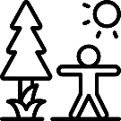  Describe what you see, hear and feel outside. | 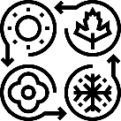  Explore how changing seasons effect the natural world. |  |   Explore and care for the environment you live in. | 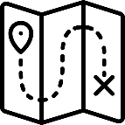  Draw information from a simple map. |  |   Recognise life in other countries may be different to ours.
Year 1  UK | My School |  | My Town |  |  | The UK
Year 1  UK | 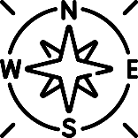  Why do we draw compass directions on a map? |  | 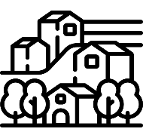  What features can we find in our town? |  |  |   Why is London the capital city of the UK and England?
Year 2  UK &  Australia | Seas and Oceans |  | Seven Continents |  |  | Hot and Cold Places
Year 2  UK &  Australia | 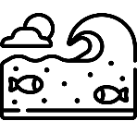  Where do we find water? |  | 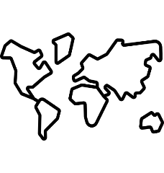  How do we locate different continents? |  |  | 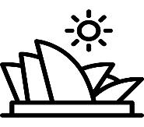  Does the UK experience the same climate as Australia?
Year 3/4  Cycle A  Europe | Rivers |  | Natural Reources |  |  | Europe
Year 3/4  Cycle A  Europe | 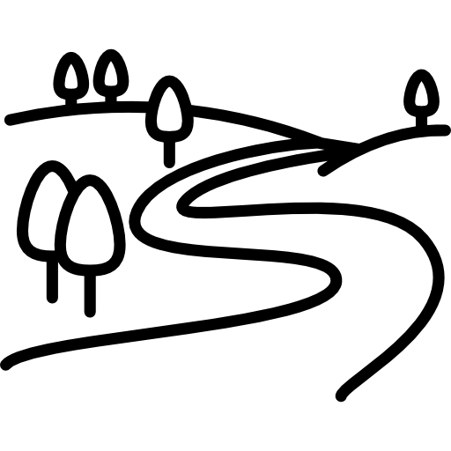  Why do rivers flow across land and end at the sea? |  | 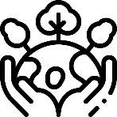  How can we use natural resources sustainably? |  |  | 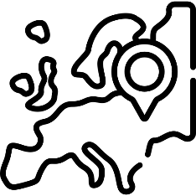  What makes a country in Europe unique?
Year 5  North America | Climate Zones |  | North America |  |  | Economic Activity
Year 5  North America | 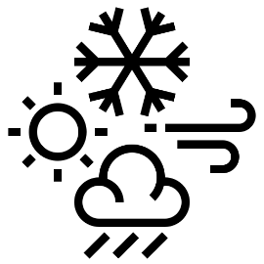  Why do places experience different climates? |  | 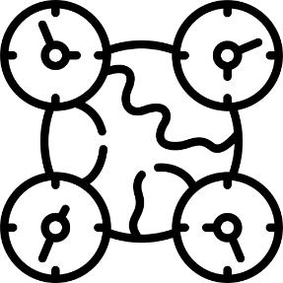  Why does North America have different time zones? |  |  | 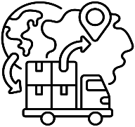  How does the UK trade with the world?
Year 6  Local Area | Local Fieldwork |  | Earthquakes and Volcanoes
Year 6  Local Area |   Why are some areas of Melton Mowbray busier than others? |  | 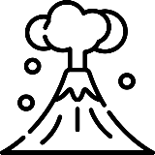  Why are some places more vulnerable to tectonic hazards?

Cycle A

Long Term Plan 2027 – 2028 Cycle B
Cycle B
 | Autumn |  | Spring |  |  | Summer
Year R  (Development  Matters) | Describe what you see, hear and feel outside. | Explore how changing seasons effect the natural world. |  | Explore and care for the environment you live in. | Draw information from a simple map. |  | Recognise life in other countries may be different to ours.
Year 1  UK | My School |  | My Town |  |  | The UK
Year 1  UK | Why do we draw compass directions on a map? |  | What features can we find in our town? |  |  | Why is London the capital city of the UK and England?
Year 2  UK &  Australia | Seas and Oceans |  | Seven Continents |  |  | Hot and Cold Places
Year 2  UK &  Australia | Where do we find water? |  | How do we locate different continents? |  |  | Does the UK experience the same climate as Australia?
Year 3/4  Cycle B  UK | The UK Regions |  | The Water Cycle |  |  | Settlements
Year 3/4  Cycle B  UK | 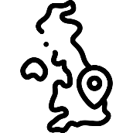  What will you find in a region? |  | 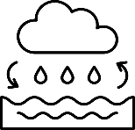  Why is the world covered in water? |  |  | 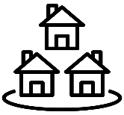  Why do people live in different settlements?
Year 5  North America | Climate Zones |  | North America |  |  | Economic Activity
Year 5  North America | Why do places experience different climates? |  | Why does North America have different time zones? |  |  | How does the UK trade with the world?
Year 6  Local Area | Local Fieldwork |  | Earthquakes and Volcanoes
Year 6  Local Area | Why are some areas of Melton Mowbray busier than others? |  | Why are some places more vulnerable to tectonic hazards?

