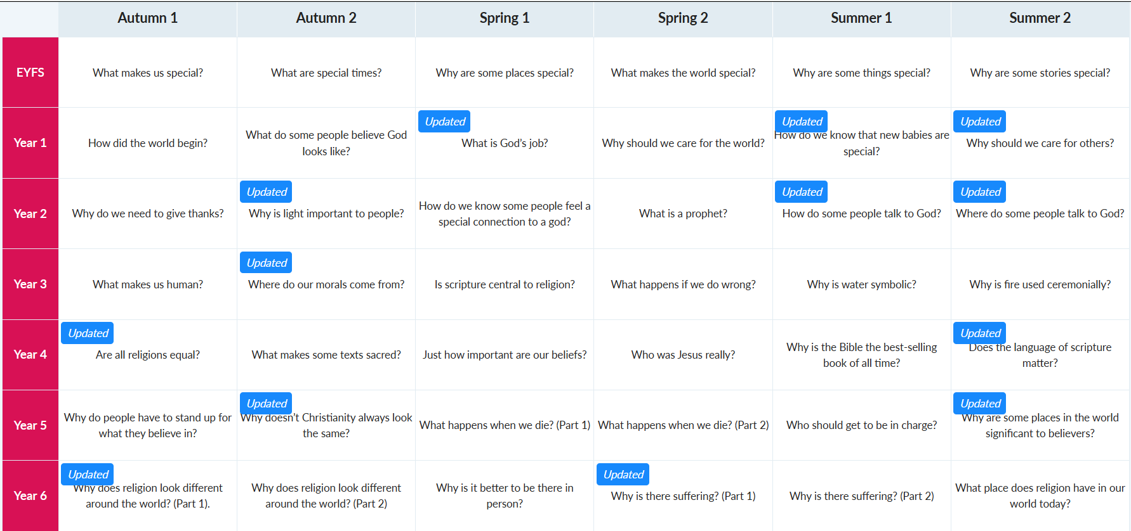
Swallowdale Primary School Religion and Worldviews LTP 2026/2027

