
Subject Unit Plan
Subject: Design Technology
Unit: Construction: pavilion
Year Group: 3 and 4 CYCLE A
Overview of Unit:
To design, make and evaluate a pavilion
There are a variety of ways to assemble a frame structure.
You can create lots of different textures for your cladding designs using different materials and techniques

Session number | Sequenced learning points | Activities
1 | To create a range of different shaped frame structures  I can make a variety of different frame structures.  I know what the structure (pavilion) is used for. | Lesson_1__Exploring_frame_structures.docx
2 | To create a range of different shaped frame structures  I know what a pavilion is  I can explain the purpose of world expos and pavilions  I can make a variety of different frame structures | Lesson_2__Designing_a_pavilion.docx
3 | I can review my design from the previous lesson  I can assemble my construction with accuracy | End of lesson:  Identify features of either your own or your peers’ frame structures which have worked well, consider and explain why this might be.  Add any notes to your design sheet about changes you would like to make in light of what you have learnt.  pavilion frame video.mp4
4 | I can select appropriate materials for my cladding  I can add cladding which reflects my design  I can create different textural effects with my chosen material | full cladding video.mp4
5 | I can assemble my final piece | Create final piece
6 | I can evaluate my final piece | Compare your final pavilion to your design sheet; then, as a class, we will discuss what you found easiest/most difficult, what worked well and what didn’t go to plan

Subject Knowledge Support
15 Sustainable and Green Building Construction Materials - Conserve Energy Future (conserve-energy-future.com)

Singapore Pavilion at The Expo 2025, Osaka

Singapore Pavilion | Expo 2025 Osaka, Kansai, Japan Official Website

KS2, Y4, DT, Lesson 2: Designing a pavilion - Kapow Primary
Serpentine Galleries Build Your Own Pavilion
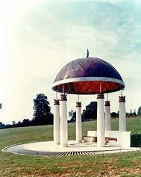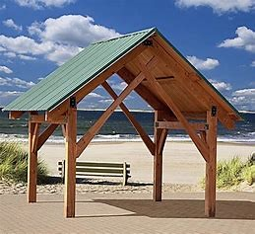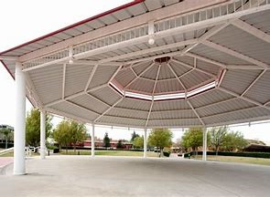

Evaluation
National Curriculum

Design
- use research and develop design criteria to inform the design of innovative, functional, appealing products that are fit for purpose, aimed at particular individuals or groups
- generate, develop, model and communicate their ideas through discussion, annotated sketches, cross-sectional and exploded diagrams, prototypes, pattern pieces and computer-aided design

Make
- select from and use a wider range of tools and equipment to perform practical tasks [for example, cutting, shaping, joining and finishing], accurately
- select from and use a wider range of materials and components, including construction materials, textiles and ingredients, according to their functional properties and aesthetic qualities

Evaluate
- investigate and analyse a range of existing products
- evaluate their ideas and products against their own design criteria and consider the views of others to improve their work
- understand how key events and individuals in design and technology have helped shape the world

Technical knowledge
- apply their understanding of how to strengthen, stiffen and reinforce more complex structures
- understand and use mechanical systems in their products [for example, gears, pulleys, cams, levers and linkages]
- understand and use electrical systems in their products [for example, series circuits incorporating switches, bulbs, buzzers and motors]
- apply their understanding of computing to program, monitor and control their products.

