
Subject Unit Plan
Subject: Design Technology
Unit: Construction windmill house
Year Group: 1
Overview of Unit:
Design, make and evaluate a windmill house
Our windmill should:​
- Stand up on its own​
- Be decorated for its owner​
- Have three parts​
- Blow in the wind​

Session number | Sequenced learning points | Activities
1 | - Introduce children to a windmill and the job of the windmill. Discuss design criteria around windmill house for a mouse  - Understand the three main parts needed: axel, turbine and structure | - https://www.youtube.com/watch?v=Bj40JtpqI0U  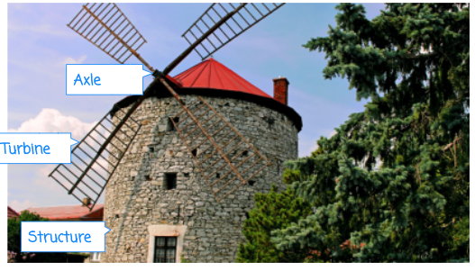
2 | - Understanding how to use a net to construct the structure and turbine. Children to explore different nets for this. | - Use a cylinder net for the structure. Discuss how to use tabs to make a base for the structure too.  Challenge- design a roof structure as well
3 | - Decorate agreed nets for structure and turbine.  - Children to design for the house. What would the house need? (Windows and doors)
4 | - Assembling the windmill- put the 3 elements together | Introduce the word:  Assemble – To put all the parts together  You now need to show children how to assemble and attach the turbine to their windmill structure.  If you are modelling to the children, show them:  - How to cut out their decorated turbine template  - How to create holes in the correct places using a sharp pencil.  Stress the importance of using templates as well as cutting them out carefully and precisely to make all components neat and of uniform size so that the turbines work properly.  The children can now assemble the turbine component by pushing the pipe cleaner through the back of the turbine and folding the corner of each of the sails into the centre, sliding them over the pipe cleaner before finally attaching this to the structure (as demonstrated in the Pupil video: Assembling the windmill).  Once the turbine has been assembled and attached, the children can attach the roof if they have created one.
5 | - Testing windmills- can they blow in the wind?  - Evaluation linked to success criteria from Knowledge Organiser | The children should now test and evaluate their own windmills in the same way as you tested the demonstration model in the Attention grabber.  Explain to the children that the evaluation is to look at the good and bad points about something to help us improve, and testing a product lets us find out if everything works as it should.  This is a great opportunity for children to develop their problem-solving skills:  - If their windmill topples over when they attach the turbine, they could add more weight to the base or attach it to a larger base.  - If the turbine isn’t able to turn, the children should check that it is not attached with tape or glue and is able to spin around the axle.  - If the turbine can turn but is too stiff to work in the wind (when the children blow on it), they need to look at the size of the hole in the centre, as well as making sure it is not attached too tightly.  Give children an opportunity to test their windmills outside if it is a windy day or using a fan on a low setting.  - The children could even record their windmills working using a tablet or camera and add a voiceover evaluating the finished product.

Subject Knowledge Support
Stable – Does not topple over easily
Unstable – Topples over easily
Strong – It does not break easily
Weak – It breaks easily

To make the turbine: https://www.youtube.com/watch?v=AZrP2vSqhQ4
Evaluation

