
Subject Unit Plan
Subject: Design Technology
Unit: Food and nutrition: fruit salad
Year Group: 1
Overview of Unit:
Design and make a healthy fruit and vegetable salad. ​
Skills to learn: the bridge, the claw and fork hold

Session number | Sequenced learning points | Activities
1  Explore | - Know and understand the difference between fruit and vegetables | - Taste and explore different fruit and vegetables
2  Explore | - Explore where different vegetables (e.g. under ground)  - Know which parts of the plant we eat: leaves, root or stem.​ | - Quiz: Match the fruit/veg to the plant - CBBC - BBC  - Can you guess the vegetable? - CBeebies - BBC
3  Design | - Introduce idea of a fruit salad and what it is made from  - Plan the recipe – ingredients and method  - Take account of hygiene practices | - OLIVER'S FRUIT SALAD | Healthy Eating Story | Read aloud #storyoftheweek - YouTube  Getting ready to cook - KS1 - BBC Bitesize
4 + 5  Make | - Skills to be learnt from knowledge organiser and practised and creating fruit salad in groups | - Complete fruit salad- this may be completed in groups to allow for supervision while cutting  - Slicing and cutting safely - KS2 - BBC Bitesize – good video demonstrating the cutting methods
6  Evaluate | - Evaluation of the product | - 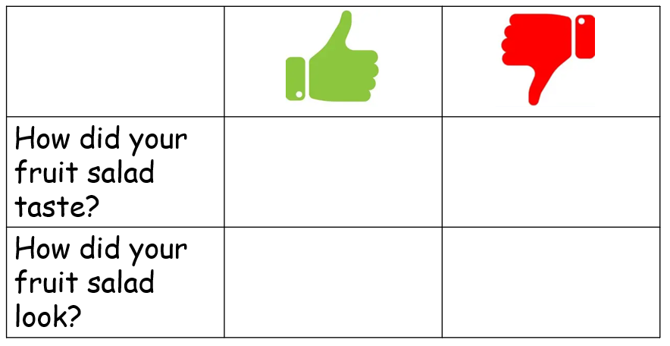

Subject Knowledge Support
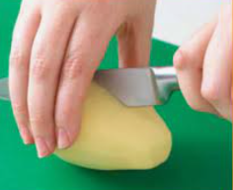 The bridge Using knife (bridge hold) - YouTube

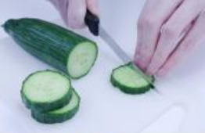The claw The Claw Grip - YouTube

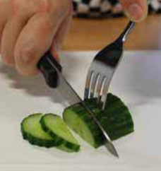Fork hold How to use a Knife - The Fork Secure - YouTube – stop at 45 seconds

Slicing and cutting safely - KS2 - BBC Bitesize

Evaluation
2 stars and a wish

2 things that went well

1 thing that could be improved

Refer back to the design brief – have you made a healthy fruit and vegetable salad.

