
Subject Unit Plan
Subject: Design Technology
Unit: Mechanisms
Year Group: 1
Overview of Unit:
To design, make and evaluate a moving story book.

Session number | Sequenced learning points | Activities
1 | - Explore different story books with moving parts e.g. Dear Zoo and Pop up dinosaurs  - Begin to discuss how it will work | - Books with moving parts carousel – children explore the different books/ moving parts
2 | - Explore mechanisms such as levers and sliders | - Make own rabbit moving up and down to explore how the mechanism works
3 | - Plan - Look at different pictures to decide what could move in them e.g. the dog chasing the gingerbread | - Plan which picture and character will be moving
4 | - Make: To make and the design setting and character for the moving picture | - Make own design on moving picture to include a setting and a character
5 | - Make: To make the slider and attach the moving character to create a moving picture​ | - Complete the moving picture by adding the character to the picture
6 | - Evaluate moving pictures  - Has the design brief been met? | - 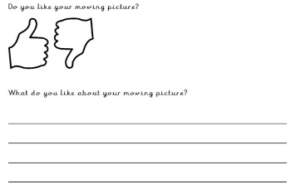

Subject Knowledge Support
Mechanism for lesson 1
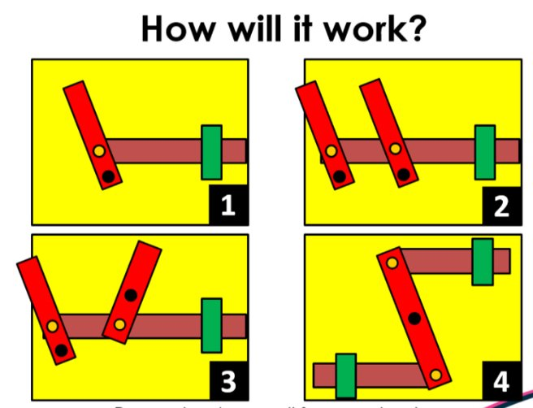

What is a slider mechanism? - KS1 - BBC Bitesize

What is a lever mechanism? - KS1 - BBC Bitesize

Evaluation

