
Subject Unit Plan
Subject: Design Technology
Unit: Food and nutrition: bread
Year Group: 2
Overview of Unit:
Design and make a loaf of bread.
Skills to learn: knead, weigh and measure

Session number | Sequenced learning points | Activities
1  Explore | - Explore food Health and Safety  - Food groups - Which group does bread come into? | - Scenarios – what are the risk?  - 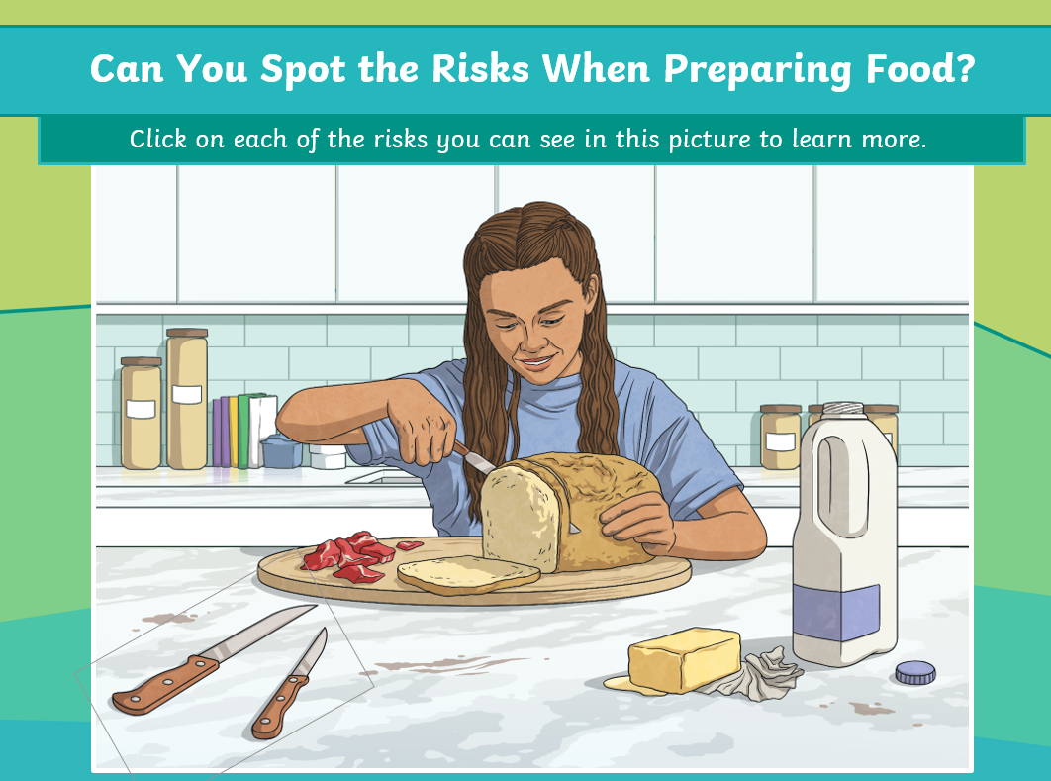  - What are the five main food groups? - BBC Bitesize
2  Explore | - Explore skills needed to make bread  - Kneading  - Measuring  - Weighing | - Practical – measure water, knead play doh, weigh play doh  Homemade Bread - Baking recipe for Kids - YouTube
3  Explore | - Different types of bread  What does it look like?  What does it smell like?  What does it feel like?  What does it taste like – texture? | - Bread tasting  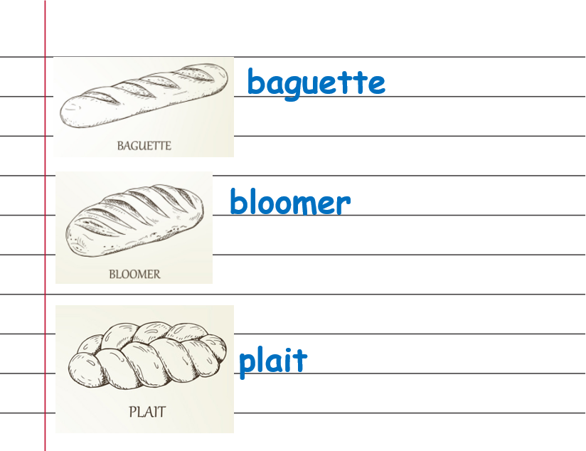  Reflect on bread tasting in books.
4  Design | - Design a loaf of bread | - Chose from 3 ingredients to add into recipe.  Raisins, cheese, herbs
5  Make | - Make a loaf of bread | Work in small groups to make the loaf of bread
6  Evaluate | - Evaluate loaf of bread | I have made ….  The skills I have used …  I liked/disliked…  It come be improved by…  I met/did not meet the design brief…

Subject Knowledge Support
What are the five main food groups? - BBC Bitesize – food groups video

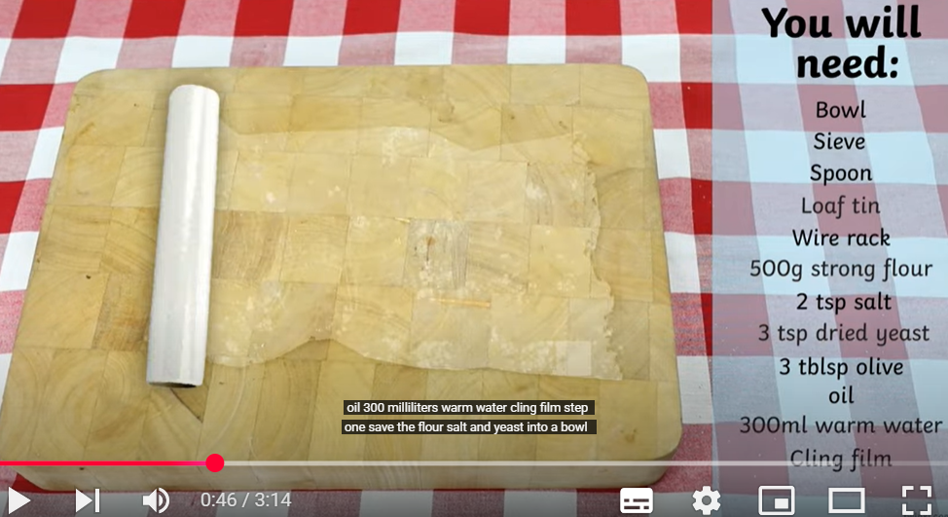 How To Make Bread - Homemade Bread - Baking recipe for Kids | Twinkl kids tv - YouTube
Evaluation
2 stars and a wish –
2 things that went well

! thing that could be changed

Skills used

Refer back to the design brief – have you made a loaf of bread?

