
Subject Unit Plan
Subject: Design Technology
Unit: Mechanisms moving Monsters
Year Group: 2
Overview of Unit:
To design, make and evaluate a moving monster

Session number | Sequenced learning points | Activities
1 | - Explain to the children the design brief for this project: ‘Design and make a moving monster toy for children using levers and linkages.’ | The children will be making a monster from card and a paper-fastener/split pin linkage system. It will include a monster’s head, which can open and close as you control the linkage from the handles.  Investigation (15 minutes)  Explain to the children that before they start, they need to investigate levers, linkages and toys in more detail with the following two activities:  - Mechanism identification exercise: Levers and linkages  - Product analysis exercise: toys  Mechanism identification exercise: Levers and linkages  Levers and linkages- ask them to identify the pivots (a central point from where something can turn, like your elbow) in each of the products.
2 | - Exploring different mechanisms | Give each child a copy of the Activity: Linkage diagram and explain to the children that they are to explore making Linkage Systems 1 and 2, which they will use to make their moving monsters.  Using the strips of pre-cut card, split pins and uncut card, the children can experiment making the linkages independently.  Remind children to experiment making a number of versions of the linkage examples by using different widths, lengths and thicknesses of card as you modelled.
3 | - Designing the monster | Design ideas  Remind children that they should aim for their designs to satisfy each of the five Design Criteria and direct them to complete their design brief by:  - Sketching two different design ideas for their monsters and adding design.  - Adding arrows to their designs to indicate the parts that move and the direction of movement.  - Drawing a diagram of the linkage systems they have chosen based on the parts they want to move and the direction of movement.
4 | - Making the model | Provide:  - A pile of the pre-made thick card strips for children to make their linkage systems as well as additional thick card for children to create their own.  - Thin card for children to make their head and jaw pieces if they choose.  The children can then start making.
5 | - Evaluation | - Link back to the design brief

Subject Knowledge Support
Example of model:
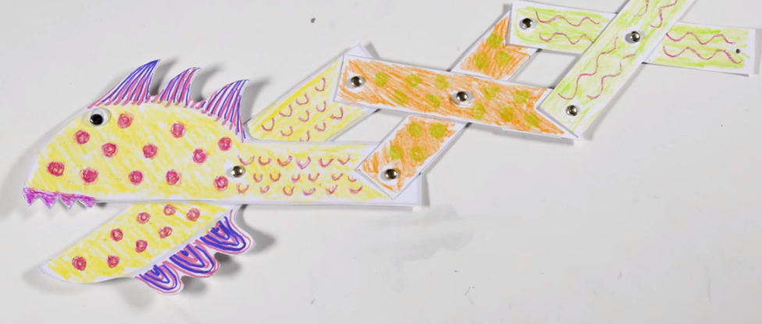

Mechanisms - KS1 Design and Technology - BBC Bitesize

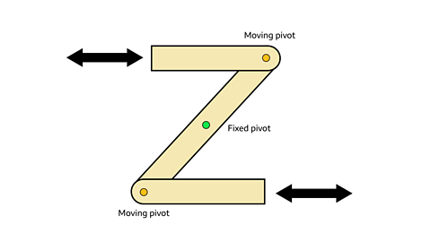

Levers and Linkages - YouTube

Evaluation

