
Subject Unit Plan
Subject: Design Technology
Unit: Construction Andersen Shelters
Year Group: 6
Overview of Unit:
I can research to inform my plans and ideas.​
I can show that I consider culture and society in my plans and designs.​
I can justify my plans in a convincing way.​
I can show, test and explain and evaluate my products against a clear criteria. ​
I can use a range of tools and equipment competently.

Design brief: Design, make and evaluate your own Anderson shelter. Collect research, explore materials and select appropriate tools and resources to use. Consider appropriate features of Anderson shelters and select materials fit for purpose.

Session number | Sequenced learning points | Activities
1 | - Exploring how to fold paper together to make it secure | - Practical
2 | - Explore how to complete lashing, running, over and catch stitch | - https://www.animatedknots.com/square-lashing-knot
3 | - Introduce the concept of the design brief.  - Research the purpose of the Andersen shelter | - Sketch the concept of an Andersen shelter
4 | - This week, we are going to think about the strength of the materials we are using and how we may need to modify our design choices.  - Plan shelter based on strength test and design brief to house 6 Duplo men | 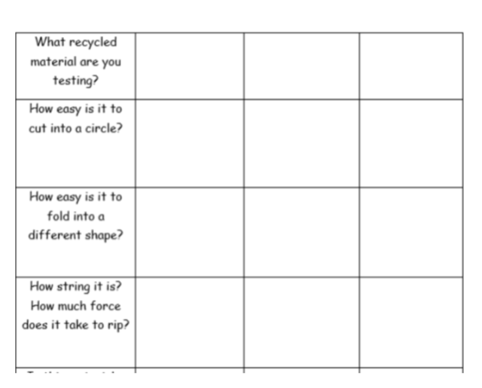  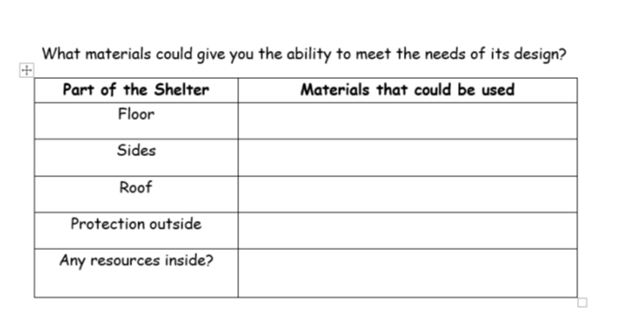
5 | - Build shelter and test
6 | - Evaluate | What did you do? – step by step  What went well?  What would you do differently next time?  Did your materials meet the needs of its design?

Subject Knowledge Support
https://childreninww2.wordpress.com/dt-creating-anderson-shelter-models/
https://www.edencamp.co.uk/wp-content/uploads/2020/04/Design-your-own-Anderson-Shelter.pdf

anderson-shelters-information-sheet.docx

How to make an Anderson Shelter - YouTube

Evaluation
Has the design brief been met?

