Why do we draw compass directions on a map?
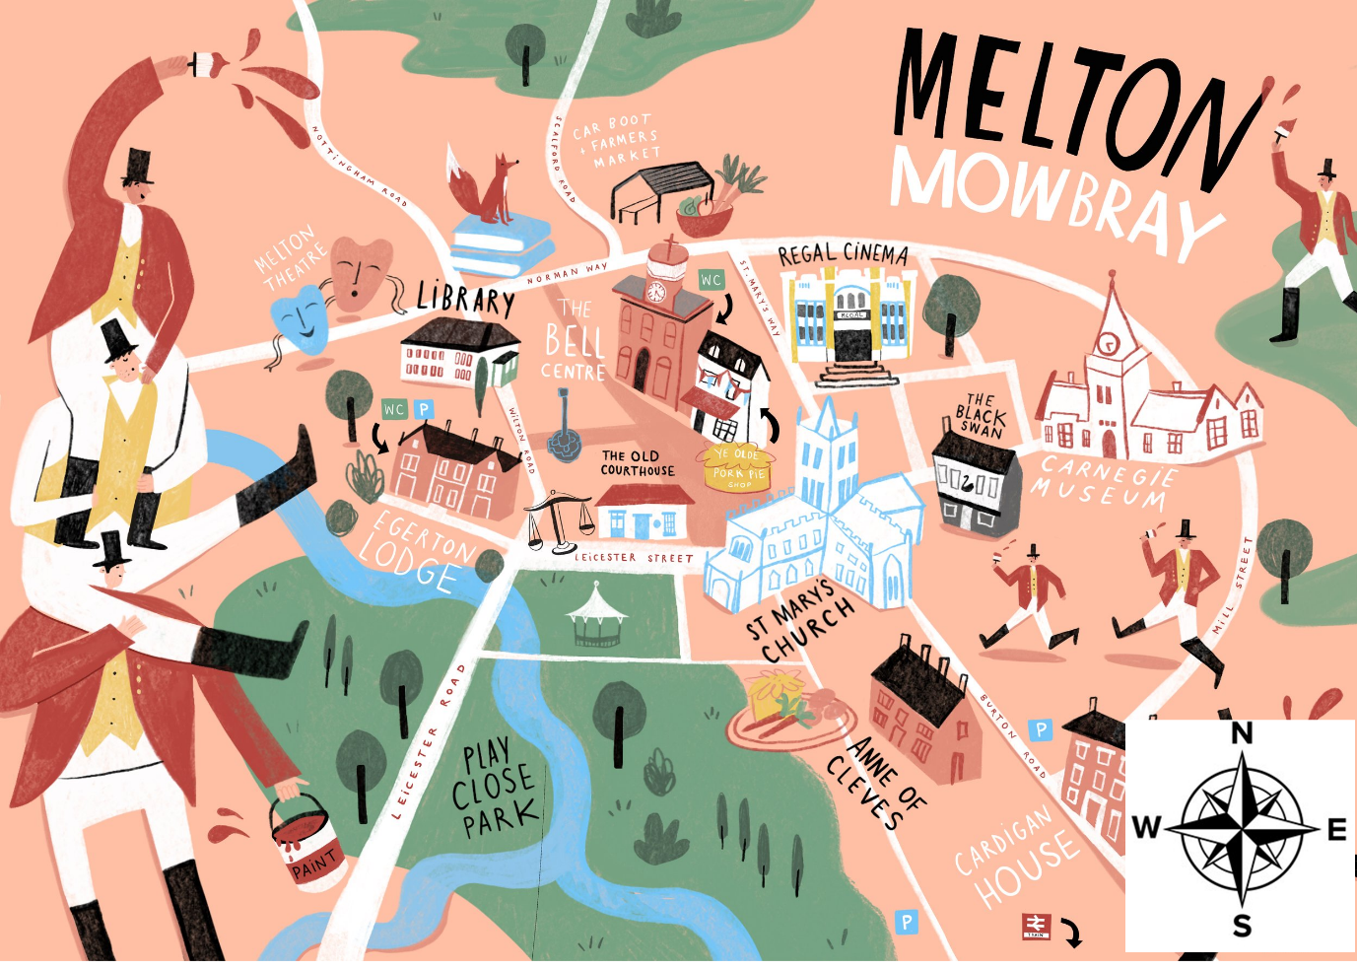

Name: _______________________________________________

Class: ________________________________________________

Date of the Fieldwork: ________________________________

1. This is an aerial map of a Little Town.
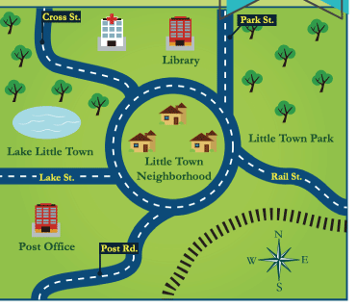

2. What is located East of the roundabout?

3. A map needs a key to tell what every shape means. Finish the key for the Little Town map.

Key
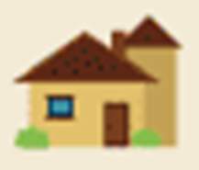 | house |  | 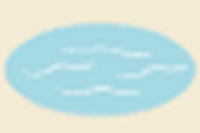
 |  |  |  | hospital
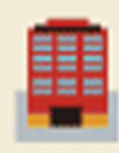 | building |  | 
 |  |  | 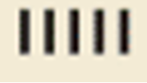 | railroad

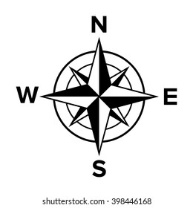
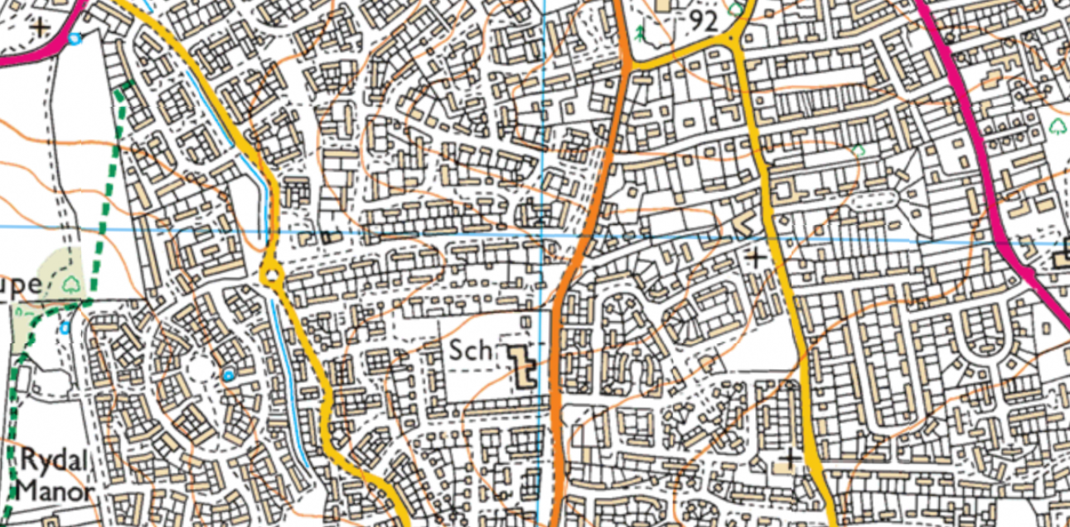
This is an OS Map of Melton Mowbray. Features are represented by shapes.

5. Make a key for the OS Map.
Key
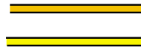 | = |  |  | =
 | = |  | 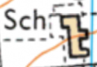 | =

6. What is located West of the map?

7. Draw an aerial map.

8. Make a key for your map.
Key
=

=

=

=

=

=

9. What is located South of the map?

