
Subject Unit Plan
Locational Knowledge
Place Knowledge
Human and Physical Geography
Geographical Skills and Fieldwork
Climate Education
Subject: Geography
Year Group: Year 1
Unit: My School
Enquiry Question: Why do we draw compass directions on a map?
National Curriculum Link
• use simple compass directions (N,S, E,W) and locational and directional language to describe the location of features and routes on a map
• use simple fieldwork and observational skills to study the geography of their school and its grounds and the key human and physical features of its surrounding features
• devise a simple map and use and construct basic symbols in a key

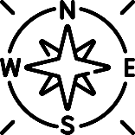 | Enquiry question:  Why do we draw compass directions on a map?
Session number |  | Sequenced learning points
1. Why do we give directions? |  | ● What is a direction?  ○ In front, behind, near, far, left, right  ● Why do we give directions?  ● Respond to directions correctly
2. What are compass directions? |  | ● What is a direction?  ● What is a compass?  ● There are 4 compass directions: north, east, south and west  ● Respond to compass directions
3. How do compass directions help us locate features? |  | ● There are 4 compass directions: north, east, south and west  ● Why do we use a compass?  ● What is a feature?  ● Locate features using compass directions
4. What is a map? |  | FIELDWORK BOOKLET  ● What is a map?  ● Why do we use maps?  ● Features are represented on a map using shapes  ○ The key tells us what each shape represents  ● Why is a compass drawn on a map?
5. Create a simple map of our school. |  | FIELDWORK BOOKLET  ● What school do we attend?  ● Find our school using a satellite map  ● Why do we create maps?  ● Create a map of the KS1 area  ○ Children sit on KS1 playground facing north  ○ Draw features using shapes to represent them
6. Why do we draw compass directions on a map? |  | FIELDWORK BOOKLET  ● Look at your map of the KS1 area  ○ Children sit in same position facing north  ● Why do we need a key?  ○ Draw a key  ● Why do we need compass directions?  ○ Draw a compass on your map  ● Describe where features are located using compass directions

Subject Knowledge
1. Why do we give directions? | ● What is a direction?  ○ In front, behind, near, far, left, right | ● Directions are instructions  ● They can tell you which way to move  ○ Left, right, forwards, backwards  ● They can also tell you where something is located  ○ In front, behind, near, far
1. Why do we give directions? | ● Why do we give directions? | ● We give directions to tell someone where something is located “the pencils are in front of you.”  ● We give directions to help locate something “go left and find your chair.”
1. Why do we give directions? | ● Respond to directions correctly | ● Practise responding to directions  ○ Step (forward) 3 times, etc.  ● Practise giving directions to describe where something is (in front, behind, next to, left, right)
2. What are compass directions? | ● What is a direction? | ● A direction is an instruction which tells you where something is or which way to move
2. What are compass directions? | ● What is a compass?  ● There are 4 compass directions: north, east, south and west | ● A compass is an instrument that you use to find a direction  ● It has a dial and a magnetic needle that always points to the north  ● A compass has 4 main directions – North, South, East and West  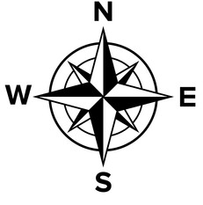
2. What are compass directions? | ● Respond to compass directions | ● Give compass to children to explore the 4 directions  ● What happens when you move the compass? The needle should move to keep pointing north.  ● Practise responding to compass directions “move 4 jumps north.” Identify north, point, then jump, etc.
3. How do compass directions help us locate features? | ● There are 4 compass directions: north, east, south and west | ● A compass is an instrument that you use to find a direction  ● The needle always points to the north  ● A compass has 4 main directions – North, South, East and West
3. How do compass directions help us locate features? | ● Why do we use a compass? | ● We use a compass to find a direction
3. How do compass directions help us locate features? | ● What is a feature?  ● Locate features using compass directions | ● A feature is something you can see in the environment  ○ What can you see in the classroom environment?  ● Explore school and children sit in same position (facing north?) with compass.  ● What features can you see south of your position?
4. What is a map? | ● What is a map?  ● Why do we use maps? | ● A map is a drawing of a particular area, showing its main features.  ● Maps are drawn from an aerial view, known as a “birds eye view.”  ● Maps can help us plan journeys from one location to another  ○ Google maps – journey navigation  ● Maps can also show us where something is located
4. What is a map? | ● Features are represented on a map using shapes  ● Why is a compass drawn on a map?  ○ The key tells us what each shape represents | FIELDWORK BOOKLET  ● Objects on a map are represented by shapes  ● A map has a key to show what the shapes on the map represent  ● Compass direction are usually on a map – we use these to find the location of something  ● E.g where is the lake located? north of the map? east of the map?  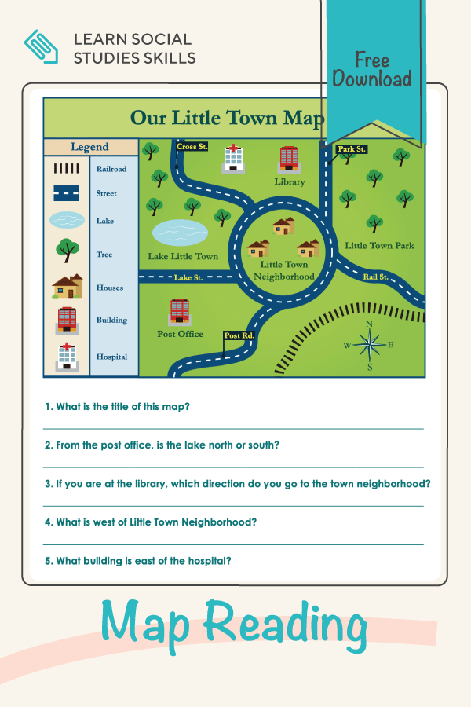  ---------------------------------  ● Visit Bing Maps, search for Melton Mowbray, zoom into Swallowdale School area (as most familiar to children)  ● Show using Aerial map (this is a satellite map – pictures taken from the sky, aerial view = birds eye view) – children should recognise some features. What is this… our school. Look for, school, houses, trees, grass, roads, etc.  ● Then change map to Hybrid map – this highlights the roads.  ● Then change to Road Map – what’s happened to the buildings? They are represented using shapes.  ● Then change to Ordnance Survey map – features are represented using shapes/colours. What do you notice?  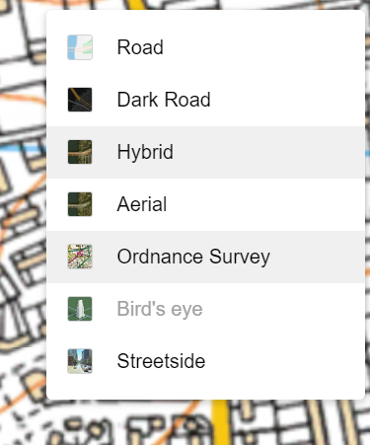  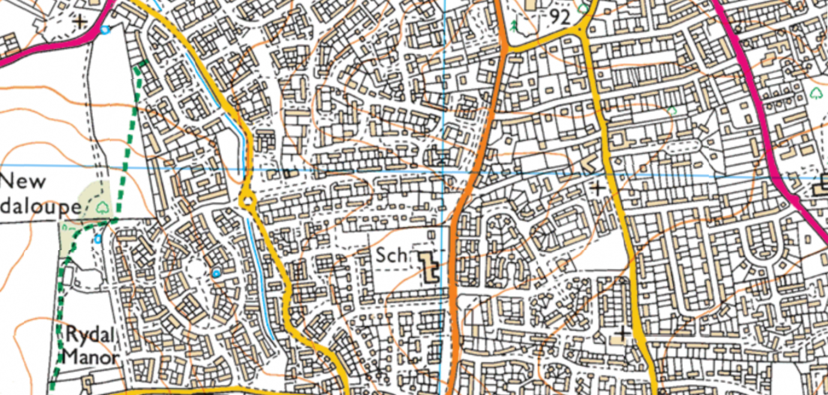  ● Let’s create a key for the OS Map.
5. Create a simple map of our school | ● What school do we attend? | ● We attend Swallowdale Primary School  ● Over 300 children go to school here  ● We live in the town Melton Mowbray  ● Swallowdale Primary School is located in Melton Mowbray
5. Create a simple map of our school | ● Find our school using a satellite map | ● Visit Bing Maps and look at Melton Mowbray using Aerial maps.  ● What features can you see?  ● Change to OS/Hybrid to demonstrate that when we draw maps we use shapes to represent features
5. Create a simple map of our school | ● Why do we create maps? | ● A map is a drawing of a particular area, showing its main features.  ● Maps are drawn from an aerial view, known as a “birds eye view.”  ● Maps can help us plan journeys from one location to another  ● Maps can also show us where something is located
5. Create a simple map of our school | ● Create a map of the KS1 area  ○ Children sit on KS1 playground facing north  ○ Draw features using shapes to represent them | FIELDWORK BOOKLET  ● Sit outside in KS1 area in a line, making sure children are facing north (sitting towards Year 1)  ● We are going to make a map of our school to show where objects are located  ● When drawing a map we need to use shapes to represent objects  ● What is north of us? What is in front of us – Year 1 classroom. What shape could we draw to represent the classroom. Draw at top of the paper.  ● What is east of us? What is to the right – fence. What shape could we draw to represent the fence?  ● What is south of us? What is behind us – trees. What shape could we draw to represent the trees?  ● What is west of us?  ● Colour
6. Why do we draw compass directions on a map? | ● Look at your map of the KS1 area  ○ Children sit in same position facing north | FIELDWORK BOOKLET  ● Sit in the same position as last lesson when creating the map.  ● We drew a map of the features in our school. What features did we see?  ● What is in front/behind/left/right north/east/south/west?
6. Why do we draw compass directions on a map? | ● Why do we need a key?  ○ Draw a key | ● A map has a key to show what the shapes on the map represent  ● Draw key of the features drawn on map
6. Why do we draw compass directions on a map? | ● Why do we need compass directions?  ○ Draw a compass on your map | ● Compass direction on a map are used to find the location of something  ●Draw compass on map
6. Why do we draw compass directions on a map? | ● Describe where features are located using compass directions | ● What is located north/east/south/west of your map?

