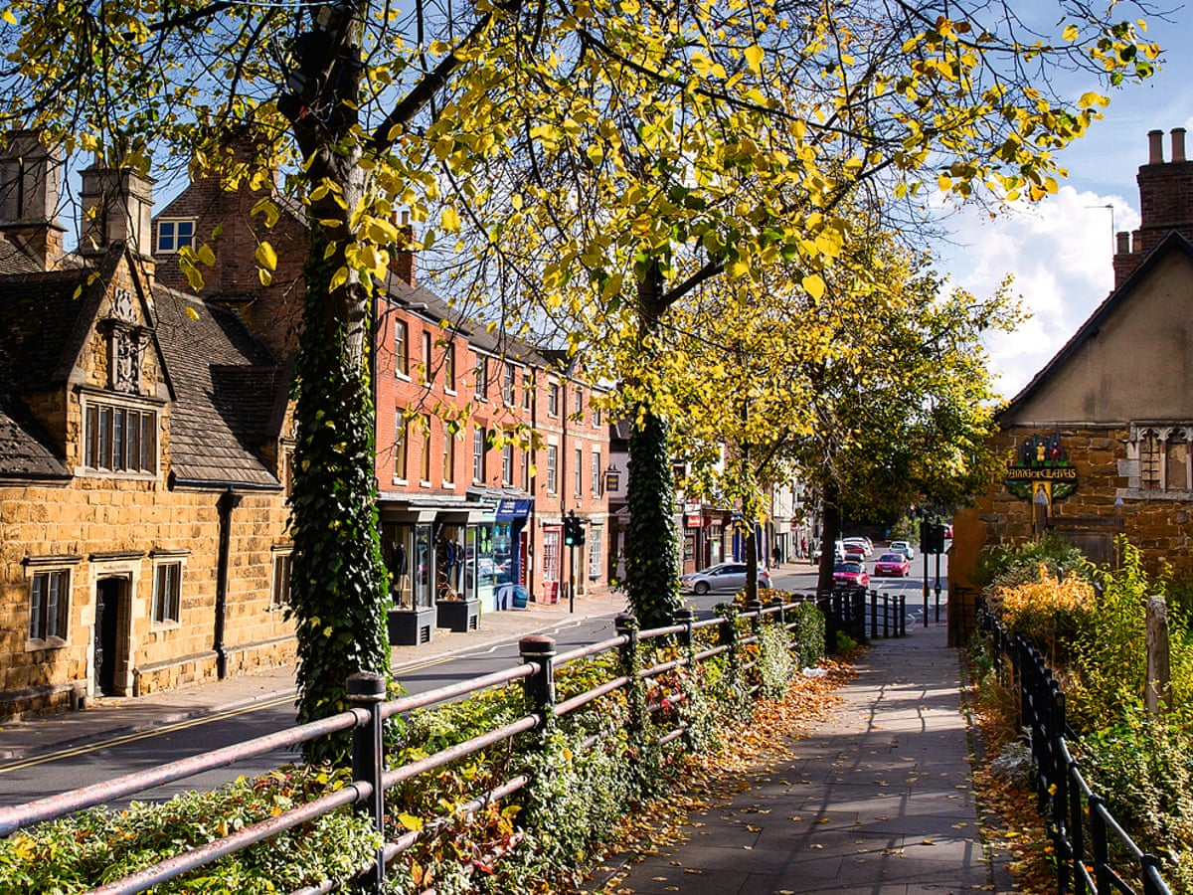
What features can we find in our town?

Risk Assessment:

1.

2.

Date of Fieldwork:

1. What is a human feature? Name some examples.
- _________________________________________
- _________________________________________
- _________________________________________

2. What is a physical feature? Name some examples.
- _________________________________________
- _________________________________________
- _________________________________________

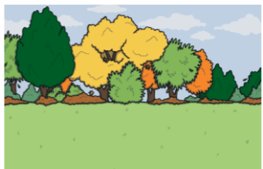
3. What type of feature is this?

physical feature

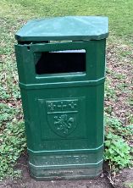

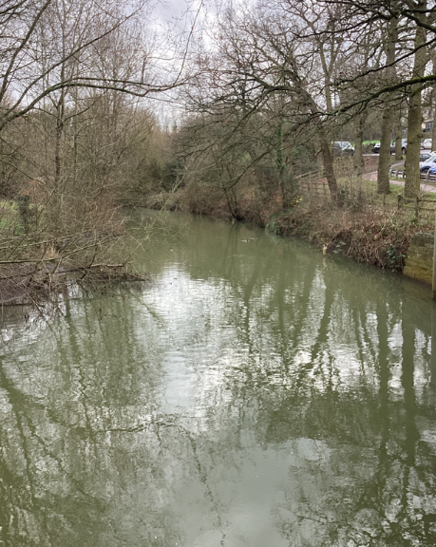
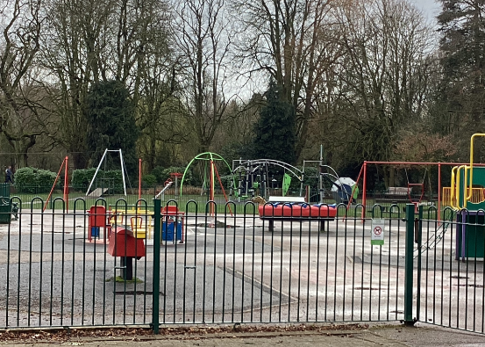

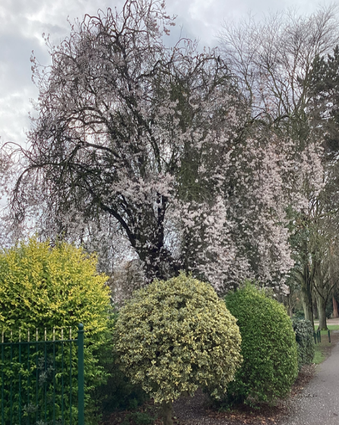

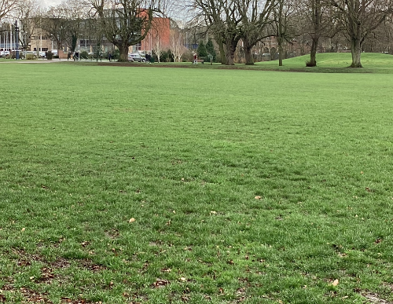
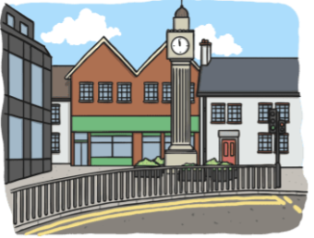

human feature

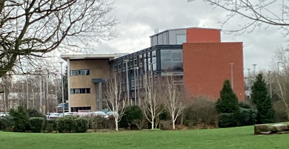

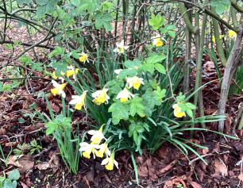

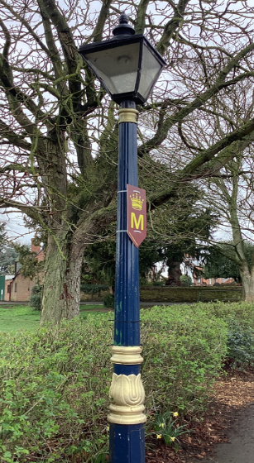

4. Sketch a picture of a feature you can see.

5. What type of feature is this? Is it human or physical?

