
Subject Unit Plan
Locational Knowledge
Place Knowledge
Human and Physical Geography
Geographical Skills and Fieldwork
Climate Education
Subject: Geography
Year Group: Year 1
Unit: The UK
Enquiry Question: Why is London the capital city of the UK and England?
National Curriculum Link
• name, locate and identify characteristics of the four countries and capital cities of the UK
• use geographical vocabulary which relates to human and physical features
• use world maps, atlas and globe to identify the UK and its countries.
• use photographs to recognise landmarks and basic human and physical features
• identify seasonal and daily weather patterns in the United Kingdom

 | Enquiry question:  Why is London the capital city of the UK and England?
Session number |  | Sequenced learning points
1. What country do you live in? |  | ● What town do you live in?  ● What is a country?  ○ What country do to you live in?  ● The United Kingdom (UK) is made up of 4 countries.  ○ Each country has its own flag  ● Use an atlas to identify the UK and its countries
2. What is a capital city? |  | ● The UK is made up of 4 countries  ● Locate each country on a map  ● Create a map of the UK  ● Each country has a capital city  ● Locate each capital city on map of UK
3. What weather does the UK experience? |  | ● The UK is made up of 4 countries  ● Each country is the UK experiences similar weather  ● What type of weather do we have?  ● There are 4 seasons  ● How does climate change affect our weather?  ● How does weather change throughout the day?
4. Why does the UK have lots of beaches? |  | ● What is a physical feature?  ○ Use correct geographical vocabulary for this feature  ● Learn about some famous physical features from each country  ○ Use photographs to identify physical features  ● The UK is an island, each country has a coastline
5. Why are some human features known as landmarks? |  | ● What is a human feature?  ○ What is a landmark?  ○ Use correct geographical vocabulary for this feature  ● Learn about some famous landmarks from each country  ○ Use photographs to identify landmarks
6. Why is London the capital city of the UK and England? |  | ● The UK is made up of 4 countries  ○ Locate each country on a map  ● Each country has a capital city  ● London is the capital city of England and the UK  ● What do people think of when they hear UK?

Subject Knowledge
1. What country do you live in? | ● What town do you live in?  ● What is a country?  ○ What country do to you live in? | ● We live in a town called Melton Mowbray.  ● We live in a country.  ● A country is an area of land that has its own government.  ○ Government is a group of people who make laws we have to follow.  ● Melton Mowbray is located in the country England.  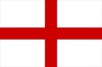  ● We live in England.
1. What country do you live in? | ● The United Kingdom (UK) is made up of 4 countries.  ○ Each country has its own flag | 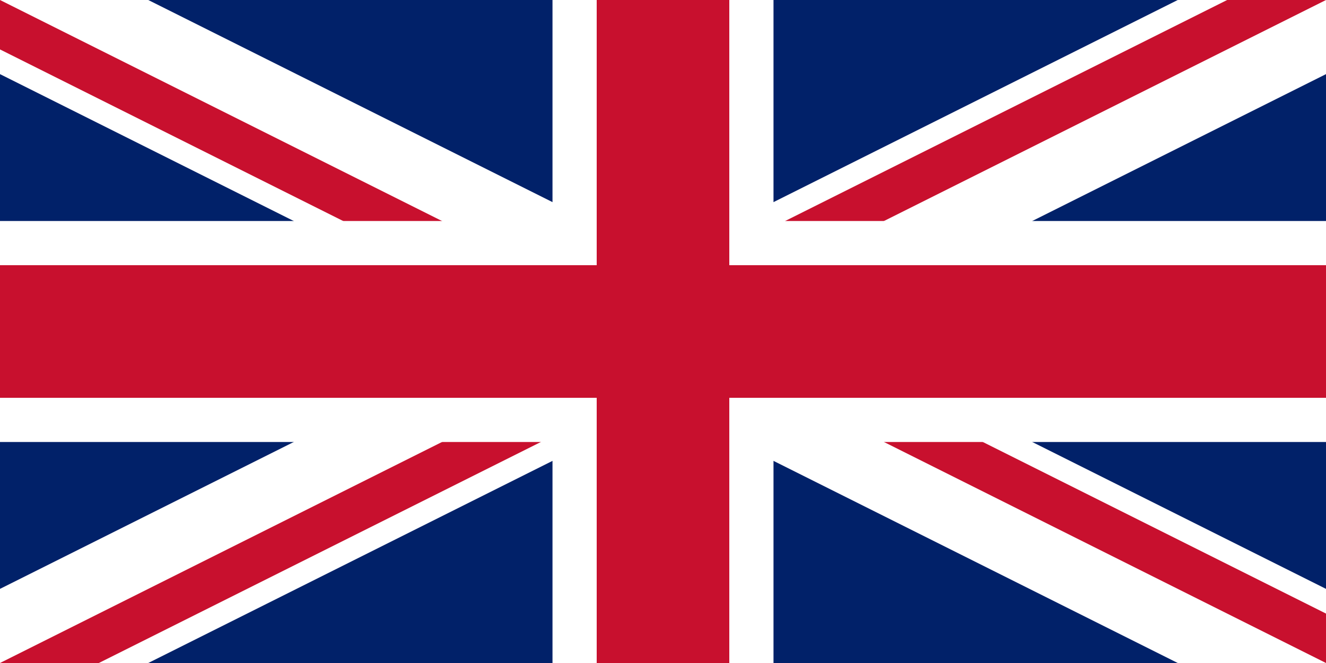  ● The United Kingdom is a country made up of countries.  ○ England, Scotland, Wales and Northern Ireland  ○ The UK’s flag is known as the ‘Union Jack’  ● Each country has its own flag and government.  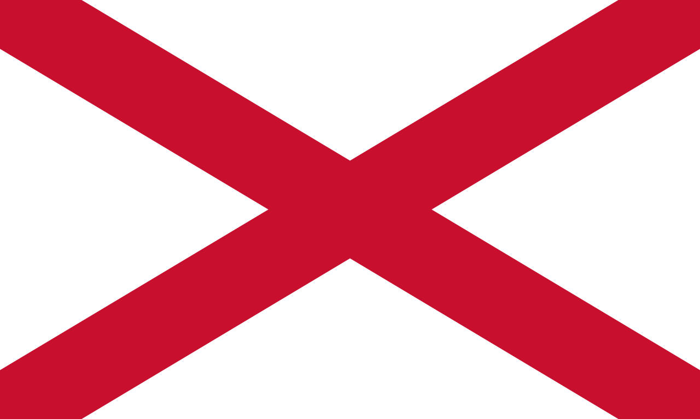  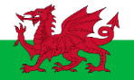  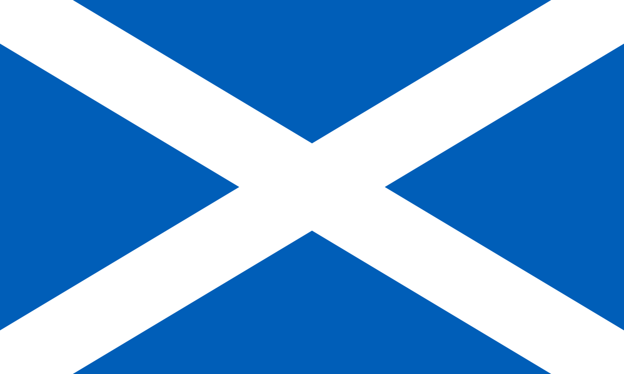  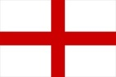  ○ Northern Ireland’s official flag is the Union Jack – however the flag of Saint Patrick is sometimes used by Northern Ireland at international events
1. What country do you live in? | ● Use an atlas to identify the UK and its countries | ● An atlas is a book of maps  ● The maps include countries from all over the world  ● Choose a map of the United Kingdom in atlas  ● Children to identify the 4 countries of the UK
2. What is a capital city? | ● The UK is made up of 4 countries  ● Locate each country on a map | ● The United Kingdom is a country made up of countries.  ○ England, Scotland, Wales and Northern Ireland  ○ The UK’s flag is known as the ‘Union Jack’  ● We live in England. This county is located in the UK.  ● Map of the UK, children to identify each country (England, Scotland, Wales and Northern Ireland)
2. What is a capital city? | ● Create a map of the UK | ● Create a map of the UK by correctly identifying the 4 countries that make up the UK  ● Add compass directions in corner of the map (N, E, S, W)
2. What is a capital city? | ● Each country has a capital city  ● Locate each capital city on map of UK | ● A capital city is the main city in a country, usually where the government meets  ○ England – London, Scotland – Edinburgh, Wales – Cardiff, Northern Ireland - Belfast  ● Locate capital city on map of UK
3. What weather does the UK experience? | ● The UK is made up of 4 countries  ● Each country is the UK experiences similar weather | ● The United Kingdom is a country made up of countries.  ○ England, Scotland, Wales and Northern Ireland  ● The UK is an island  ● An island is land that is surrounded by water  ● The 4 countries that make up the UK are next to each other, they UK experiences similar weather
3. What weather does the UK experience? | ● What type of weather do we have? | ● There are lots of different types of weather, some hot, some cold  ● Sunny, cloudy, windy, rain, wind, snow,
3. What weather does the UK experience? | ● There are 4 seasons | ● There are 4 seasons: autumn, winter, spring and summer  ● Each country experiences the same season at the same time – but temperature/specific weather can differ  ○ BBC Weather has a weather map of UK – good way to show how weather is different across the island  ● Weather changes as we move through the seasons  ● What type of weather will the UK have during the winter/summer/spring/autumn season
3. What weather does the UK experience? | ● How does climate change affect our weather? | ● We know what weather to expect in each season.  ● However the climate (the temperature and weather) we experience in these season is changing. This is called climate change.  ● Climate change = a change in usual temperatures and weather patterns due to human activity.  ● Humans are damaging the environment and this is causing our usual/expected weather to change.  ● Use real life examples with children – for example have you ever experienced snow? Link to grandparents, they will have seen snow drifts for weeks on end in peak winter. Rainy winters are now the norm due to increased temperatures.  ● Older pictures of Melton.
3. What weather does the UK experience? | ● How does weather change throughout the day? | ● BBC Weather – shows daily weather for areas of UK (children loved looking at these maps during Year R and have a little background knowledge on the weather symbols)  ● How does the weather in Melton change throughout the day/week?  ● Compare to capital city of another country
4. Why does the UK have lots of beaches? | ● What is a physical feature?  ○ Use correct geographical vocabulary for this feature | ● A feature is something you can see in the environment  ● Physical features are natural objects or features  ● Physical Features include – beach, cliffs, coast, forest, hill, sea, river, soil, vegetation, season and weather
4. Why does the UK have lots of beaches? | ● Learn about some famous physical features from each country  ○ Use photographs to identify physical features | ● For example:  ● London – River Thames (river), Hyde Park  ● Edinburgh – Arthur’s Seat (hill), Loch Ness (lake)  ● Cardiff – Snowdonia (mountain)  ● Belfast – Giant’s Causeway  ● Use photographs to help learn and identify these physical features
4. Why does the UK have lots of beaches? | ● The UK is an island, each country has a coastline | ● The UK is an island  ● An island is land that is surrounded by water  ● This means that every country (in the UK) has a coastline – land next to the sea  ● You will find beaches, cliffs, sea, sand and stones at the coastline  ● This means that every country has beaches to enjoy
5. Why are some human features known as landmarks? | ● What is a human feature?  ○ Use correct geographical vocabulary for this feature | ● A feature is something you can see in the environment  ● Human features are things that are built by humans. They are “man-made.”  ● Human Features include – city, town, factory, house, office, port, shops, harbours, buildings, bridges, etc
5. Why are some human features known as landmarks? | ○ What is a landmark? | ● A landmark is a feature that has importance or makes a place easily recognisable.  ● Famous human features are often referred to as a landmark.  ● A picture of a landmark should make you instantly think of the place it is located in
5. Why are some human features known as landmarks? | ● Learn about some famous landmarks from each country  ○ Use photographs to identify landmarks | ● We are going to learn about some of the most popular, recognisable landmarks from each country in the UK. These landmarks are human features, they were made by humans.  ○ London: Buckingham Palace, Houses of Parliament, London Eye, Tower Bridge, Wembley Stadium  ○ Edinburgh: Edinburgh castle  ○ Wales: Conwy Castle, Principality Stadium  ○ Northern Ireland: castle, churches  ● Use photographs to help learn and identify these human features
6. Why is London the capital city of the UK and England? | ● The UK is made up of 4 countries  ○ Locate each country on a map | ● The United Kingdom is a country made up of countries.  ○ England, Scotland, Wales and Northern Ireland  ● The UK is an island nation
6. Why is London the capital city of the UK and England? | ● Each country has a capital city  ● London is the capital city of England and the UK | ● A capital city is the main city in a country, usually where the government meets  ○ England – London, Scotland – Edinburgh, Wales – Cardiff, Northern Ireland – Belfast  ● The UK also has a capital city  ● The UK’s capital city is London which is the biggest city in the whole of the UK, lots of people live there
6. Why is London the capital city of the UK and England? | ● What do people think of when they hear UK? | ● When people hear the UK what do they think of…  ● People tend to think of the British flag, English accent and the city of London  ● Images that spring to mind tend to be London landmarks, rather than Scottish landmarks  ● People who come to visit the UK, always visit London to see/experience these landmarks

