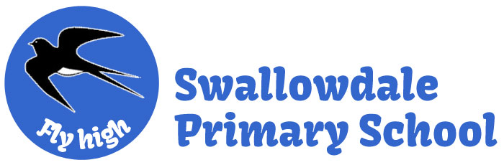
Subject Unit Plan
Locational Knowledge
Place Knowledge
Human and Physical Geography
Geographical Skills and Fieldwork
Climate Education
Subject: Geography
Year Group: Year 2
Unit: Seas and Oceans
Enquiry Question: Where do we find water?
National Curriculum Link
• name and locate the United Kingdom’s surrounding seas
• name and locate the world’s five oceans
• use maps, atlases and globes to identify the UK seas and oceans
• use simple compass directions (North, East, South, West) to describe the location of features on a map

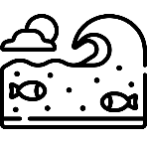 | Enquiry question:  Where do we find water?
Session number |  | Sequenced learning points
1. Where do we live? |  | ● What town do we live in?  ● What country do we live in?  ● The United Kingdom (UK) is made up of 4 countries  ● Each country has a capital city  ● Use an atlas to identify the UK and its countries  ● The UK is an island nation  ○ What surrounds the UK?
2. What surrounds the UK island? |  | ● The UK is an island nation  ● What is a sea?  ● There are 3 seas that surround the British Isles  ● Use maps to locate and identify the UK seas
3. How many oceans are there? |  | ● What is an ocean?  ● How many oceans are there?  ● Use a map/atlas to identify the 5 oceans  ● The oceans are different sizes
4. Where are the 5 oceans located? |  | ● There 5 oceans  ● Create a map of the 5 oceans  ● What are compass directions?  ○ Add compass directions to your map  ● Describe the location of an ocean using compass directions
5. Where do we find water? |  | ● Our world is covered in water  ● What is the difference between a sea and an ocean?  ● What seas surrounds the British Isles?  ● What ocean borders the British Isles?  ○ Why do we travel across the water?

Subject Knowledge
1. Where do we live? | ● What town do we live in?  ● What country do we live in? | ● We live in a town called Melton Mowbray.  ● We live in a country.  ● A country is an area of land that has its own government.  ○ Government is a group of people who make laws we have to follow.  ● Melton Mowbray is located in the country England  ● England is part of the United Kingdom (UK)
1. Where do we live? | ● The United Kingdom (UK) is made up of 4 countries  ● Each country has a capital city  ● Use an atlas to identify the UK and its countries | 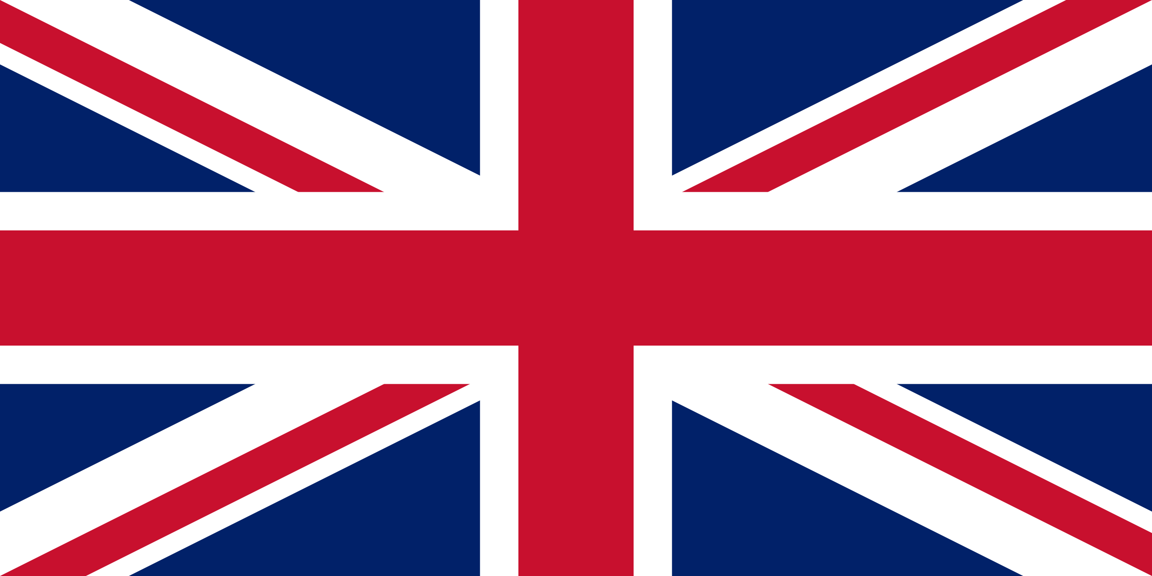  ● The United Kingdom is a country made up of countries.  ○ England, Scotland, Wales and Northern Ireland  ● Each country has its own government and capital city  ○ England – London, Scotland – Edinburgh, Wales – Cardiff, Northern Ireland – Belfast, United Kingdom – London  ● An atlas is a book of maps  ● The maps include countries from all over the world  ● Choose a map of the United Kingdom in atlas  ● Children to identify the 4 countries of the UK
1. Where do we live? | ● The UK is an island nation  ○ What surrounds the UK? | ● Looking at maps/atlases/Google Earth you can see water surrounding the UK  ● The UK is an island nation  ● An island is land that is surrounded by water
2. What surrounds the UK island? | ● The UK is an island nation | ● Looking at maps/atlases/Google Earth you can see water surrounding the UK  ● The UK is an island nation  ● An island is land that is surrounded by water  ● The UK is made up of oucntries located on 2 islands  ○ England, Scotland and Wales are located on one island – this is known as Great Britain  ○ Northern Ireland is located on the island on another island – this is known as Ireland  ○ Both islands (GB and Ire) are known as the British Isles
2. What surrounds the UK island? | ● What is a sea? | ● A sea is a body of water that is surrounded by land
2. What surrounds the UK island? | ● There are 3 seas that surround the British Isles  ● Use maps to locate and identify the UK seas | ● The 3 seas that surround the British Isles include: North Sea, Irish Sea, English Channel  ● There is 1 ocean that surrounds the British Isles – Atlantic Ocean (will learn about this later on)  ● Use maps / atlases to name and identify the 3 seas that surround the UK
3. How many oceans are there? | ● What is an ocean? | ● World map – the UK is a country in the world. Where is the UK?  ● Seas surround the UK.  ● Looking at the world map what can you see? Lots of water.  ● An ocean is a large body of water that separates large areas of land (continents)  ● Looking at maps/atlases/Google Earth you can demonstrate the different size of a sea and an ocean
3. How many oceans are there? | ● How many oceans are there?  ● Use a map/atlas to identify the 5 oceans | ● There are 5 oceans in the world  ● The world’s oceans are the Atlantic Ocean, Arctic Ocean, Indian Ocean, Pacific Ocean and the Southern Ocean  ● Use maps/atlases to name and identify the world’s 5 oceans  ● What ocean is next to the British Isles?  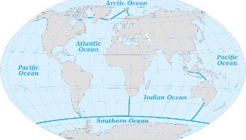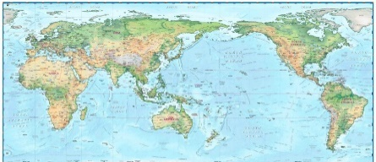
3. How many oceans are there? | ● The oceans are different sizes | ● The Pacific Ocean is the biggest ocean in the world. It’s size if not always captured on a map. Show children the traditional map where the Pacific is largely hidden. Use globes (Google Earth) and other alternate maps to demonstrate its size  ● The Atlantic Ocean is the second biggest ocean in the world. The British Isles and Republic of Ireland lies next to this Ocean  ● The Indian Ocean is the third biggest ocean in the world. The Indian Ocean is home to many endangered sea creatures, including turtles and seals  ● The Southern Ocean is the second smallest ocean in the world. It is the coldest and wildest ocean in the world  ● The Arctic Ocean is the smallest ocean in the world. Often, the Arctic Ocean is covered in ice.  ● Five Oceans Song: https://www.youtube.com/watch?v=X6BE4VcYngQ  This song sings about the 5 oceans and talks about size order.  ● The oceans are bigger than a sea
4. Where are the 5 oceans located? | ● There 5 oceans  ● Create a map of the 5 oceans | ● An ocean is a large body of water that separates large areas of land (continents)  ● There are 5 oceans in the world  ● The world’s oceans are the Atlantic Ocean, Arctic Ocean, Indian Ocean, Pacific Ocean and the Southern Ocean  ● Create a map of the 5 oceans and correctly identify each oceans location
4. Where are the 5 oceans located? | ● What are compass directions?  ○ Add compass directions to your map | ● A compass is an instrument that you use to find a direction  ● It has a dial and a magnetic needle that always points to the north  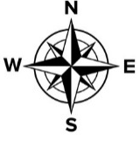  ● A compass has 4 main directions – North, South, East and West  ● We use a compass to find a direction or explain the location of something  ● Adding compass directions on a map enables us to identify the location of the 5 oceans, eg if the ocean is south of the earth, etc.
4. Where are the 5 oceans located? | ● Describe the location of an ocean using compass directions | ● Describe the location of oceans using compass directions.
5. Where do we find water? | ● Our world is covered in water | ● Google Earth / globe – demonstrates that Earth is covered in water  ● Large bodies of water and small bodies of water  ● You can also find water inside land
5. Where do we find water? | ● What is the difference between a sea and an ocean? | ● An ocean is a large body of water that separates large areas of land  ● Whereas a sea is a smaller body of water that surrounds land  ● Seas are smaller
5. Where do we find water? | ● What seas surrounds the British Isles? | ● The 3 seas that surround the British Isles include: North Sea, Irish Sea, English Channel
5. Where do we find water? | ● What ocean borders the British Isles?  ○ Why do we travel across the water? | ● There is 1 ocean that surrounds the British Isles – Atlantic Ocean (will learn about this later on)  ● Looking at the British Isles, why would we travel across the Irish Sea?  ● Looking at the world, why would we travel across the ocean?  ● How do we travel across water?

