
Subject Unit Plan
Locational Knowledge
Place Knowledge
Human and Physical Geography
Geographical Skills and Fieldwork
Climate Education
Subject: Geography
Year Group: Year 2
Unit: Seven Continents
Enquiry Question: How do we identify different areas of land?
National Curriculum Link
• name and locate the world’s seven continents
• identify the Equator, North Pole and South Pole
• identify hot and cold areas of the world in relation to the Equator and the North and South Poles
• use maps, atlases and globes to identify the UK, the continents and oceans
• devise a simple map and use and construct basic symbols in a key

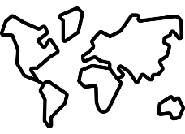 | Enquiry question:  How do we locate different continents?
Session number |  | Sequenced learning points
1. What is a continent? |  | ● What is land?  ● What is a country?  ○ Where do we live?  ○ What country do we live in?  ● What is a continent?  ○ How many continents are there?  ○ What continent do we live in?
2. Where are the 7 continents located? |  | ● What is a continent?  ● Using an atlas locate the seven continents  ○ What separates the continents?  ○ Continents are different sizes  ● Create a map and identify the seven continents  ○ Draw compass directions on the map
3. Which imaginary lines run across the world? |  | ● Where are the seven continents located?  ● We draw imaginary lines across the world to help people locate things  ● What is the Equator?  ○ Which hemisphere is the continent Europe located in?  ● What are the Poles?  ● What are the Tropics?
4. Where are these imaginary lines located? |  | ● We draw imaginary lines across the world to help people locate things  ● What imaginary lines do we use?  ● Create a map showing the position of these imaginary lines  ○ Create a key for your map  ○ Draw compass directions on the map
5. Describe the location of different continents. |  | ● There are seven continents  ● We draw imaginary lines across the world to help people locate things  ● We can describe the location of a continent using these imaginary lines and compass directions
6. How does a continents location affect the climate? |  | ● Continents are located in different places  ○ Continents cannot move  ● What is climate?  ○ What type of weather can we experience?  ● A place’s position relative to the Equator and Poles determines the climate it experiences  ○ Cold areas are located near to the Poles  ○ Hot areas are located near to the Equator

Subject Knowledge
1. What is a continent? | ● What is land?  ● What is a country?  ○ Where do we live?  ○ What country do we live in? | ● The surface of the world is called land.  ○ Most of the Earth’s surface is covered with water (71%)  ● We live in a town called Melton Mowbray.  ● We live in a country.  ● A country is an area of land that has its own government.  ○ Government is a group of people who make laws we have to follow.  ● Melton Mowbray is located in the country England.  ● The United Kingdom is a country made up of countries.  ○ England, Scotland, Wales and Northern Ireland  ● We live in the UK
1. What is a continent? | ● What is a continent?  ○ How many continents are there? | 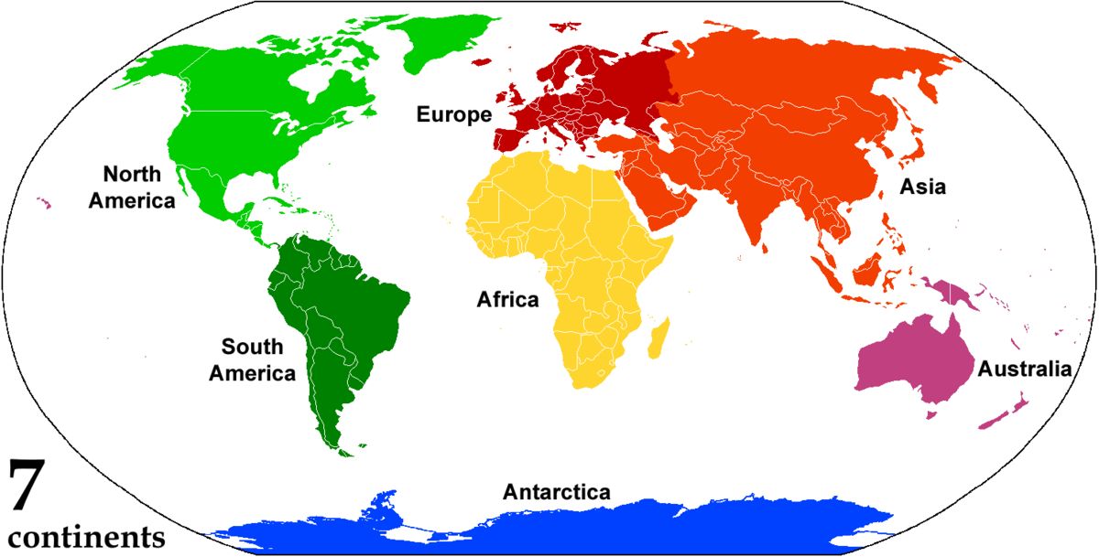  ● A continent is a large area of land  ● There are lots of countries located in each continent  ● Many continents are separated by oceans  ○ An ocean is a large body of water  ● The world’s continents are: Asia, Africa, North America, South America, Antarctica, Europe, and Oceania
1. What is a continent? | ○ What continent do we live in? | ● The UK is located on the continent Europe  ● We live on the continent Europe  ● There are many other countries located in Europe
2. Where are the 7 continents located? | ● What is a continent? | ● A continent is a large area of land  ● There are lots of countries located in each continent  ● The world’s continents are: Asia, Africa, North America, South America, Antarctica, Europe, and Oceania  ● Continents are different sizes and shapes  ● Land does not move
2. Where are the 7 continents located? | ● Using an atlas locate the seven continents  ○ What separates the continents?  ○ Continents are different sizes | ● Use atlas to see a world map  ● Explore how the world is split into continents using atlas, identify continents location  ● Where is the UK? What continent is the UK located in?  ● See how the oceans (a large body of water) separate some continents (but not all!)  ● Continents are different sizes and shapes, they are all unique
2. Where are the 7 continents located? | ● Create a map and identify the seven continents  ○ Draw compass directions on the map | ● Create a map of the world, identify how the land is separated in continents  ● Label the continents  ● Draw compass direction in the bottom right hand side of the map  ● A compass is an instrument that you use to find a direction  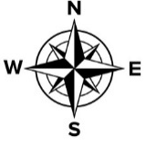  ● It has a dial and a magnetic needle that always points to the north  ● A compass has 4 main directions – North, South, East and West  ● We use a compass to find a direction or explain the location of something  ● Adding compass directions on a map enables us to identify the location of the continents
3. Which imaginary lines runs across the world? | ● Where are the seven continents located? | ● A continent is a large area of land  ● There are lots of countries located in each continent  ● The world’s continents are: Asia, Africa, North America, South America, Antarctica, Europe, and Oceania
3. Which imaginary lines runs across the world? | ● We draw imaginary lines across the world to help people locate things | ● Maps are a useful tool to demonstrate where things are located  ● Geographers draw imaginary lines across the world map  ● These imaginary lines help us to locate countries, continents, oceans, etc  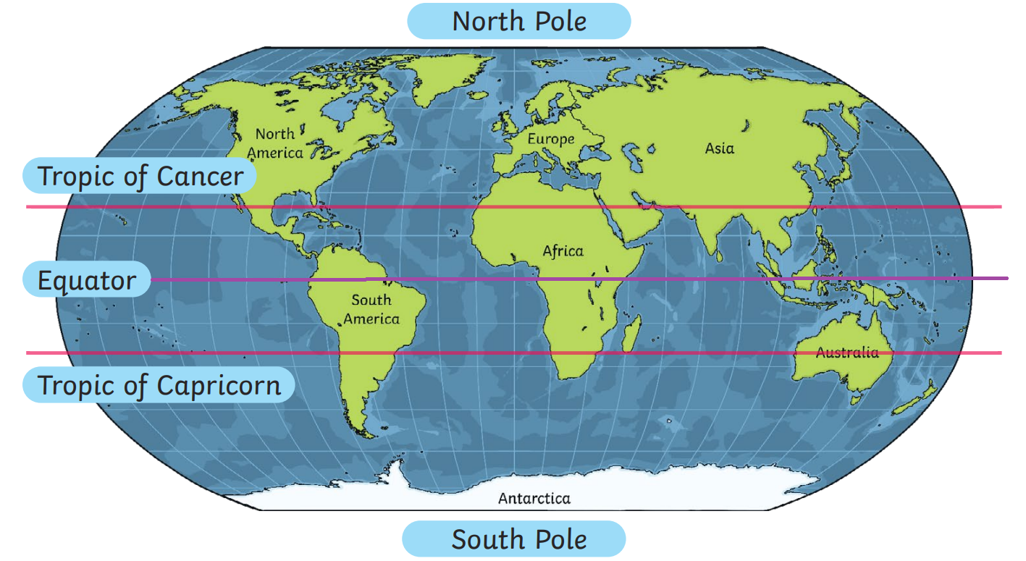
3. Which imaginary lines runs across the world? | ● What is the Equator?  ○ Which hemisphere is the continent Europe located in? | ● The Equator is an imaginary line around the middle of the Earth.  ○ The equator splits the Earth into the Northern Hemisphere and the Southern Hemisphere.  ● Europe is located in the Northern Hemisphere  ○ Europe is North of the Equator (link to compass directions)  ● The Equator runs through many continents (and countries)
3. Which imaginary lines runs across the world? | ● What are the Tropics? | ● The Tropic of Cancer is an imaginary line in the Northern Hemisphere  ● The Tropic of Capricorn is an imaginary line in the Southern Hemisphere
3. Which imaginary lines runs across the world? | ● What are the Poles? | ● The Poles are not imaginary lines but a point on the Earth (the top and bottom of the Earth)  ● The North Pole is the most northern point on the Earth. It can be found in the Arctic. The Arctic is located in the continent Europe.  ● The South Pole is the most southern point on the Earth. It is located in the continent Antarctica.  ● Why do you think it’s called the North Pole/South Pole – link to compass directions
4. Where are these imaginary lines located? | ● We draw imaginary lines across the world to help people locate things | ● Maps are a useful tool to demonstrate where things are located  ● Geographers draw imaginary lines across the world map  ● These imaginary lines help us to locate countries, continents, oceans, etc
4. Where are these imaginary lines located? | ● What imaginary lines do we use? | ● The imaginary lines we learn about are: The Equator, The Tropic of Cancer and the Tropic of Capricorn  ● We learn about the North Pole and South Poles – these are not imaginary lines but points on the Earth
4. Where are these imaginary lines located? | ● Create a map showing the position of these imaginary lines  ○ Create a key for your map | ● Create a map showing the position of the Poles, Equator and Tropics  ● World map, with each continent a different colour  ● Teachers, please draw a reasonably sized dot either side of the map in the estimated location of the Poles, Equator and Tropics  ● Identify the Poles first, colour dot, and label dot – use different colour for North Pole and South Pole  ● What can you tell me about the Equator? It runs through the middle of the Earth. Draw line connected dots with different colour, label  ● A map has a key to show what the lines on the map represent  ● Draw key: in the box draw the coloured line and label
4. Where are these imaginary lines located? | ○ Draw compass directions on the map | ● Compass direction on a map are used to find the location of something  ● Draw compass on map
5. Describe the location of different continents | ● There are seven continents | ● A continent is a large area of land  ● The world’s continents are: Asia, Africa, North America, South America, Antarctica, Europe, and Oceania
5. Describe the location of different continents | ● We draw imaginary lines across the world to help people locate things | ● Maps are a useful tool to demonstrate where things are located  ● Geographers draw imaginary lines across the world map  ● These imaginary lines help us to locate countries, continents, oceans, etc  ● The imaginary lines we learn about are: The Equator, The Tropic of Cancer and the Tropic of Capricorn  ● We learn about the North Pole and South Poles – these are not imaginary lines but points on the Earth
5. Describe the location of different continents | ● We can describe the location of a continent using these imaginary lines and compass directions | ● Which continent is located in the northern/southern/both hemisphere?  ● What continents does the Equator run through?  ● What continent is located west of the map?  ● What continent is located south of the map?  ● Which imaginary line is the UK closest to?
6. How does a continents location affect the climate? | ● Continents are located in different places  ○ Continents cannot move | ● A continent is a large area of land  ● The world’s continents are: Asia, Africa, North America, South America, Antarctica, Europe, and Oceania  ● Continents are located across the world!  ● They cannot move, they stay still
6. How does a continents location affect the climate? | ● What is climate?  ○ What type of weather can we experience? | ● Weather is a description of weather conditions in a particular place e.g. hot, wet, cold, windy, snowy, mild, etc.  ● Climate is the average weather conditions in a place  ● For example, generally the UK experiences mild temperatures and rain
6. How does a continents location affect the climate? | ● A place’s position relative to the Equator and Poles determines the climate it experiences  ○ Cold areas are located near to the Poles  ○ Hot areas are located near to the Equator | ● A continents relative position to the Equator/Poles determines its climate and weather it experiences  ● The weather near the North and South Pole is cold all year round  ● The weather on the equator is hot all year round  ● Cold places – the North pole is in an area called the Artic and it is at the very top of the globe. The South pole is in the continent of Antarctica and is at the very bottom of the globe. The further away from the equator the colder the area is.  ● Hot places – areas near the equator are mainly hot and humid. They have little water and are dry and sandy places.  ○ Pictures of different continents to demonstrate difference  ● What climate do you think Antarctica will experience? Why/how do you know this…  ○ Is Antarctica closer to the Equator or the Poles?  ● What climate do you think Oceania will experience? Why/how do you know this…  ○ Is Oceania closer to the Equator or the Poles?  ● The UK is closer to the North Pole than the Equator. How will the UK’s position affect the weather we experience?

