Does the UK experience the same climate as Australia?
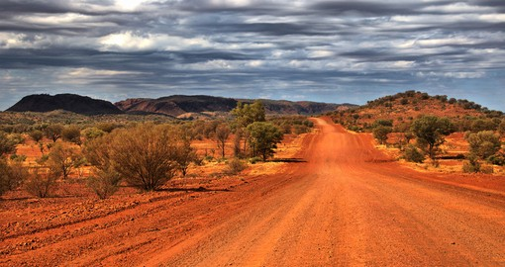

My name is _________________
Class ___________

Lesson 1: Where is Australia?
1. Where is the UK? Locate the country on the map.

2. Where is Australia? Locate the country on the map.
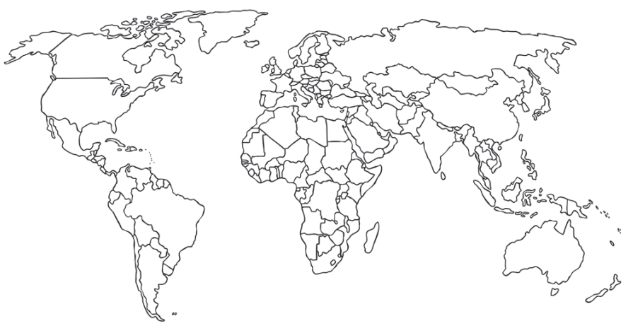

3. Create a key for your map
Key
=

=

4. What continent is Australia located on?

____________________________________________

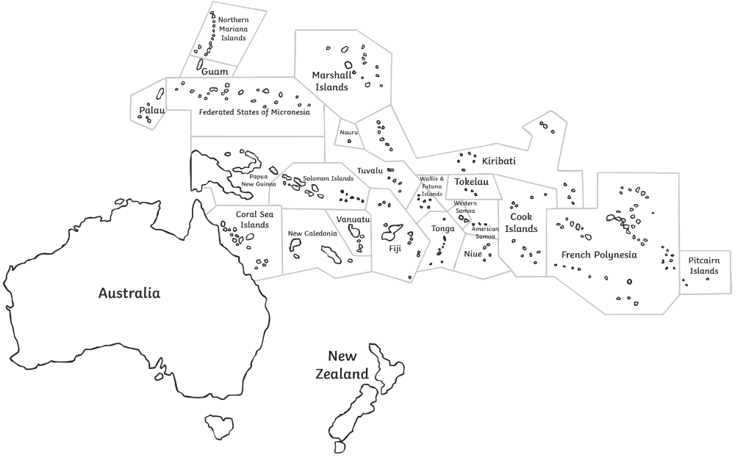
5. Here is a map of the Oceania continent. Locate Australia on the map.

6. The capital city of Australia is Canberra. Locate Canberra on the map of Australia.
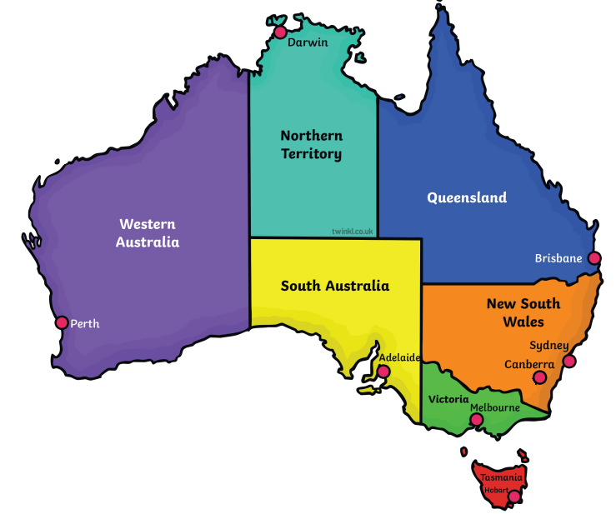

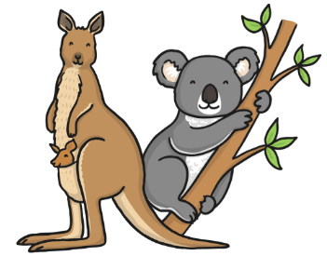
7. What language does an Aussie speak?

______________________
g’day mate!

Lesson 2: What climate does Australia experience?
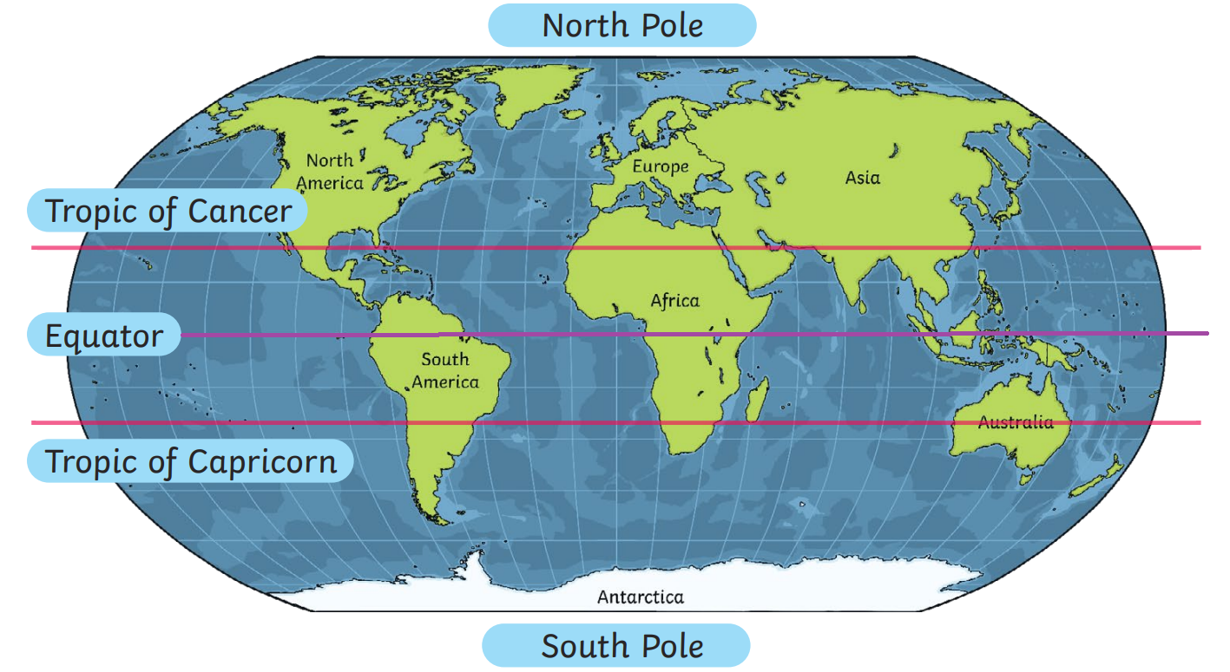
1. Here is a world map with imaginary lines drawn on.

Is Australia closer to the Equator or the South Pole?

____________________________________________

____________________________________________

2. What type of climate will Australia experience?

____________________________________________

____________________________________________

I think the UK is closer to the Equator than Australia. The UK must have hotter climate!

3. Koala believes the UK will experience hotter climate than Australia. Is he right?
____________________________________________

____________________________________________

____________________________________________
____________________________________________

Here is a weather forecast for the UK.
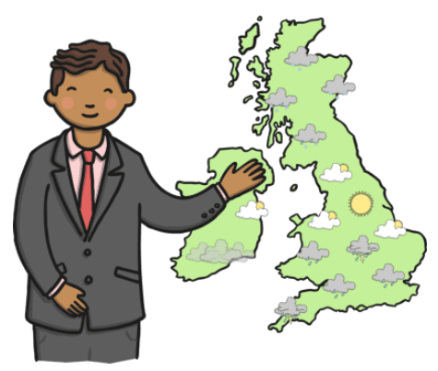

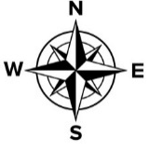

The weather is getting wetter tomorrow. If you live in the South watch out for heavy rainfall. You will need your umbrella.

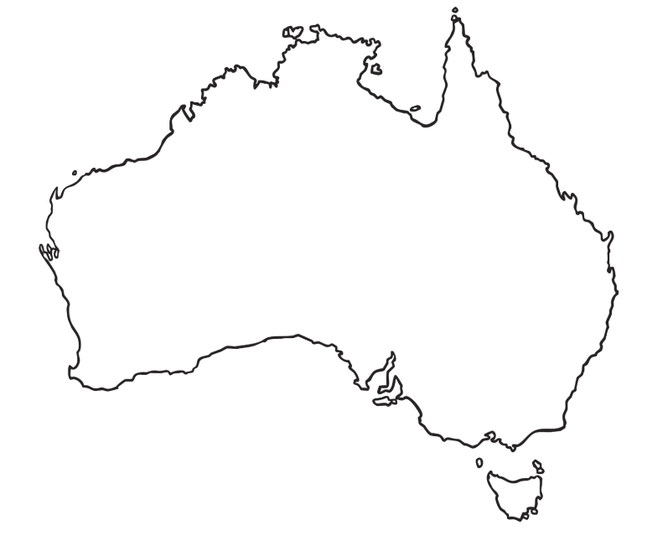
4. Create a weather forecast for Australia.
What type of weather will they experience?


Lesson 3: Why are beaches popular in Australia?
Australia is home to beautiful sandy beaches.
1. Where do you think this beach is located?
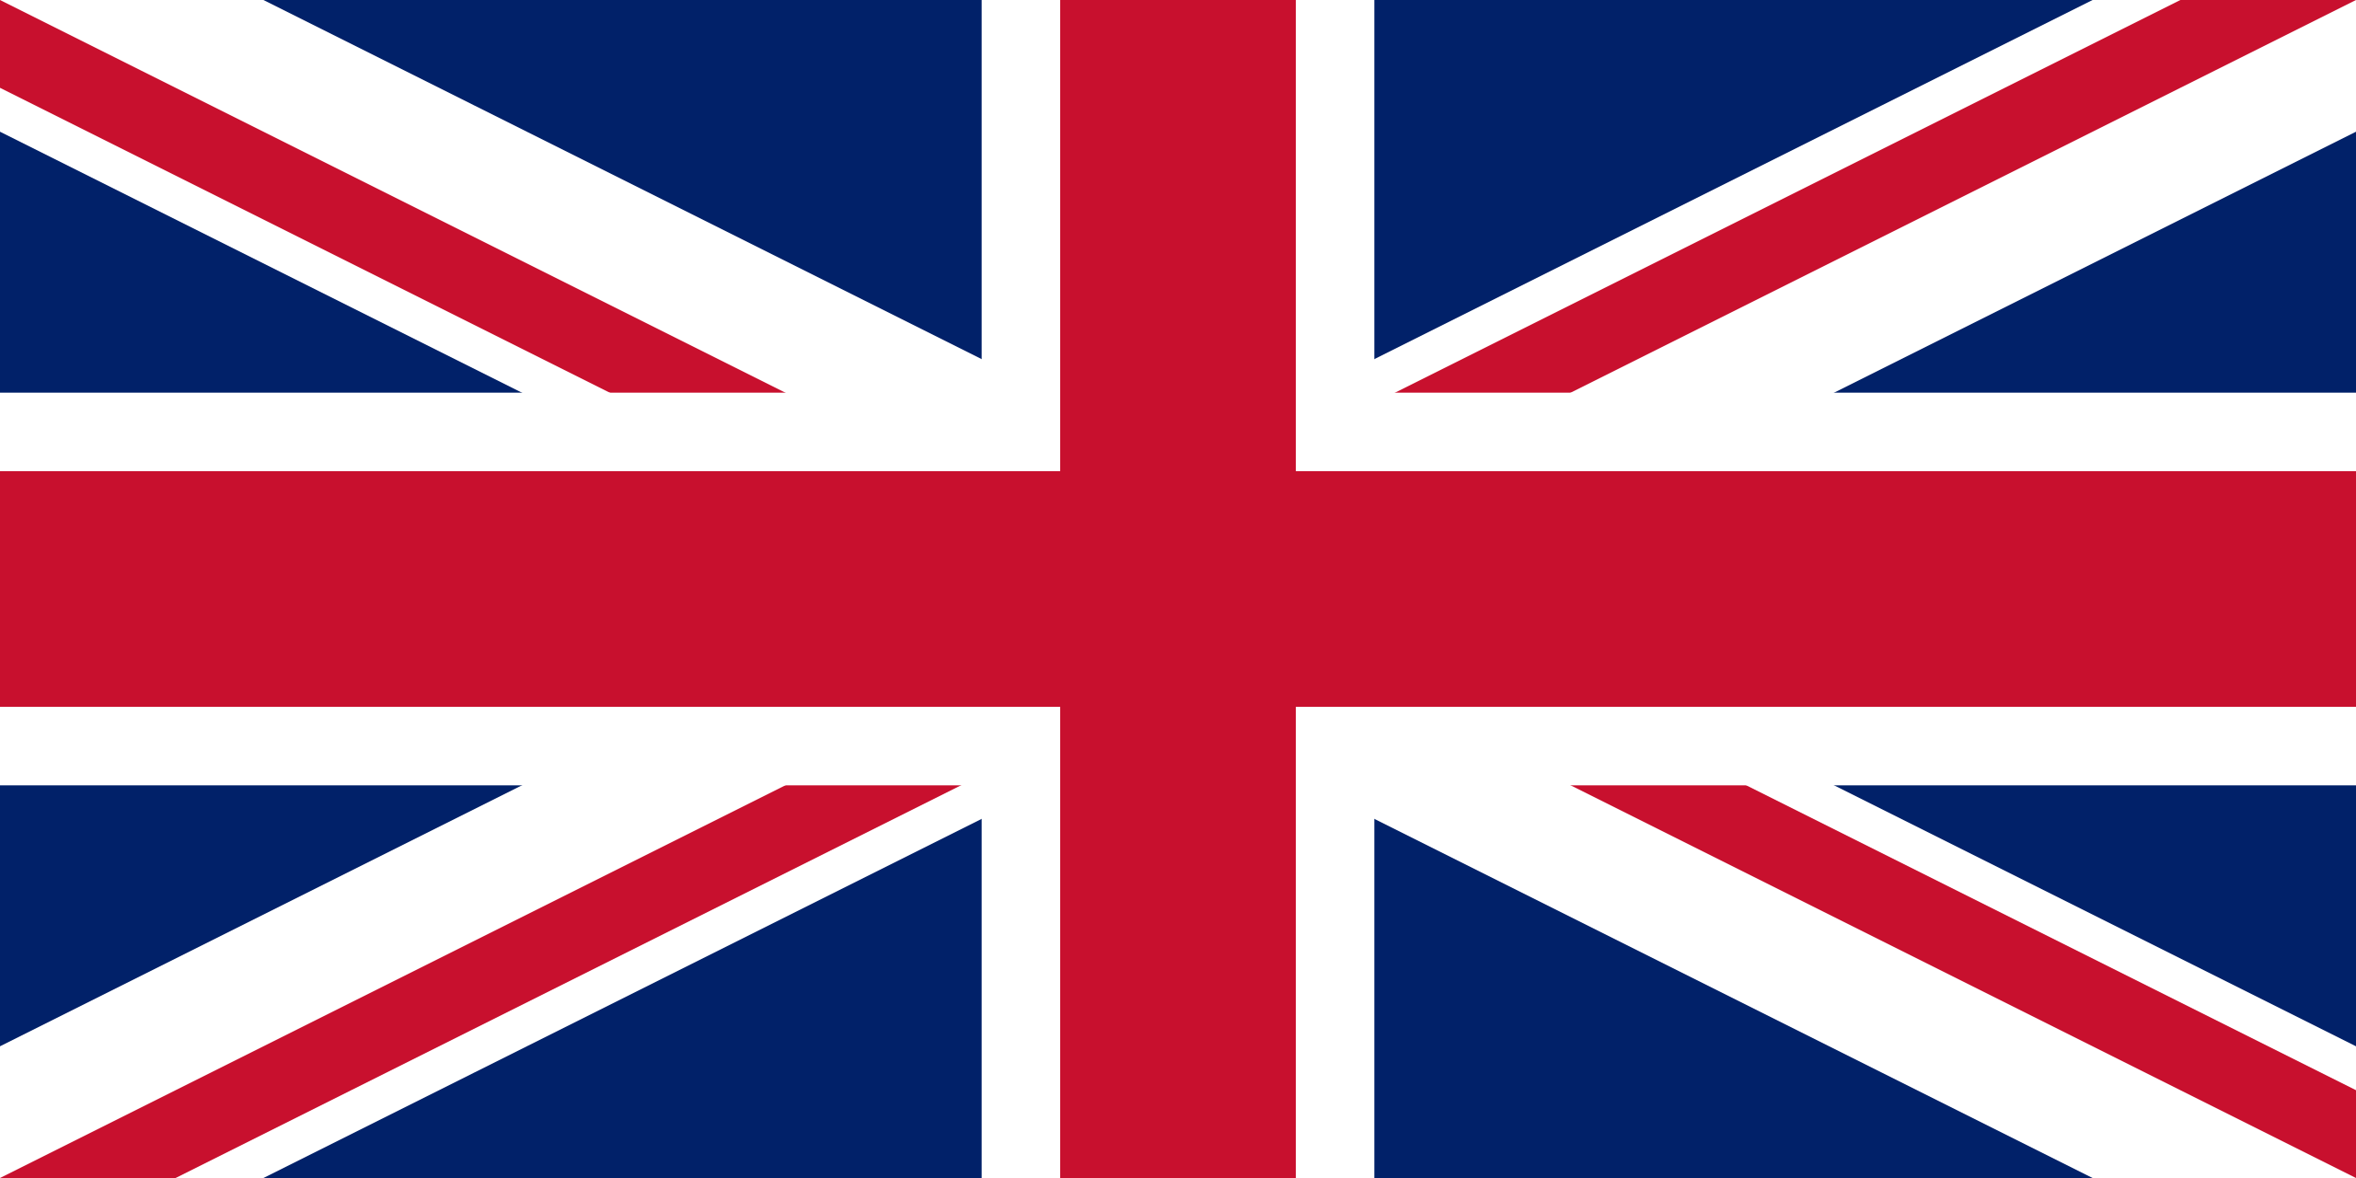
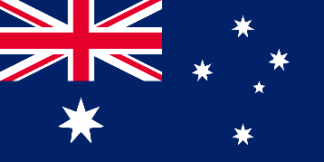

Australia

UK

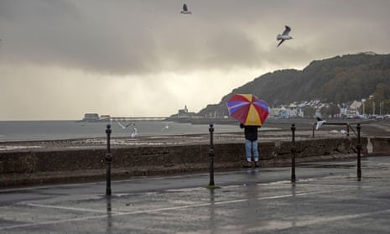
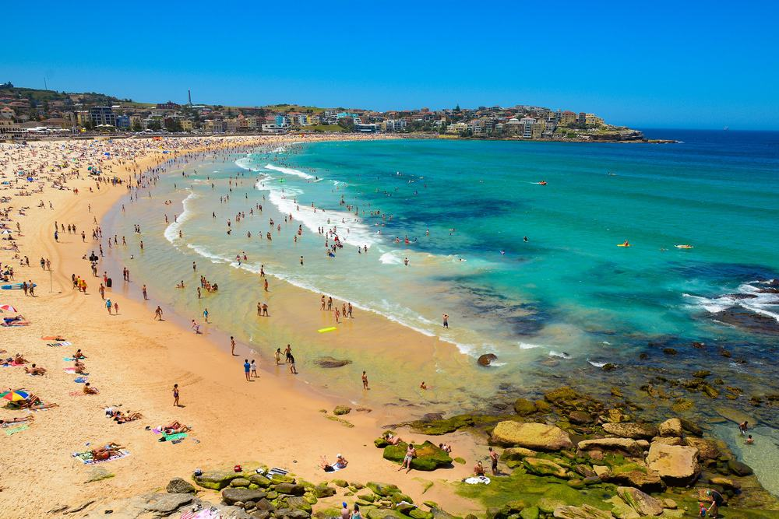

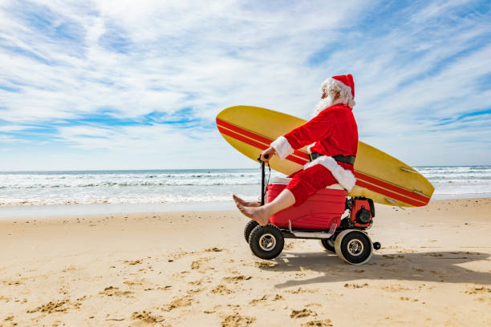

2. Why do Australians spend Christmas at the beach?
____________________________________________

____________________________________________

____________________________________________

____________________________________________

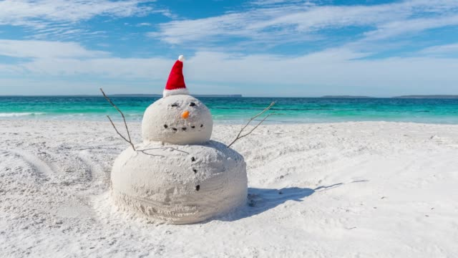

Lesson 4: Why should you visit Australia?
The Smith family are going on holiday. Why should they visit Australia for their holiday?
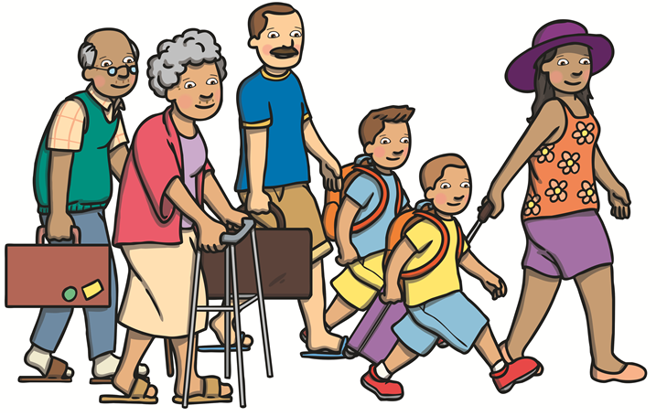

We would like to visit Australia.

1. What is the climate like in Australia?
____________________________________________

____________________________________________



2. What should I take in my suitcase for a holiday in hot Australia?

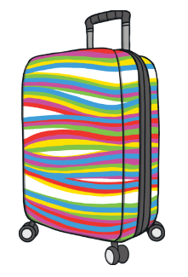

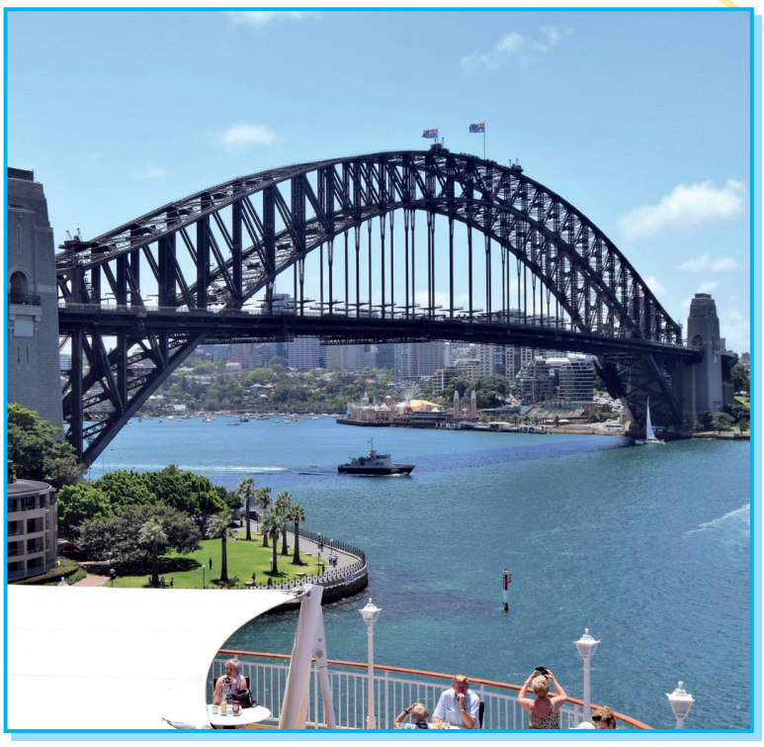
3. This is the Sydney Harbour Bridge. Is it a human or physical feature?

___________________

4. Here are some human and physical features located in Australia. Which feature do you think we should we visit?
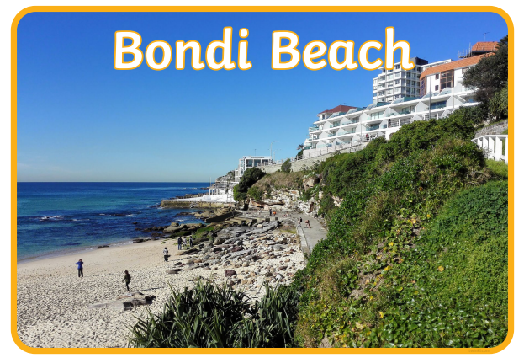
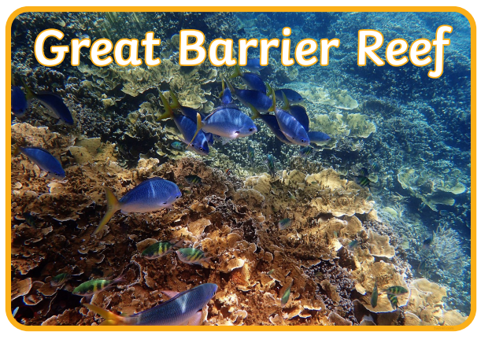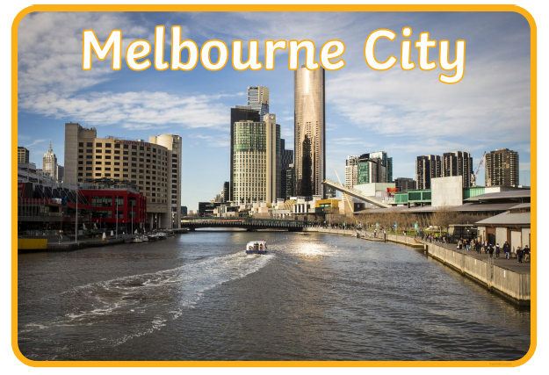

____________________________________________________________________________

______________________________________________________________________________

______________________________________________________________________________

______________________________________________________________________________

_____________________________________________________________________________

5. There are loads of animals native to Australia. Which native Australian creature is your favourite and why?












