Is the River Eye’s river course straight?

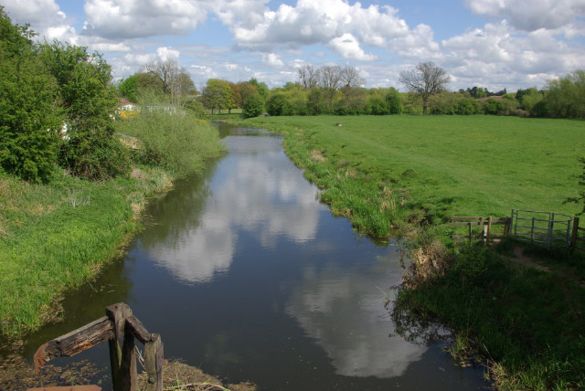

Risk Assessment:
1.

2.

3.

Date of Fieldtrip:

Time of Fieldtrip:
1. Identify the River Eye on the OS Map.
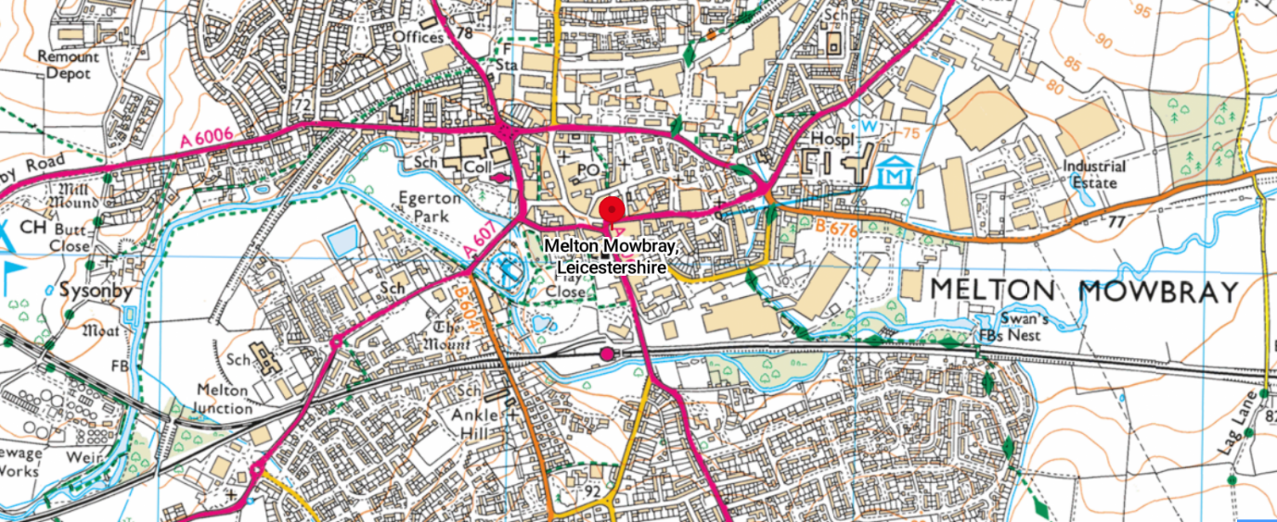

OS Map Key
 =
=
 =
=

2. What do you notice about the river course?

__________________________________________________

__________________________________________________
Enquiry Question:
Is the River Eye river course straight?
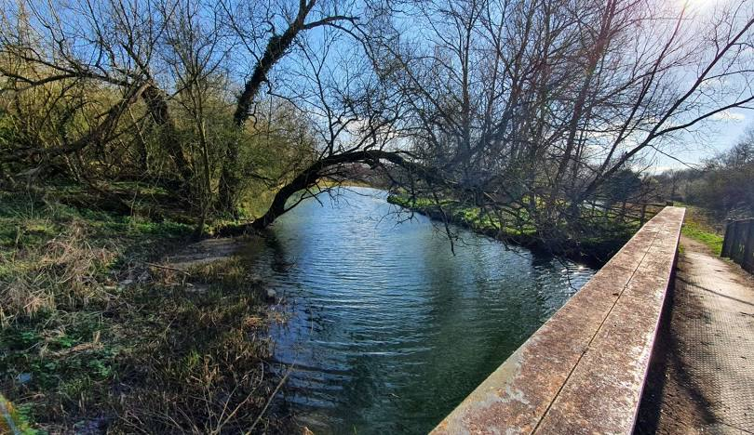
3. Enquiry prediction:

____________________________________________________

____________________________________________________

____________________________________________________

____________________________________________________

Location: River Eye, Melton Mowbray

1. Label the river channel



2. What can you see lying on the river bed?

3. Field sketch of the river’s course through the park

4. Answering the enquiry question:

Is the River Eye river course straight?

__________________________________________________

__________________________________________________

__________________________________________________

__________________________________________________

__________________________________________________

__________________________________________________

__________________________________________________

