
Subject Unit Plan
Locational Knowledge
Place Knowledge
Human and Physical Geography
Geographical Skills and Fieldwork
Climate Education
Subject: Geography
Year Group: Year 3/4 Cycle A
Unit: Rivers
Enquiry Question: Why do rivers flow across land and end at the sea?
National Curriculum Link
• describe and understand key aspects of rivers
• name and locate key topographical features including hills, mountains, coasts and rivers
• use symbols and keys to read a map
• use fieldwork to observe, measure, record and present physical features in the local area using a range of methods

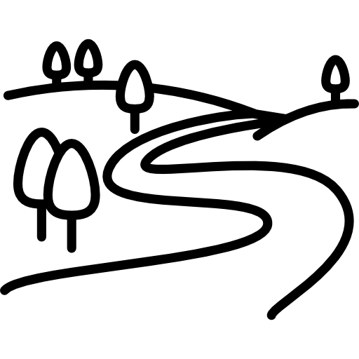 | Enquiry question:  Why do rivers flow across land and end at the sea?
Session number |  | Sequenced learning points
1. Where does water come from? |  | ● What is water?  ● Where do you find water?  ● How does water move around the Earth?  ● What happens during the water cycle?
2. How does water flow in a river? |  | ● What is a river?  ● What does a river look like?  ● Identify rivers on different types of maps  ● How do rivers flow across land?  ● What can we find inside the river channel?
3. Is the river course (of the River Eye) straight? |  | ● Prepare your risk assessment  ● Engage in fieldwork adhering to risk assessment  ● Locate the River Eye on an OS Map  ● Observe features of the river channel  ● Observe features of the river course
4. Where do rivers begin? |  | ● The river course can be broken into 3 parts.  ● Where do rivers begin?  ● Why do rivers begin on a mountain or hill?  ● What features might you find in the upper course?
5. How does the river course bend and meander? |  | ● The river course can be broken into 3 parts.  ● What happens to river as it flows into the middle course?  ○ Use maps to identify river feature  ● What do oxbow lakes form?  ● What features might you find in the middle course?
6. Why do rivers flow across land and end at the sea? |  | ● The river course can be broken into 3 parts.  ● What happens to the river as it flows into the lower course?  ● Where do rivers end?  ○ Use maps to identify the river, coast, sea

Subject Knowledge
1. Where does water come from? | ● What is water?  ● Where do you find water? | ● Water is a liquid  ● Go onto Google Earth, what do you notice about our world? It is covered in water.  ● Where would we find water? (ponds, rivers, streams, lakes, the seaside, oceans, seas, etc)
1. Where does water come from? | ● How does water move around the Earth? | ● Water is transported around the planet through the water cycle. It is not created or destroyed.  ● Water changes state as it is transported through the cycle.  ● What are the 3 states of water? Solid (ice), liquid (water), gas (water vapour)
1. Where does water come from? | ● What happens during the water cycle? | ● There are 4 processes in the water cycle  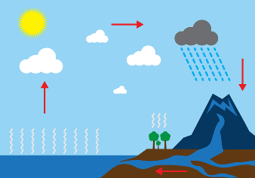  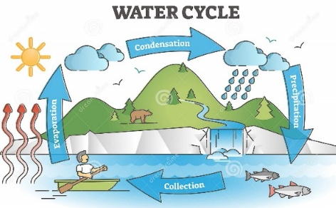  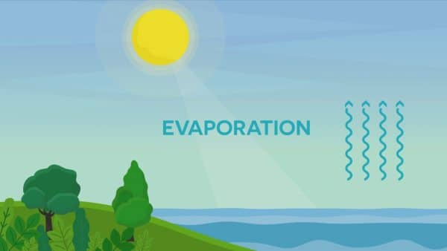  1. Evaporation  ○ Sun heats up water and changes states from a liquid to a gas  ○ Evaporated water is known as water vapour  ○ Water vapour travels upwards into the air  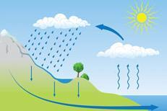  2. Condensation  ○ Water vapour in the air gets cold  ○ Cold water vapour turns the water back into a liquid form  ○ This process creates clouds  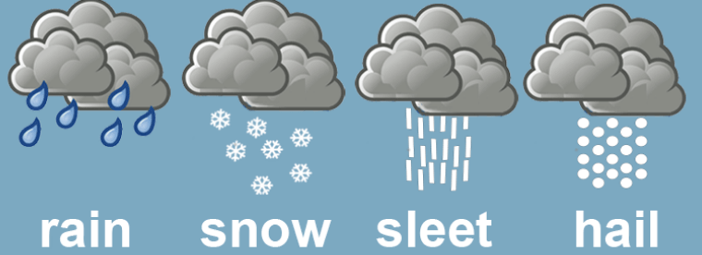  3. Precipitation  ○ Clouds release the water back to the ground  ○ Depending on the temperature, the water can come down as a liquid (rain) or a solid (snow)  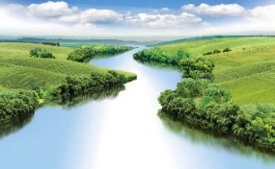  4. Accumulation (Collection)  ○ Water collects in one place and forms a body of water  ○ Water accumulates in the oceans, sea, rivers and streams
2. How does water flow in a river? | ● What is a river? | ● A river is a moving body of water that flows across the surface of the land, usually to the sea  ● The path of a river is known as the river course.
2. How does water flow in a river? | ● What does a river look like?  ● Identify rivers on different types of maps. | ● Satellite maps (Google Earth, with Aerial View), OS Map of local area, other type of map  ● Can you identify the river? How do you know this is a river?  ○ OS Map has a key to help people identify rivers  ● Is there anything else next to the river? Mountain, hills, coast, sea?  ● What do you notice about the river course? Is it straight, curvy, wiggly?
2. How does water flow in a river? | ● How do rivers flow across land?  ● What can we find inside the river channel? | 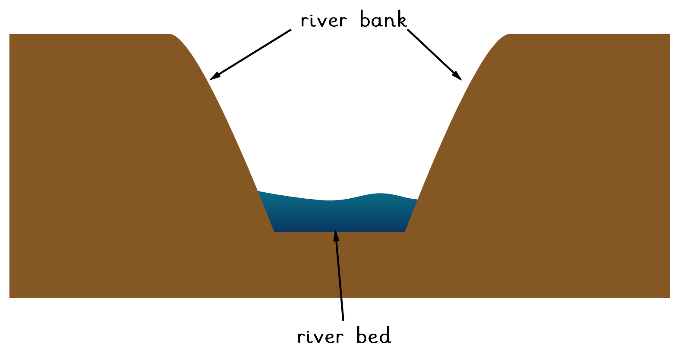● Rivers flow in channels.  ● A channel is a long cut in the land that a river flows along  ● The bottom surface of the river channel is called the river bed. The water flows on top  ● The edge or sides of the river channel that the water flows within is called the river bank
3. Is the river course, the River Eye, straight. | ● Prepare your risk assessment  ● Engage in fieldwork adhering to risk assessment | ● How can we be safe on our fieldtrip, walking to a place, visiting a river, walking next to a body of water  ● Take booklets on fieldtrip, visiting the River Eye
3. Is the river course, the River Eye, straight. | ● Locate the River Eye on an OS Map | ● OS Map of Melton and River Eye  ● Locate the River Eye on the map  ● Complete the OS Map key  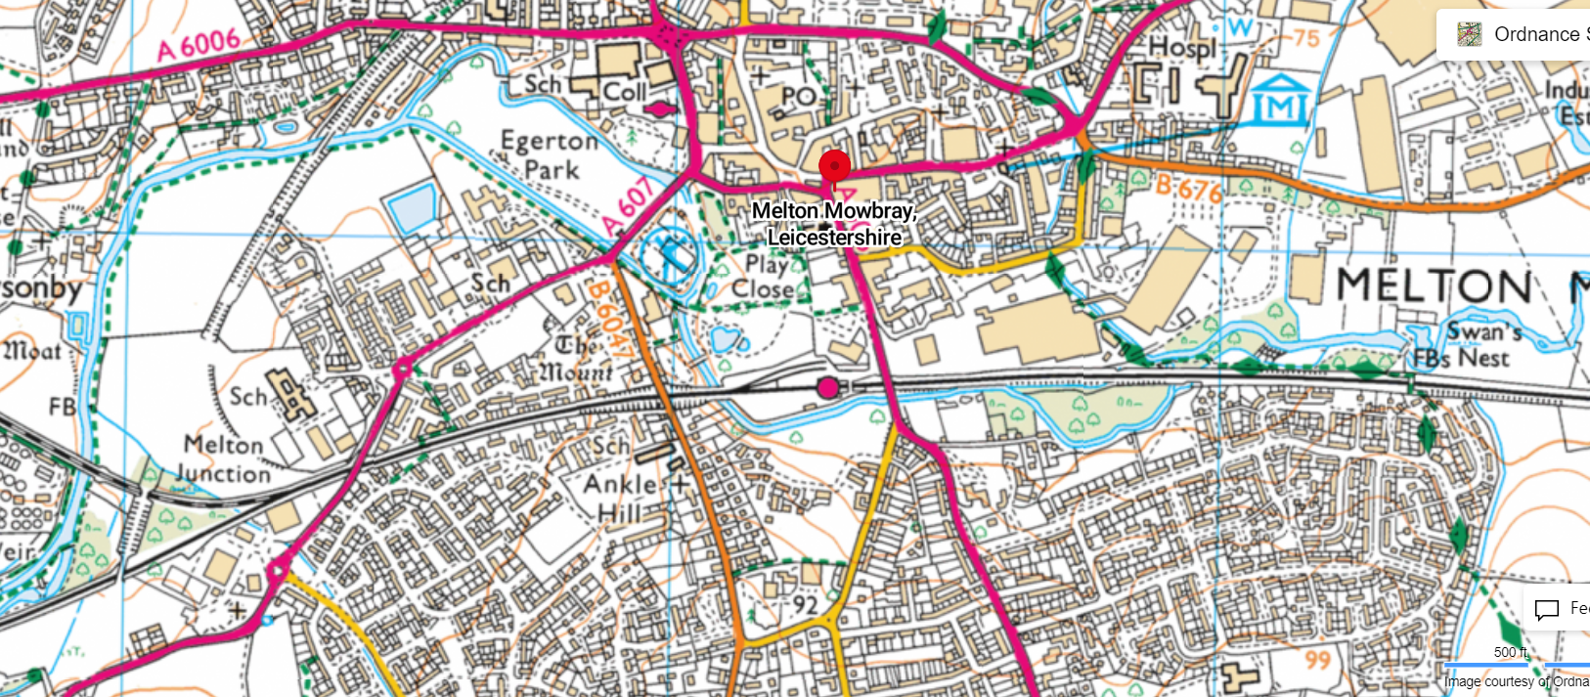
3. Is the river course, the River Eye, straight. | ● Observe features of the river channel | ● A river is a flowing body of water. The water flows in a channel.  ● Where is the river channel?  ● What do you notice about the River Eye channel?  ● Complete cross-section of river channel and label features.  ● Is the river channel thick or thin?  ● What is sitting on the river bed?
3. Is the river course, the River Eye, straight. | ● Observe features of the river course | ● Is the river course straight?  ● Draw a sketch on the river course.  ● Why do you think the river course is not straight?
4. Where do rivers begin? | ● The river course can be broken into 3 parts | 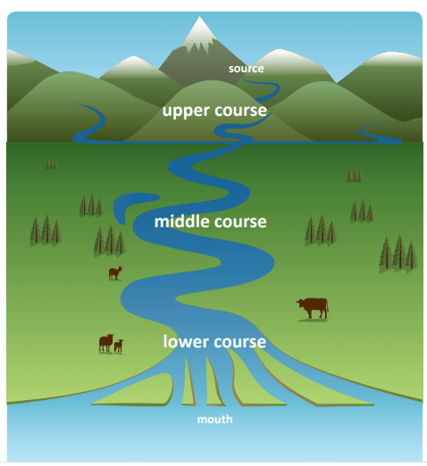  ● A river flows along the river course.  ● The course is the path of the river.  ● The river course can be broken into 3 parts: upper, middle and lower course (see picture)
4. Where do rivers begin? | ● Where do rivers begin?  ● Why do rivers begin on a mountain or hill? | Cycle A: Mountain = is a new word for Year 3s.  ● Rivers begin in high, mountainous areas.  ● Where a river begins is known as the river source.  ●Rain (precipitation) falls on high ground and the water flows downhill. This is the beginning of the river course – known as the upper course.  ● Downhill water flow is the beginnings of a river. The water is flowing fast as it is travelling downhill.  ● https://www.youtube.com/watch?v=rl4SldJ76JE  Watch to 2:10 mark – video of water from source and its downhill journey.
4. Where do rivers begin? | ● What features will you find in the upper course? | 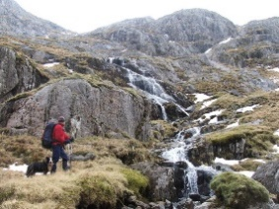  ● Source = where the river starts  ● Steep land. Steep land can be found on a mountain/hill  ● Waterfalls = water flows over a vertical step drop
5. How does the river course bend and meander? | ● The river course can be broken into 3 parts | ● A river flows along the river course.  ● The course is the path of the river.  ● The river course can be broken into 3 parts: upper, middle and lower course (see picture)  ● Rivers begin in high, mountainous areas. Rain falls on high, steep ground and flows downhill. (upper course).
5. How does the river course bend and meander? | ● What happens to river as it flows into the middle course?  ○ Use maps to identify river features. | ● The ground becomes less step in the middle course and the water starts to slow down.  ● As water flows downhill as a stream (or a small river) it will meet and feed into larger rivers. The meeting of 2 rivers is known as a tributary.  ● GoogleMaps image below. The River Eye runs through Melton Mowbray. We live in the middle course of the river. Children to identify a tributary on the map and explain what a tributary is.  ● As the water flows in the middle course it travels around big objects. The river bends around them. This bend in a river is known as a meander.  ● Look at the River Eye river course around our local area. It is not straight, it meanders. Children to identify where a meander in the river course and explain what a meander is.  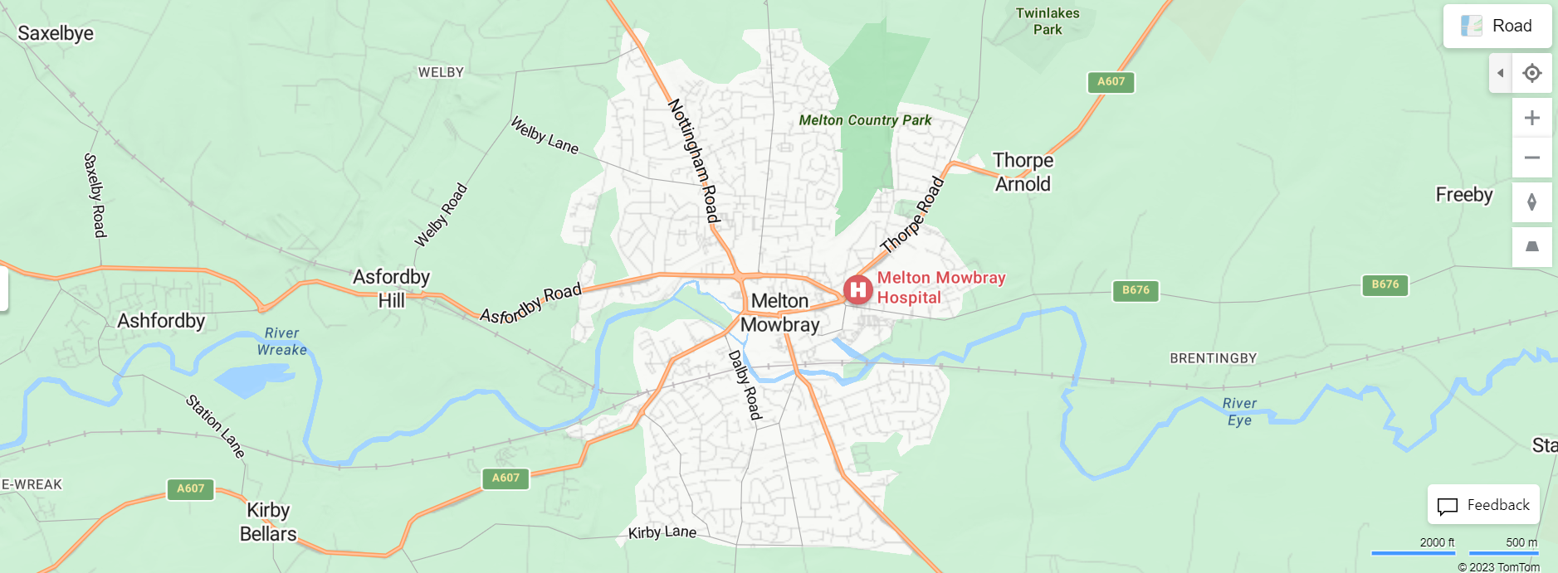
5. How does the river course bend and meander? | ● Why do oxbow lakes form? | ● Water is always flowing in the river channel. The river course continues to change shape.  ● Video demonstrates how a river course changes over time as it continues to meander. https://www.youtube.com/watch?v=nGJXxAZPm8M  ● When 2 meanders meet the river changes course. Instead of the water going around the bend it finds the quickest route straight through.  ● An oxbow lake forms and it cut off from the main river.
5. How does the river course bend and meander? | ● What features will you find in the middle course? | 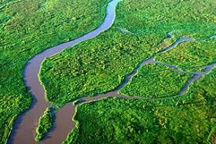  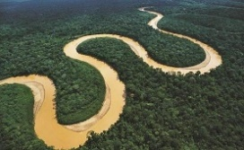  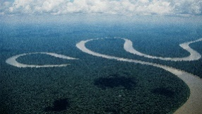  ● Tributary  ● Meander  ● Oxbow lake
6. Why do rivers flow across land and end at the sea? | ● The river course can be broken into 3 parts | ● A river flows along the river course.  ● The course is the path of the river.  ● The river course can be broken into 3 parts: upper, middle and lower course (see picture)  ● Rivers begin in high, mountainous areas. Rain falls on high, steep ground and flows downhill. (upper course).  ● The river starts to slow down. It gets wider, and travels in winding loops known as meanders (middle course).
6. Why do rivers flow across land and end at the sea? | ● What happens to the river as it flows into the lower course? | ● The ground is flat in the lower course. The water moves at its slowest.  ● The ground either side of a river is flat. It is known as a floodplain.  ● The river channel is wide and deep.
6. Why do rivers flow across land and end at the sea? | ● Where do rivers end?  ○ Use maps to identify the river, coast, sea | ● The river continues to flow until it meets a larger body of water.  ● The mouth of a river is the place where the river ends.  ● The river usually meets the sea, ocean or a larger river.  ● GoogleMaps, roadmap, satellite maps. Children to identify the mouth of a river and explain why rivers end at the sea.

