
Subject Unit Plan
Locational Knowledge
Place Knowledge
Human and Physical Geography
Geographical Skills and Fieldwork
Climate Education
Subject: Geography
Year Group: Year 3/4 Cycle A
Unit: Europe
Enquiry Question: What makes a country in Europe unique?
National Curriculum Link
• locate European countries, concentrating on their environmental regions, key physical and human characteristics, countries and major cities
• understand geographical similarities and differences through the study of human and physical geography of a region within Europe
• use maps, atlases, globes and digital/computer mapping to locate countries and describe features studied
• use four-figure grid references
• identify the position and significance of Equator, Northern Hemispheres, Southern Hemisphere, the Tropics of Cancer and Capricorn

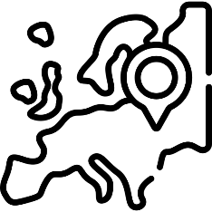 | Enquiry question:  What makes a country in Europe unique?
Session number |  | Sequenced learning points
1. What is Europe? |  | ● What is a continent?  ● Where is the European continent located?  ○ Make link to imaginary lines.  ● What countries are located in Europe?  ○ What is a county?  ○ Use maps/atlases to locate countries in Europe
2. Where do people live in Europe? |  | ● What is a city?  ● Name some cities located in Europe  ● Locate the cities on a map of Europe  ○ Use 4-grid map references to locate specific cities
3. What climate does Europe experience? |  | ● What is climate?  ○ How does the climate differ across the continent?  ● What is an environmental region?  ● How many environmental regions are there in Europe?  ○ How does the environment differ across the continent?  ● Expected weather patterns are changing
4. What features can be found in each country? |  | ● What is a feature?  ● What is a human feature?  ● What is a physical feature?  ● Use images to describe features studied
5. What is life like in France? |  | CASE STUDY BOOKLET  ● What is a case study?  ● Where is France located?  ● What is the capital city of France?  ● Locate the Paris on a map  ● What physical features can be found in France?  ● What is a landmark?  ● What landmarks are located in Paris?
6. What makes a country in Europe unique? |  | CASE STUDY BOOKLET  ● France is a country located in Europe  ● Are all countries in Europe the same?  ● What makes a country unique?  ● What makes France special?  ● Compare life in Paris to your local area  ● What makes Paris unique?

Subject Knowledge
1. What is Europe? | ● What is a continent? | • A continent is a large area of land.  • The world’s continents are, from largest to smallest: Asia, Africa, North America, South America, Antarctica, Europe, and Oceania  • Generally, oceans separate the continents, however there are exceptions. Culture differences also separate the world into continents e.g. Europe and Asia.
1. What is Europe? | ● Where is the European continent located?  ○ Make link to imaginary lines | • Europe is located in the Northern Hemisphere (above the Equator)  • The continent Asia border Europe.  • The Atlantic Ocean also borders Europe.  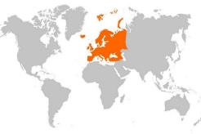  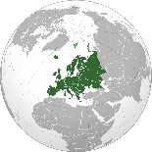
1. What is Europe? | ● What countries are located in Europe?  ○ What is a county?  ○ Use maps/  atlases to locate countries in Europe | • A country is an area of land that has its own government.  • 44 countries make up the continent.  • Russia, Germany, United Kingdom, France and Italy are the five largest countries in Europe (by population size). Russia – 144 million, Germany – 83 million, UK – 67 million, France – 64 million, Italy 58 million.  ○ population = the amount of people living in an area  • Use maps and atlases (located in KS2 library) to identify and locate some North American countries.  ○ Give children blank Europe map and they can record the countries they locate on the map.  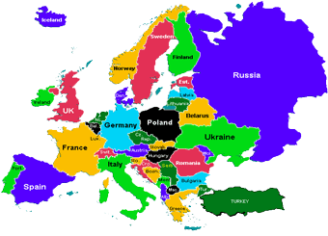
2. Where do people live in Europe? | ● What is a city? | Cycle A: City = is a new word for Year 3s.  • People live in a settlement.  • Settlements: a place where people establish a community. Settlements can vary in size from the very small (a village) to extremely large (a city)  • A city is a large settlement containing lots of buildings and lots of people. They include hospitals, sports facilities, universities, shops, offices, many houses and a cathedral.
2. Where do people live in Europe? | ● Name some cities located in Europe | • Europe has some of the world’s largest cities  • Istanbul (Turkey) – 15 million, Moscow (Russia) – 12 million, Paris (France) – 11 million, London (UK) – 9 million, Madrid (Spain) – 6.5 million
2. Where do people live in Europe? | ● Locate the cities on a map of Europe  ○ Use 4-grid map references to locate specific cities | • To help locate where a place is in the world, people use maps  • Maps can be split into squares to form a grid  • 4-figure grid references are used to locate a particular grid square on a map  • When reading 4 figure grid reference you go “Along the corridor, up the stairs”  • Map of Europe – place some cities location on map using star symbol. Children to be given city name and its grid reference. Use the 4-figure grid reference to locate the city and record city name next to symbol. See end of document for this activity  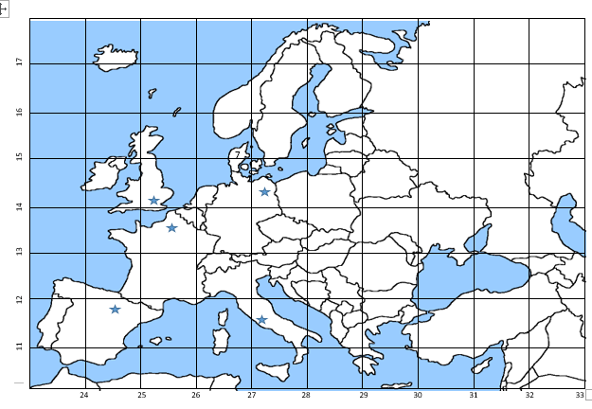
3. What climate does Europe experience? | ● What is climate?  ○ How does the climate differ across the continent? | • Climate is a description of the average weather conditions in a certain place for the past 30 or so years.  • Different areas of the world have different climates.  • Climate is influenced by how near or far it is from the Equator, Poles and Tropics of Cancer/Capricorn.  • The closer to the Equator the warmer climate. The closer to the Poles the cooler the climate.
3. What climate does Europe experience? | ● What is an environmental region? | • An environmental region is a large area that experiences a similar climate.  • This climate affects what plants grow, what animals live there and landforms.
3. What climate does Europe experience? | ● How many environmental regions are there in Europe? | • There are 4 different environmental regions across Europe.  • Blue = Northern Europe has a temperate climate: winters are generally cold and summers are moderate.  • Green = Western Europe is known for its mild winters, with heavier rainfall in the west. Summers are moderate and become cooler as you move north.  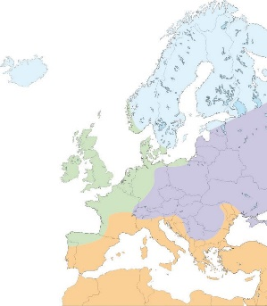  • Purple = Eastern Europe have cool summers with temperatures around 25°C and cold, cloudy, humid winters.  • Orange = Southern Europe are bright and sunny during most of the year. The winters are usually mild but the summers are hot and dry.  • Make the link to: the closer to the Equator the warmer climate. The closer to the Poles the cooler the climate.
3. What climate does Europe experience? | ○ How does the environment differ across the continent? | • Use pictures from each European environmental region to illustrate what the environment looks like. The climate impacts what may grow in each environment.
3. What climate does Europe experience? | ● Expected weather patterns are changing | ● Climate change = a change in usual temperatures and weather patterns due to human activity.  ● We can generalise what climate an area will experience.  ● However due to human activity our climate is changing. This is known as climate change.  ● Extreme weather events are more common – extreme heat in Spain, wetter weather in UK.
4. What features can be found in each country? | ● What is a feature? | • Geographic features are objects and things that can be found in a geographical location  • There are 2 types of geographic features: human features and physical features
4. What features can be found in each country? | ● What is a human feature? | • Human features are objects and things that have been built by humans. They are man-made objects.  • Human features can be found in nearly every area of the world.  • Human features include: roads, pavements, houses, buildings, churches, bridges, fences, ports, football stadiums, etc.  • A landmark is a feature that has importance or makes a place easily recognisable.  • Famous human features are often referred to as a landmark.  • A picture of The London Eye will make you instantly think of London.
4. What features can be found in each country? | ● What is a physical feature? | • Physical features are natural objects or features. They were made by nature.  • Physical features include: rivers, lakes, forests, beaches, mountains, hills, etc.  • Physical features can be found across the world.
4. What features can be found in each country? | ● Use images to describe features studied | • Use images of physical and human features located across Europe  • Children to identify what type of feature it is.
5. What is life like in France? | ● What is a case study? | • A case study is where you research one place and find out information about that place.  • We will be doing a case study of France  • Exploring France – living in Paris. A nice introduction to the country/city.  https://www.bbc.co.uk/programmes/p0114qpv
5. What is life like in France? | ● Where is France located?  ● What is the capital city of France?  ● Locate the Paris on a map | • France is located in the continent Europe.  • It borders lots of countries and is close to the UK.  • You can drive to France from the UK by driving through the Channel Tunnel.  • A capital city is the main city in a country, usually where the government meets.  • The capital city of France is Paris.
5. What is life like in France? | ● What physical features can be found in France? | • Some physical features located in France to focus on:  ○ The French Apls – a mountain range  ○ The River Seine – runs through the capital city Paris  ○ The French Riviera – southern coastline of France includes famously glamorous beaches. The area is known for sunny weather.
5. What is life like in France? | ● What is a landmark?  ● What landmarks are located in Paris? | • A landmark is a feature that has importance or makes a place easily recognisable.  • There are many famous human features (landmarks) in capital city Paris  • Some landmarks located in Paris to focus on:  ○ Eiffel Tower. It was built in 1889 for the Paris World’s Fair. The Eiffel tower was originally designed as a temporary structure but has stood for over 100 years. It is one of the most visited sites in Paris.  ○ Arc de Triomphe – finished building in 1836. It stands at the centre of the Place Charles de Gaulle (a large road junction in Paris) and honours those who fought and died for France in past battles and wars.  ○ The Louvre – The Louvre is the world’s biggest museum in the world. It is home to 35,000 priceless artefacts and paintings including Leonardo da Vinci’s Mona Lisa.  ○ Notre Dame – a cathedral located in the very heart of Paris and is one of the city’s most popular tourist sites. It is one of the largest religious buildings in the world.
6. What makes a country in Europe unique? | ● France is a country located in Europe | • France is the 4th largest country in terms of population (64 million)
6. What makes a country in Europe unique? | ● Are all countries in Europe the same?  ● What makes a country unique? | • Each country is different to each other.  • The climate is different.  • There are lots of different languages spoken  • We eat different foods  • We have different landmarks  • Physical features are formed in different ways  • We like different sports
6. What makes a country in Europe unique? | ● What makes France special? | • Think language, physical features, landmarks, etc.
6. What makes a country in Europe unique? | ● Compare life in Paris to your local area  ● What makes Paris unique? | • What have we learnt about Paris, how does this compare to our local area.  • What differences are there. What similarities are there?  • What makes Paris unique and different to our local area?

11 12 13 14 15 16 17 |  |  |  |  | 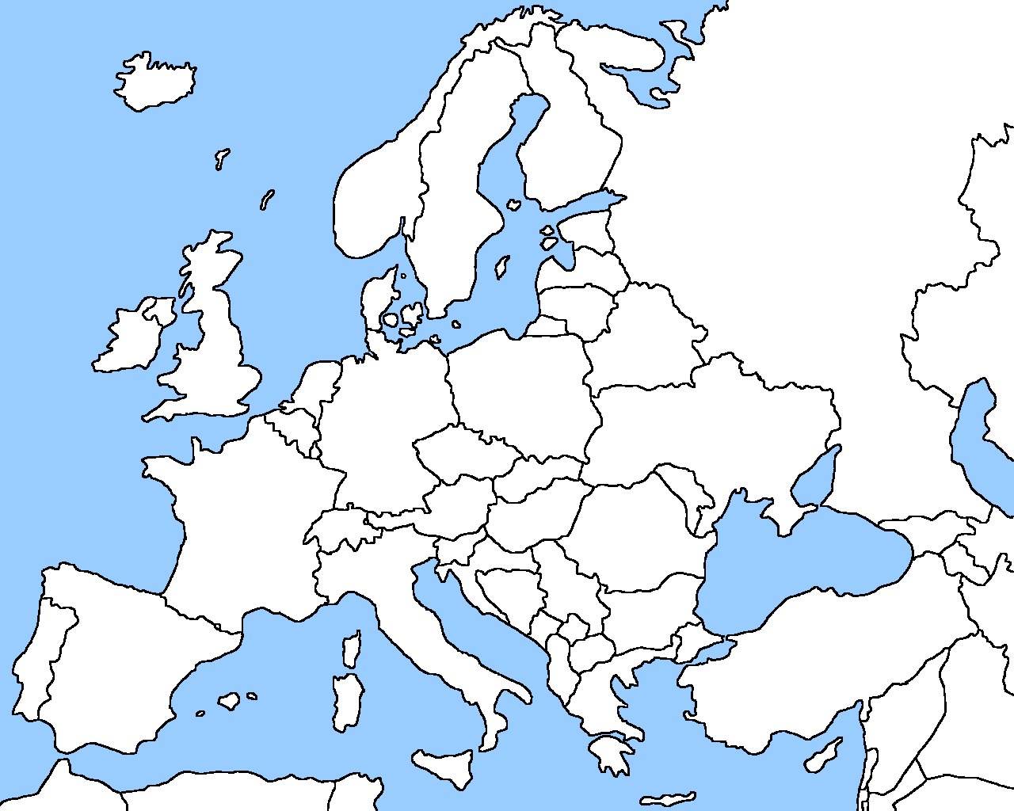
11 12 13 14 15 16 17 |  |  |  | 7
24 25 26 27 28 29 30 31 32 33
 | City | Grid reference | Country
1 | London | (25, 14)
2 | Madrid | (24, 11)
3 | Paris
4 | Berlin
5 | Rome
6 | Istanbul |  | Turkey
7 | Saint Petersburg
8 | Dublin |  | Ireland

Need to place stars round about in the right location

