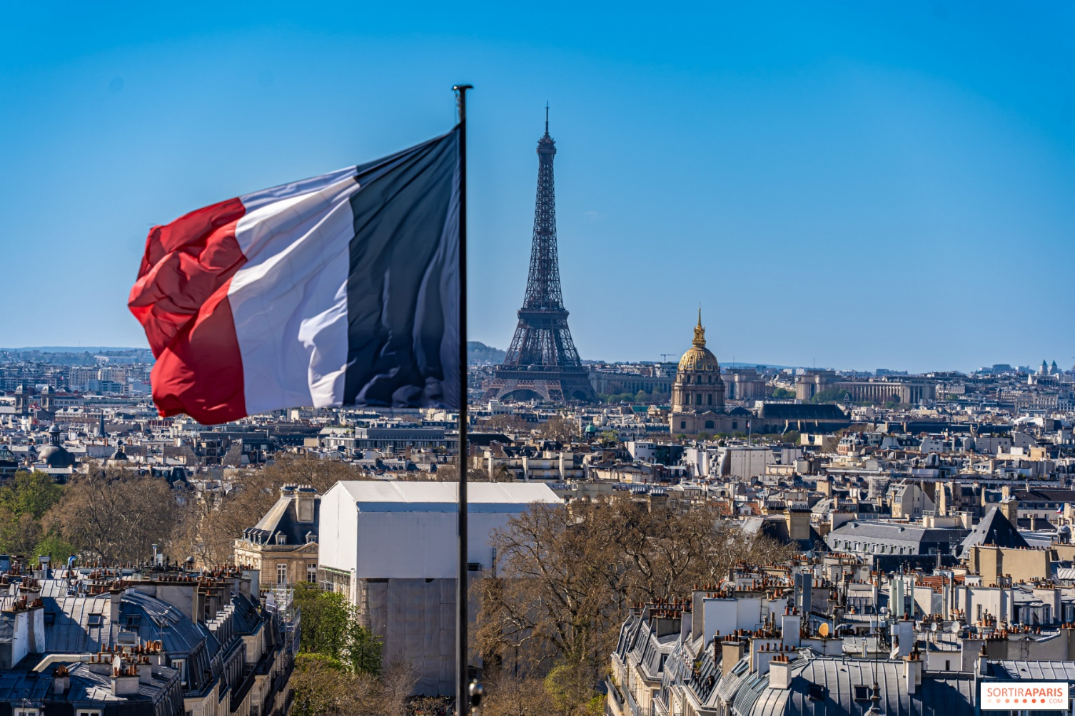
My Case Study of France

je m’appelle _________________
Lesson 1: What is life like in France?
1. Where is France? Locate the country on the map.
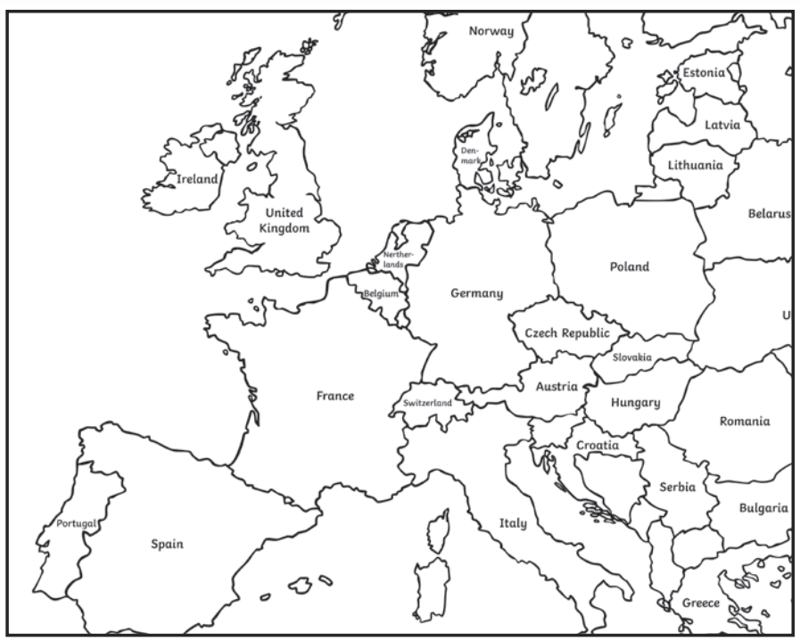

2. What continent is France located on?
____________________________________________________________________________


3. What language does a French person speak?
bonjour!
_______________________________________________
4. What is the capital city of France?

____________________________________________

5. Locate the capital city of France on the map
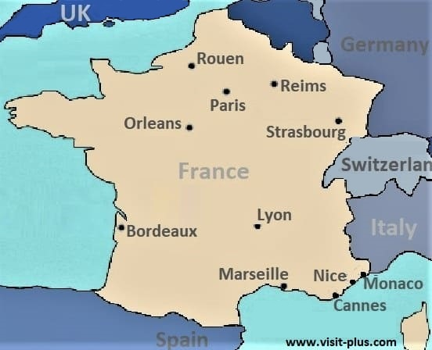

Physical features are natural objects or features.

6. Make a prediction, what physical features might be located in France?

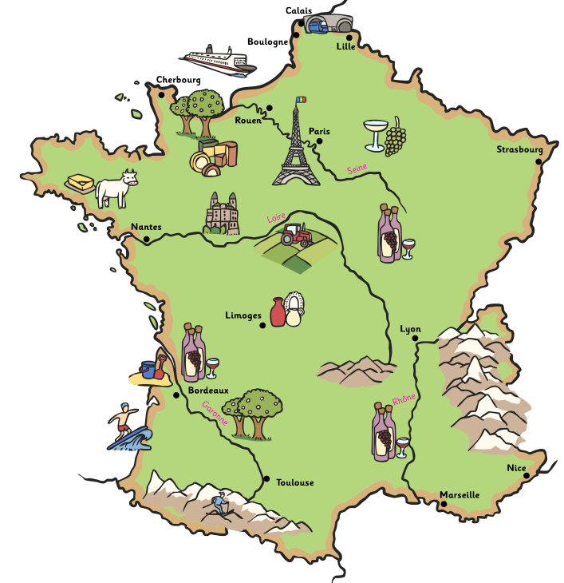

7. Here are some physical features located in France. Label these features.
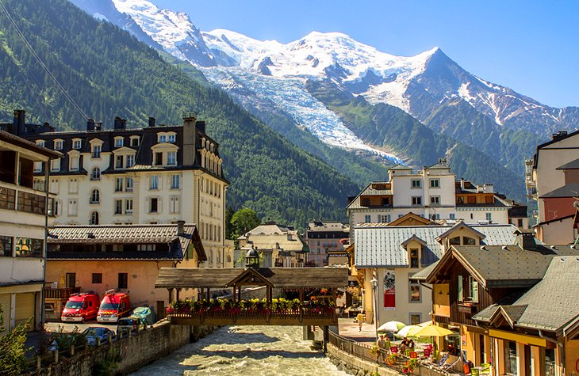

___________________________
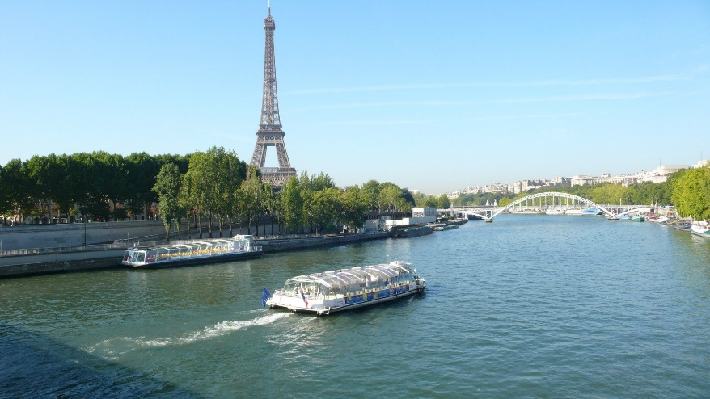

___________________________

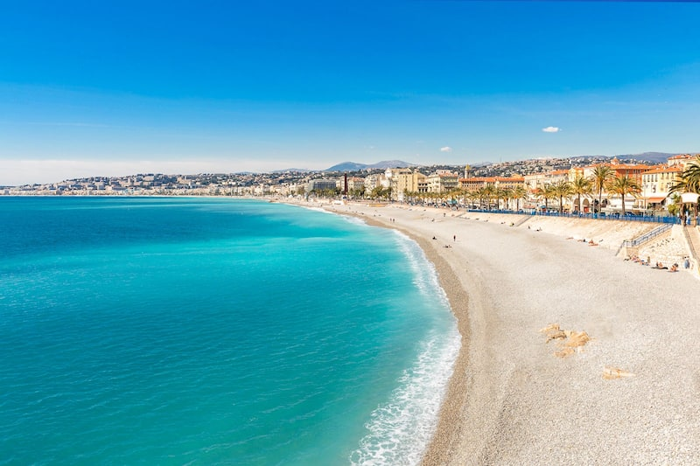

___________________________
Human features are objects that are built by humans. Famous human features are often called landmarks. Paris has some of the most famous landmarks in the world!
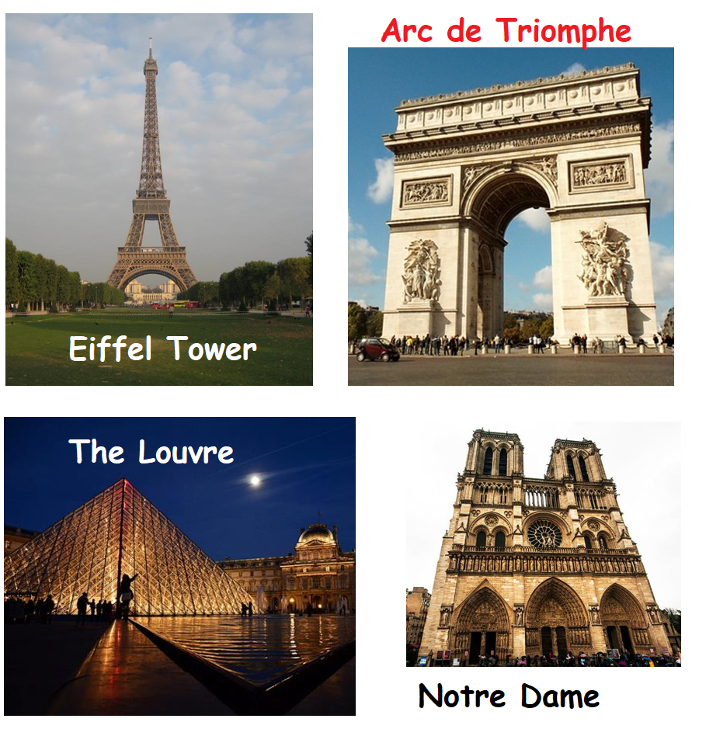

8. What is your favourite Paris landmark?

Lesson 2: What makes a country in Europe unique?
1. What is special about France? Add some suggestions to the thought bubbles.
Day to day living

Physical features

Landmarks

2. Compare life in Paris to your life in your local area.
 | Paris | My local area
What language is spoken?
What are the main types of land use? | Satelitte view of Paris  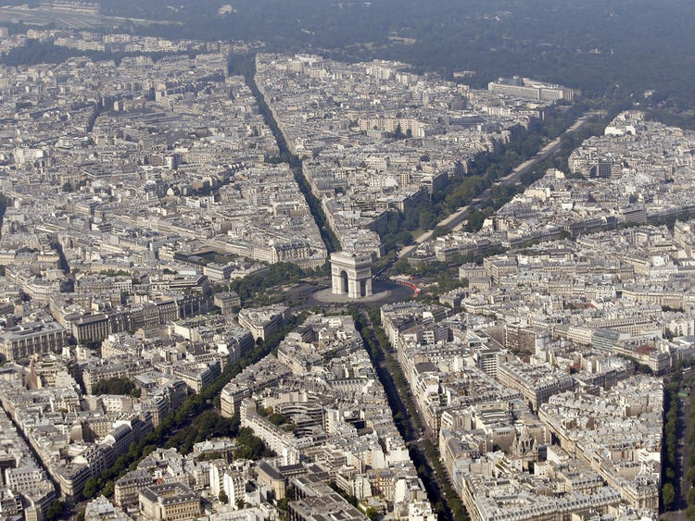 | Satelitte view of Melton Mowbray  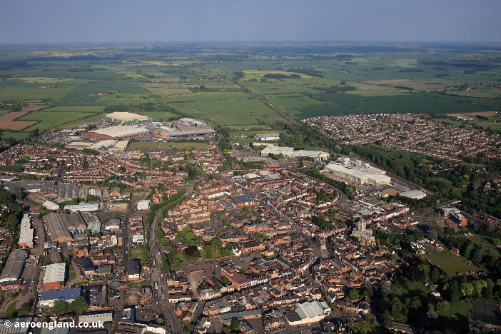
 | Paris | My local area
What physical features are found in this area?

What are the main landmarks in this area?

What makes Paris unique?

