
Subject Unit Plan
Locational Knowledge
Place Knowledge
Human and Physical Geography
Geographical Skills and Fieldwork
Climate Education
Subject: Geography
Year Group: Year 5
Unit: Climate Zones
Enquiry Question: Why do places experience different climates?
National Curriculum Link
• describe and understand key aspects of climate zones, biomes and vegetation belts
• identify the position and significance of latitude, longitude, Equator, Northern Hemispheres, Southern Hemisphere, the Tropics of Cancer and Capricorn, Arctic and Antarctic Circle
• use maps, atlases, globes and digital/computer mapping to locate and describe features studied

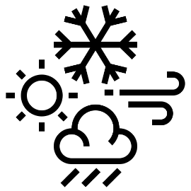 | Enquiry question:  Why do places experience different climates?
Session number |  | Sequenced learning points
1. What is meant by place? |  | ● What is a place?  ● What do we use to locate a place?  ● Maps have lots of information about a place.  ○ Identify the position of imaginary lines  ○ Discuss the significance of imaginary lines
2. What climate can we experience? |  | ● What is meant by climate?  ● Do we all experience the same climate?  ● What is a climate zone?  ● How many climate zones are there?  ● Use maps to locate climate zones
3. How does a place’s location determine the climate experienced? |  | ● What is meant by climate?  ● How many climate zones are there?  ● Why are there different climate zones?  ○ What is the significance of imaginary lines on a place’s climate?  ● Climate patterns are changing
4. How do I locate a place using map coordinates? |  | ● Why does a place location determine its climate?  ● How do we locate a place on a map?  ○ How to read latitude and longitude coordinates.  ○ How to use latitude and longitude coordinates to locate a place.  ○ What climate does a place experience?
5. Why does the same vegetation grow in different places? |  | ● How does climate affect the environment?  ● What is a biome?  ● What climate is experienced in biomes?  ○ Use maps and pictures to compare climate zones and biomes  ● What is a vegetation belt?  ○ Use maps and pictures to compare biomes and vegetation belts.
6. How has climate change affected the Tundra biome? |  | ● Why are climate patterns changing?  ● How will climate change affect biomes?  ● What is the tundra biome?  ● What is happening to the tundra’s climate?  ● What is the impact of climate change to the Tundra?  ● How will this affect the UK?

Subject Knowledge
1. What is meant by place? | ● What is a place? | ● Place is a location.  ● ‘Place’ can be used to describe a specific location at different scales. From a town, to a country, to a continent.
1. What is meant by place? | ● What do we use to locate a place?  ● Maps have lots of information about a place. | ● We use maps to look at a place.  ● World map – land can be split into 7 continents. What continental places do you recognise?  ● The UK is located in the continent Europe.  ● We draw imagery lines on the world map.  ● We draw these lines to accurately position places.  ● These lines are used to navigate our world, navigate place (at different scales: world, national, local, etc..)
1. What is meant by place? | ○ Identify the position of imaginary lines | ● The Equator is an imaginary line around the middle of the Earth.  ○ The equator splits the Earth into the Northern Hemisphere and the Southern Hemisphere.  ● The Tropic of Cancer is an imaginary line in the Northern Hemisphere.  ● The Tropic of Capricorn is an imaginary line in the Southern Hemisphere.  ● The Arctic Circle is an imaginary line in the Northern Hemisphere.  ● The Antarctic Circle is an imaginary line in the Southern Hemisphere.  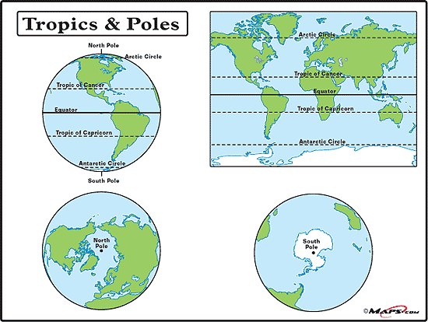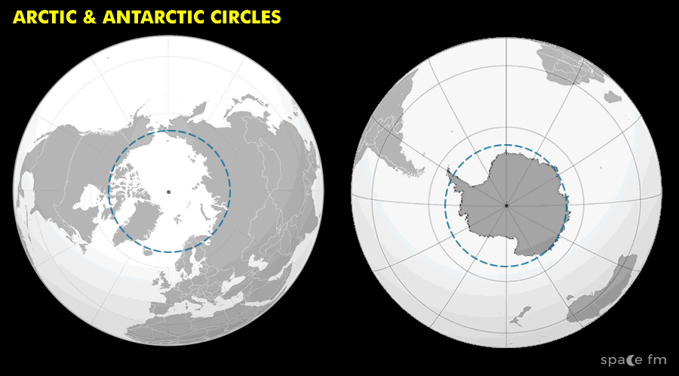
1. What is meant by place? | ○ Discuss the significance of imaginary lines | ● A place’s relative position to the Equator/Tropics/Poles determines the weather it experiences.  ○ The weather at the Equator is hot all year round. Average temperature 31°C  ○ The weather at the Circles is cold all year round. Average temperature -9°C  ○ The UK is closer to the Arctic Circle than the Equator. What type of weather do we experience, on average? Cooler weather. Average temperature 13°C
2. What climate can we experience? | ● What is meant by  climate?  ● Do we all experience the same climate? | ● Weather is a description of weather conditions in a particular place e.g. hot or cold; wet or dry.  ● Climate is the average weather conditions in a place for many years.  ● Different areas of the world have different climates because of their location in the world – location to Equator/Tropics/Circles.
2. What climate can we experience? | ● What is a climate zone? | ● A climate zone is a large area that experiences a similar climate
2. What climate can we experience? | ● How many climate zones are there?  ● Use maps to locate climate zones | ● There are 4 main climate zones found on our planet.  1. Cold – very cold temperatures, precipitation will fall as snow  2. Temperate – mild temperatures and a moderate amount of rainfall  3. Warm – hot temperatures and little rain  4. Tropical – warm temperatures and lots of rain.  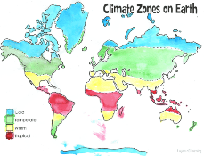  ● Plain world map at towards end of document with imaginary lines pre-drawn. Children to colour each climate zone.
3. How does a place’s location determine the climate experienced? | ● What is meant by climate? | ● Climate is the average weather conditions in a place for many years. A place’s climate is dependent on their location in the world.
 | ● How many climate zones are there? | ● A climate zone is a large area that experiences a similar climate.  ● There are 4 main climate zones found on our planet: cold, temperate, warm, tropical.
 | ● Why are there different climate zones?  ○ What is the significance of imaginary lines on a place’s climate? | ● A place’s relative position to the Equator/Tropics/Circles determines the climate experiences. Therefore, climate zones are influenced by these imaginary lines.  ● Look at word map, climate zones coloured yesterday.  ● What do you notice about places on the Equator… what climate zone are they in? What climate do they experience?  ● What do you notice about places on the Circles… what climate zone are they in? What climate do they experience?  ● What do you notice about places on the Tropics… what climate zone are they in? What climate do they experience?
 | ● Climate patterns are changing | ● Climate change = a change in usual temperatures and weather patterns due to human activity.  ● We can generalise what climate an area will experience (climate zones)  ● However due to human activity our climate is changing. This is known as climate change.  ● Extreme weather events occur, with extreme weather experiences by a place that is not usual/expected
4. How do I locate a place using map coordinates? | ● Why does a place location determine its climate? | ● A place’s relative position to the Equator/Tropics/Circles determines the climate experiences and climate zone it is part of.  ● Use examples to illustrate: UK, Nigeria, Canada, etc.
4. How do I locate a place using map coordinates? | ● How do we locate a place on a map?  ○ How to read latitude and longitude coordinates. | • To help locate where a place is in the world, people use imaginary lines latitude and longitude. These lines form a grid over the Earth.  • Lines of latitude are invisible horizontal lines that circle the Earth. These lines are parallel to the Equator and tell you how far north or south a location is.  • The Equator is at the centre of the lines of latitude and is at 0° latitude.  • Anything lying south of the Equator is labelled °S. Anything lying north of the Equator is labelled °N.  • Lines of longitude are invisible vertical lines that circle the Earth. These lines tell you how far east or west a location is.  • The Prime/Greenwich Meridian is sat at 0° longitude; this line runs through London, UK.  • Anything lying east of the Greenwich Meridian is labelled °E. Anything lying west of the Greenwich Meridian is labelled °W.  • When writing longitude and latitude coordinates – latitude first, then followed by a comma, and then longitude. For example, 15°N, 30°E.  • You can use Google Earth (turn on gridlines) to demonstrate how they form a grid over planet Earth.
4. How do I locate a place using map coordinates? | ○ How to use latitude and longitude coordinates to locate a place.  ○ What climate does a place experience? | • Longitude and latitude map of world – teacher pre colour climate zones.  • Give children a list of coordinates. Read these coordinates and locate a place on the map.  • What climate zone does this place experience?  • What continent is this place located in?  • See end of document for this activity  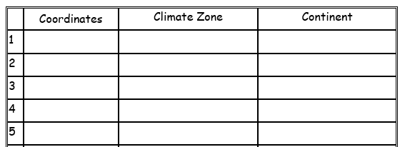
5. Why does the same vegetation grow in different places? | ● How does climate affect the environment? | ● When you visit a place, what do you see?  ● The natural environment (plants), buildings and things that lives there (animals).  ● Environment is the surroundings of a place. Plant, animals and humans live in the place’s environment.  ● Do places environment look the same? (use image from Antarctica, Melton Mowbray and the Sahara Desert to illustrate).  ● A place’s climate determines the environment and what can live there.
5. Why does the same vegetation grow in different places? | ● What is a biome? | ● A biome is a large area that has a similar climate and as a result is home to similar animals and plants.  ● There are 6 main biomes. Their environments look different as the climate determines what can live in the area  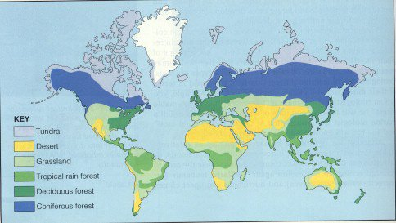
5. Why does the same vegetation grow in different places? | ● What climate is experienced in biomes?  ○ Use maps and pictures to compare climate zones and biomes. | ● Let’s compare climate zones and biomes.  ● What do you notice…  ● What climate do you think will be experienced in a tundra biome? How do you know this…
5. Why does the same vegetation grow in different places? | ● How does climate impact the vegetation? | ● A place’s climate also affects what vegetation can grow in the area  ● Vegetation = refers to all plants and trees collectively  ● A vegetation belt is an area that is home to similar plant species
5. Why does the same vegetation grow in different places? | ○ Use maps and pictures to compare climate zones and vegetation belts. | ● Let’s compare biomes and vegetation belts  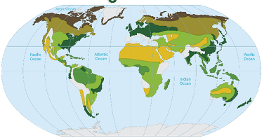  ● What do you notice…  ● Why does the UK grow the same vegetation as France? s  ● Why does…. ^children to see the oink between climate, biome and vegetation
6. How has climate change affected the tundra biome? | ● Why are climate patterns changing? | ● Climate is the average weather conditions in a place for many years. A place’s climate is dependent on their location in the world.  ● Looking at the climate zones we can generalise what climate an area will experience  ● However humans are burning fossil fuels which is releasing harmful gases into the air – they are known as greenhouse gases  ● These gases act as a blanket, trapping heat inside the Earth and increasing the Earth’s temperature  ● This increase in temperature is causing climates to change across the world and extreme weather events to take place. This is known as climate change.  ● Climate change = a change in usual temperatures and weather patterns due to human activity.
6. How has climate change affected the tundra biome? | ● How will climate change affect biomes? | ● Climate change is changing the usual temperature and expected weather patterns in areas around the world.  ● As the world gets warmer, so do biomes. Their weather is rapidly changing, making some biomes wetter than usual, and some biomes dryer.  ● A changing climate will affect the vegetation that can grow and the animals who can survive in the area
6. How has climate change affected the tundra biome? | ● What is the tundra biome?  ● What is happening to the tundra’s climate? | ● The tundra is the coldest of the biomes. It receives low amounts of rainfall.  ● The tundra biome is a cold and treeless area where harsh conditions make it hard for plants and animals alike to survive.  ● What vegetation/animals live in the Tundra biome… arctic foxes, polar bears, grey wolves, caribou (aka reindeer), snow gees, musk oxen, etc.  ● Temperatures in the Tundra are rising because of climate change, this is causing the ice to melt.
6. How has climate change affected the tundra biome? | ● What is the impact of climate change to the Tundra? | ● Melting ice reduces the size of area of animals to live on.  ● Although not all doom and gloom. Whilst some vegetation will die and animals may move away, other vegetation will thrive with new species.  ● Higher temperatures will drive the growth of shrubs (a new vegetation to the area) and decrease growth of lichen. Lichen is a food source for caribou and other animals.  ● As a result caribou are migrating to others areas.  ● The vegetation wold spider is also thriving due to increased temperatures.
6. How has climate change affected the tundra biome? | ● How will this affect the UK? | ● The mass melting of ice is causing sea levels to rise.  ● Sea level rise can cause rivers to permanently flood. Decreasing space for people to live.  ● Type into google ‘climatecentral.org land projected to below sea level in 2050’ – a really cool interactive map showing you which areas will be underwater across the world. Can look at local area, UK as a whole, Netherlands is an interestingly discussion – practically all of it will be underwater!

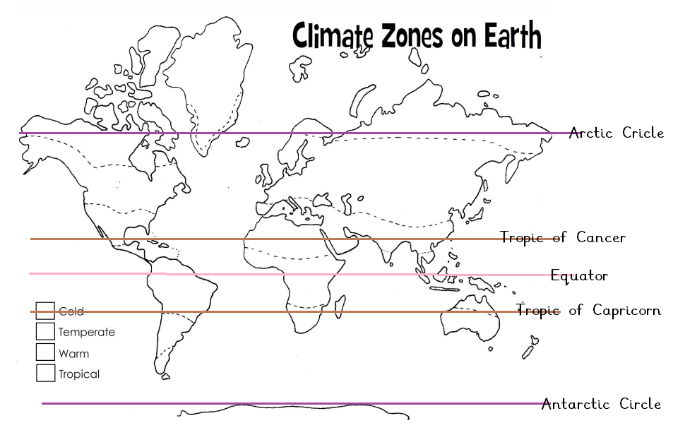

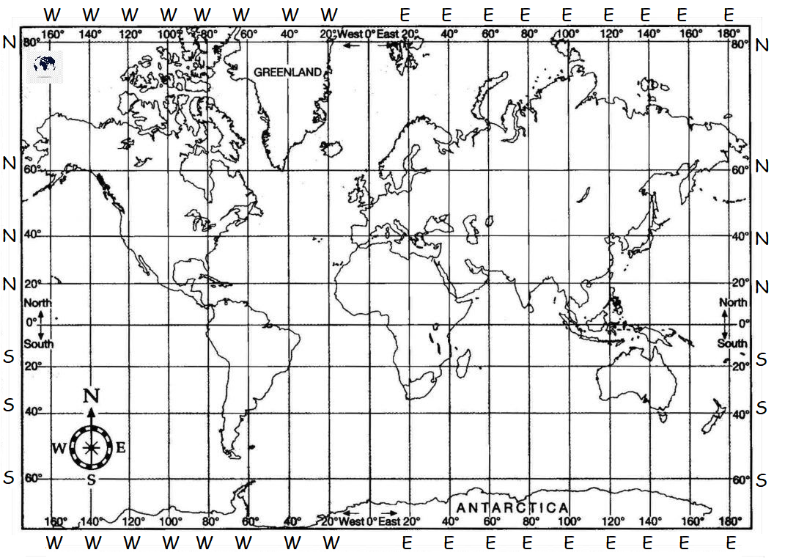
 | Latitude and Longitude Coordinates | Climate Zone | Extension (if needed): Continent
1
2
3
4
5
6
7
8

