
Subject Unit Plan
Locational Knowledge
Place Knowledge
Human and Physical Geography
Geographical Skills and Fieldwork
Climate Education
Subject: Geography
Year Group: Year 5
Unit: North America
Enquiry Question: Why does North America have different time zones?
National Curriculum Link
• locate the world’s countries using maps to focus on North America, concentrating on the environmental regions and major cities
• understand geographical similarities and differences through the study of human and physical geography of a region of North America
• use maps, atlases, globes and digital/computer mapping to locate countries and build on their knowledge of the wider world
• identify the position and significance of latitude, longitude, Equator, Northern Hemisphere, Southern Hemisphere, the Tropics of Cancer and Capricorn, Arctic and Antarctic Circle, the Prime/Greenwich Meridian and time zones (including day and night)

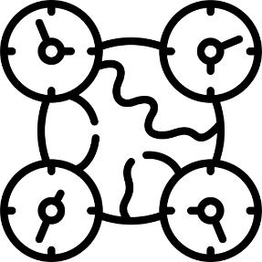 | Enquiry question:  Why does North America have different time zones?
Session number |  | Sequenced learning points
1. What is North America? |  | ● What is a continent?  ● Where is the North American continent located?  ○ Make link to imaginary lines.  ● What countries are located in North America?  ○ What is a county?  ○ Use maps/atlases to locate countries in North America.
2. Where do people live in North America? |  | ● What is a city?  ● Name some cities located in North America.  ● Locate the cities on a map of North America.  ○ Use longitude and latitude coordinates to locate specific cities.
3. What climate does North America experience? |  | ● What is climate?  ● What is an environmental region?  ● How many environmental regions are there in North America?  ○ How does the climate and environment differ across the continent?  ● Expected weather patterns are changing
4. Why does the UK and North America have different time zones? |  | ● What is the time?  ○ What is the time in the UK?  ○ What is the time in North America? Depends on your location!  ● What is a time zone?  ○ Prime/Greenwich Meridian is located in the UK.  ○ Time zones are based on this meridian.
5. How many time zones are there in North America? |  | ● What is a time zone?  ● How many time zones can be found across the North American continent?  ○ Use maps to investigate time zones across North America  ○ How many hours is this location behind the UK?

Subject Knowledge
1. What is North America? | ● What is a continent? | • A continent is a large area of land.  • The world’s continents are, from largest to smallest: Asia, Africa, North America, South America, Antarctica, Europe, and Oceania  • Generally, oceans separate the continents, however there are exceptions. Culture differences also separate the world into continents e.g. Europe and Asia.
1. What is North America? | ● Where is the North American continent located?  ○ Make link to imaginary lines. | • North America is located in the Northern Hemisphere (above the Equator)  • It lies between the Pacific and Atlantic Oceans.  • Tropic of Cancer and Arctic Circle run through this continent.  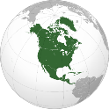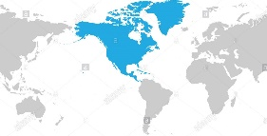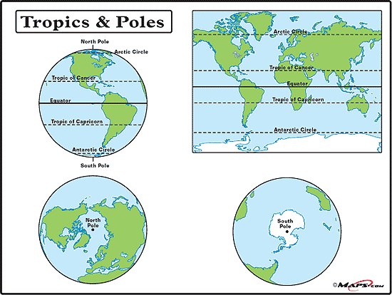
1. What is North America? | ● What countries are located in North America?  ○ What is a county?  ○ Use maps/  atlases to locate countries in North America. | • A country is an area of land that has its own government.  • 23 countries make up the continent.  • Canada, the USA and Mexico are the three largest countries in North America. USA – 328 million people. Mexico – 128 million. Canada – 38 million  • Use maps and atlases (located in KS2 library) to identify and locate some North American countries.
2. Where do people live in North America? | ● What is a city? | • People live in a settlement.  • Settlements: a place where people establish a community. Settlements can vary in size from the very small (a village) to extremely large (a city)  • A city is a large settlement containing lots of buildings and lots of people. They include hospitals, sports facilities, universities, shops, offices, many houses and a cathedral.
2. Where do people live in North America? | ● Name some cities located in North America. | • North America has some of the world’s largest cities (2015)  Mexico City, Mexico – 9 million New York City, USA – 8.5 million  Los Angeles, USA – 4 million Toronto, Canada – 2.8 million  Chicago, USA – 2.7 million + any others you feel are appropriate  • Children don’t need to know where the cities are themselves – we’re exposing them to these place names, some of which they might already know
2. Where do people live in North America? | ● Locate the cities on a map of North America.  ○ Use longitude and latitude coordinates to locate specific cities. | • To help locate where a place is in the world, people use imaginary lines latitude and longitude. These lines form a grid over the Earth.  • Lines of latitude are invisible horizontal lines that circle the Earth. These lines are parallel to the Equator and tell you how far north or south a location is.  • The Equator is at the centre of the lines of latitude and is at 0° latitude.  • Anything lying south of the Equator is labelled °S. Anything lying north of the Equator is labelled °N.  • Lines of longitude are invisible vertical lines that circle the Earth. These lines tell you how far east or west a location is.  • The Prime/Greenwich Meridian is sat at 0° longitude; this line runs through London, UK.  • Anything lying east of the Greenwich Meridian is labelled °E. Anything lying west of the Greenwich Meridian is labelled °W.  • When writing longitude and latitude coordinates – latitude first, then followed by a comma, and then longitude. For example, "15°N, 30°E.  • Map of North America – place some cities location on map using symbol. Children to be given city name and its coordinates. Use the coordinates to locate the city and record city name next to symbol. See end of document for this activity
3. What climate does North America experience? | ● What is climate? | • Climate is a description of the average weather conditions in a certain place for the past 30 or so years.  • Different areas of the world have different climates. Climate is influenced by how near or far it is from the Equator, Poles and Tropics of Cancer/Capricorn. Therefore, climate is determined by latitude!  • Link back to climate zones, the previous unit.  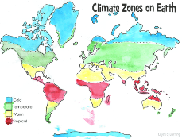
3. What climate does North America experience? | ● What is an environmental region? | • An environmental region is a large area that experiences a similar climate.  • This climate affects what plants grow, what animals live there and landforms.
3. What climate does North America experience? | ● How many environmental regions are there in North America? | • There are 5 different environmental regions across North America.  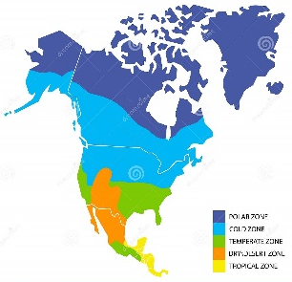  • Climate is influenced by how near or far it is from the Equator, Poles and Tropics of Cancer/Capricorn. THE LATITUDE.  • What sort of climate do you think they will experience in the polar zone…. how do you know this?  • What sort of climate will they experience in the tropical zone…. how do you know this?
3. What climate does North America experience? | ○ How does the climate and environment differ across the continent? | • You can use pictures from each North American environmental region to illustrate what the environment looks like.  • Children don’t need to know all the environmental regions off by heart, they need to know that the climate changes across the region and why.
3. What climate does North America experience? | ● Expected weather patterns are changing | ● Climate change = a change in usual temperatures and weather patterns due to human activity.  ● We can generalise what climate an area will experience.  ● However due to human activity our climate is changing. This is known as climate change.  ● Extreme weather events are more common – for example extreme heat causing wildfires in Canada.
4. Why does the UK and North America have different time zones? | ● What is the time?  ○ What is the time in the UK?  ○ What is the time in North America? Depends on your location! | ● https://www.timeanddate.com/worldclock/converter.html  Use this website to compare time across the world!  ● What is the time in the UK?  ● Will people who live in North America experience the same time as us?  ● Name a city in North America. Search city on website – what country is this city located in?  ● New York and Los Angeles are in the same country USA, but have a different time. Why might this be? Show both cities location on map to support discussions.
 | ● What is a time zone? | ● As the Earth spins, the sun only shines on the side of the Earth that it is facing. This means at one time some areas of the Earth experience day, and the other side experiences night.  ● A time zone is an area which observes a standard time.  ● There are 24 time zones across the world – one for each hour in a day.
 | ○ Prime/  Greenwich Meridian is located in the UK. | ● The world has been divided into time zones using imaginary vertical lines called Meridians. Meridians run from the North Pole to the South Pole.  ● There is an imaginary line running through the UK called the Prime Meridian. It runs through a place in London called Greenwich.  • The Prime Meridian splits the world into eastern and western hemispheres.
 | ○ Time zones are based on this meridian. | • Time in countries to the east of the Prime Meridian is always in front of that in the UK. Time in countries to the west of the Prime Meridian is always behind that of the UK.  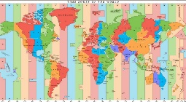
5. How many time zones are there in North America? | ● What is a time zone? | ● A time zone is an area which observes a standard time. There are 24 time zones across the world – one for each hour in a day.  ● Time zones are based on imaginary lines called Meridians.
5. How many time zones are there in North America? | ● How many time zones can be found across the North American continent? | ● Very large countries that are spread out across many time zones, such as Russia or the USA, are divided into separate time zones. Most smaller countries keep to the same time zone even if part of them falls outside a meridian line.  ● The USA has 4 main time zones. (6 including Alaska and Hawaii)  ● North American countries time is always behind the UK, why? (west of Prime Meridian).
5. How many time zones are there in North America? | ○ Use maps to investigate time zones across North America  ○ How many hours is this location behind the UK? | ● Use a map of North America with time zones.  ● Choose a city, children to locate this on the map. How many hours behind the UK is this area?  ● What time is it in the UK? What time is it in this location?

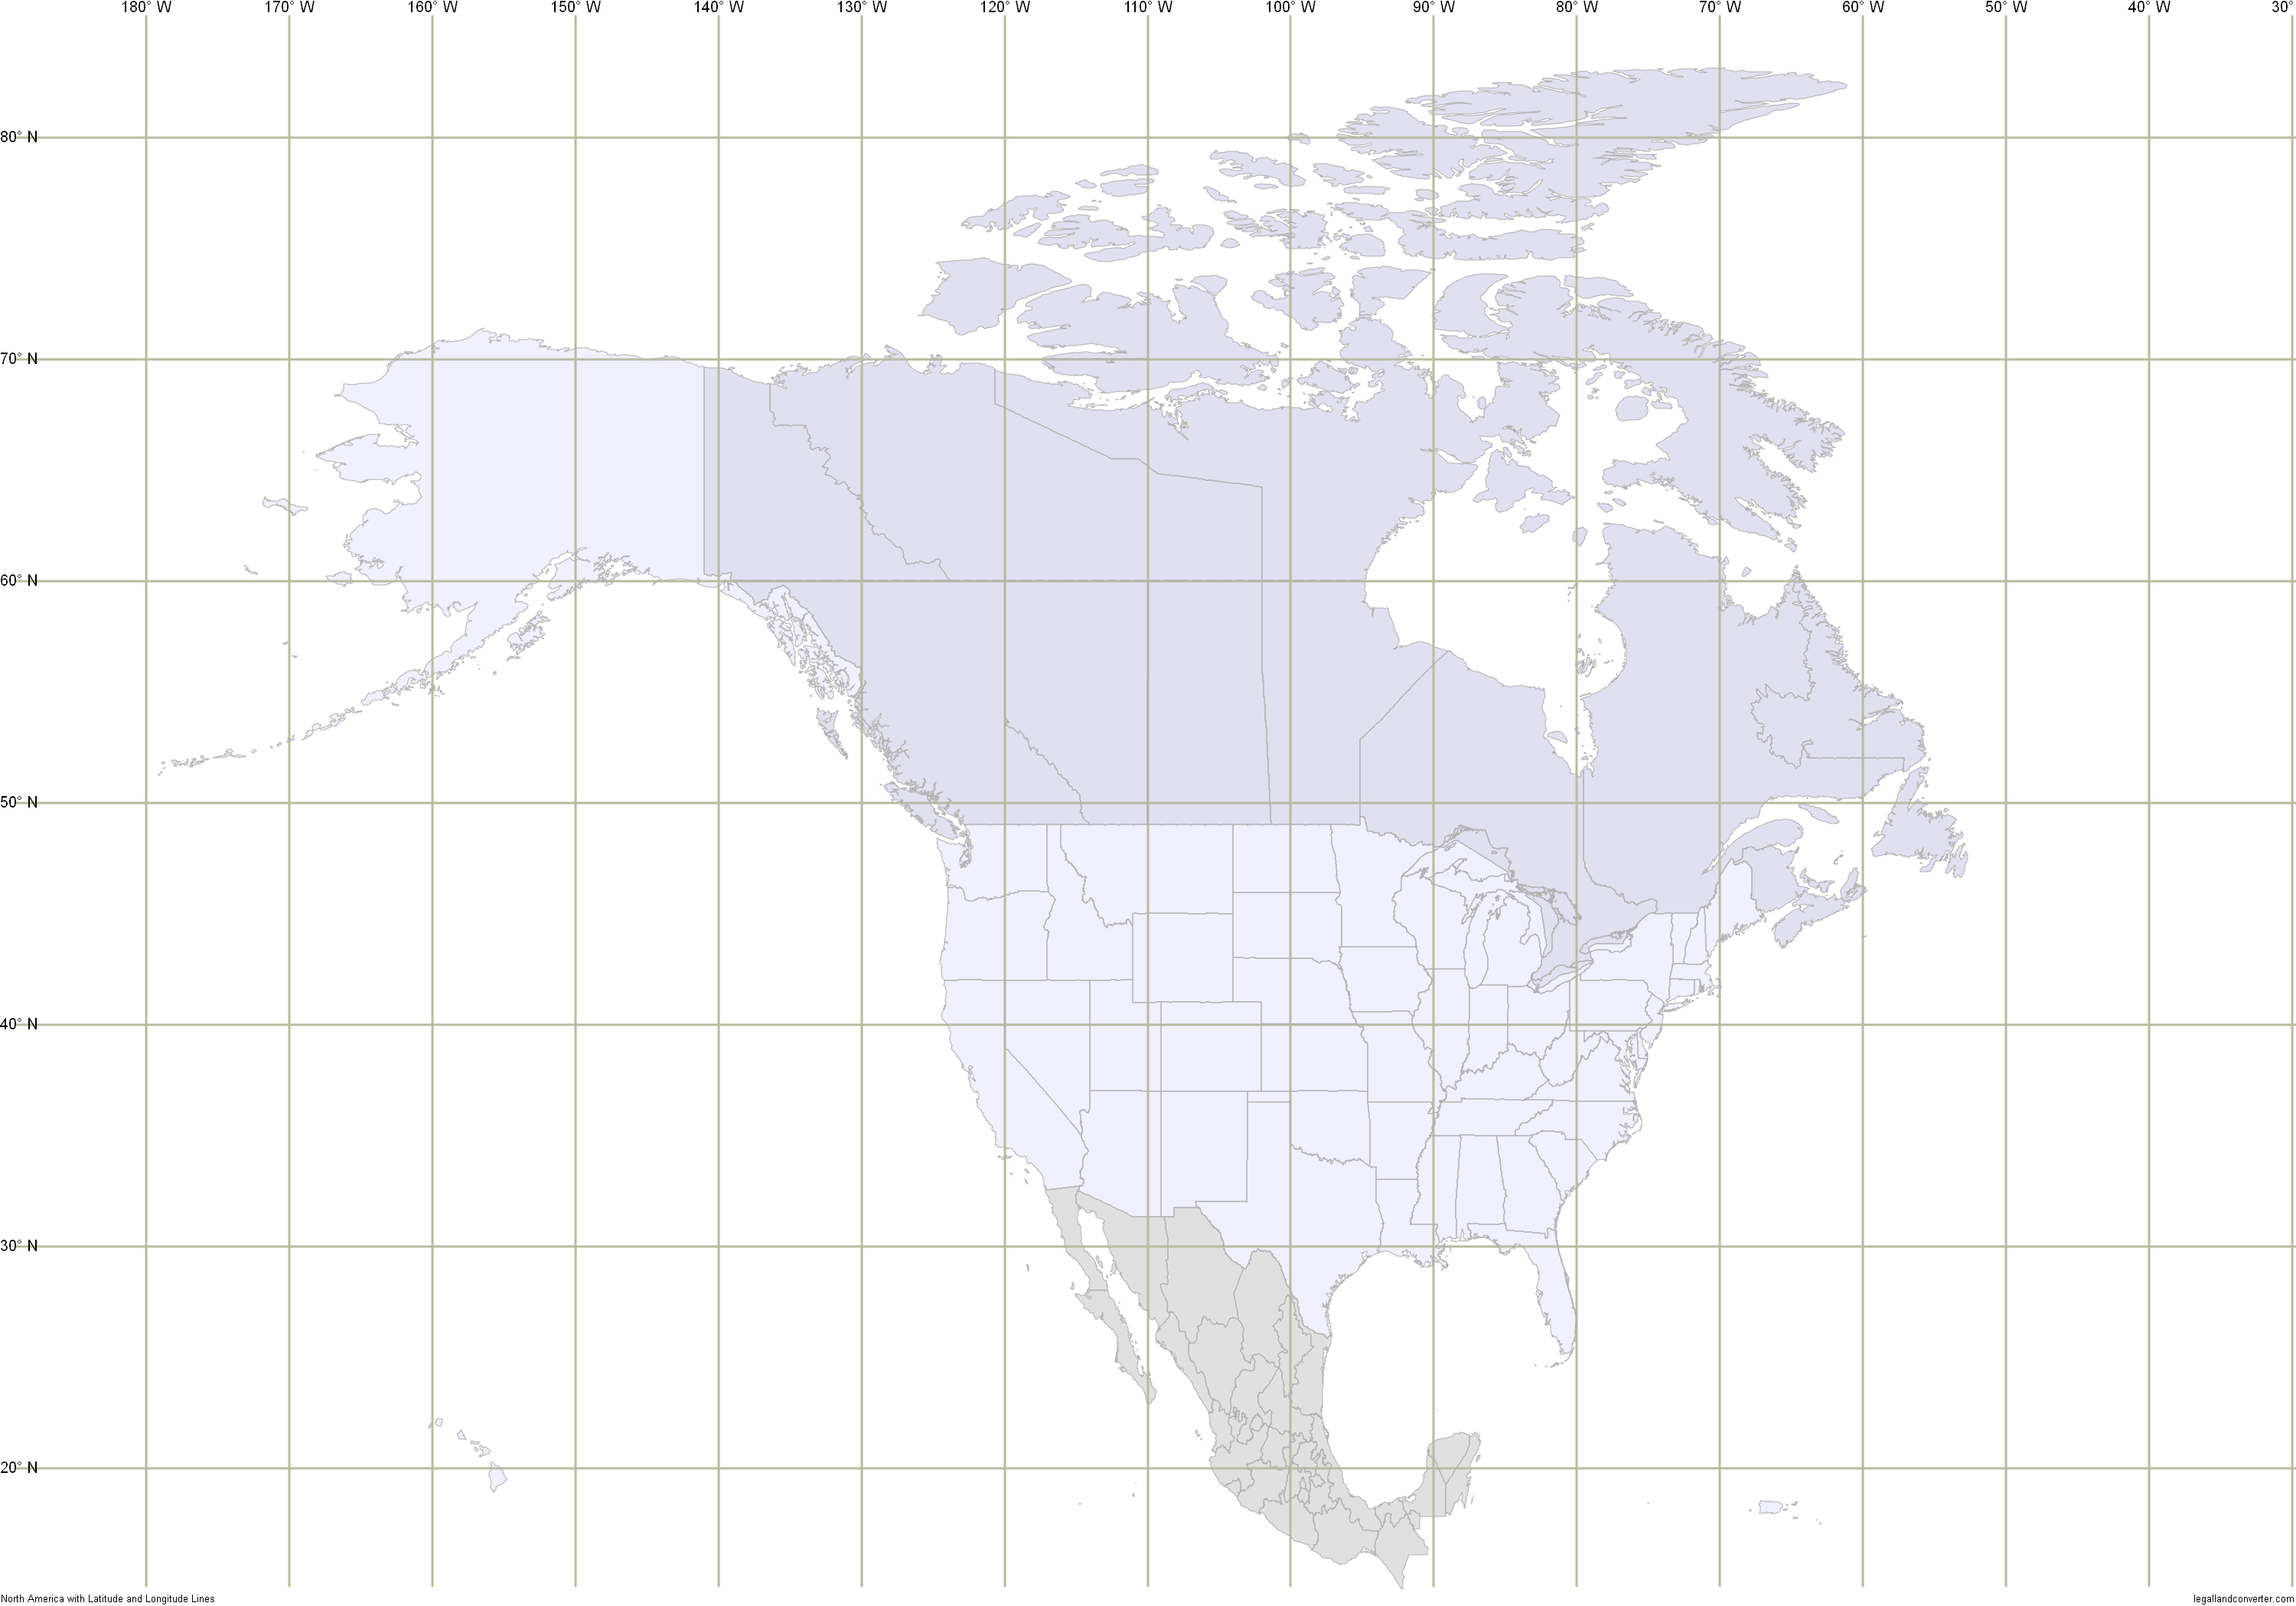
 | City | Country | Latitude and Longitude Coordinates
1
2
3
4
5
6
7
8

Place dots / stars on map of cities in North America. Children to find the lat/lon coorindate and record what country the city is in.

