
Subject Unit Plan
Locational Knowledge
Place Knowledge
Human and Physical Geography
Geographical Skills and Fieldwork
Climate Education
Subject: Geography
Year Group: Year 5
Unit: Economic Activity
Enquiry Question: How does the UK trade with the world?
National Curriculum Link
• describe and understand key aspects of economic activity including trade links
• use fieldwork to observe, measure, record and present the human and physical features in the local area using a range of methods, including sketch maps, plans and graphs, and digital technologies

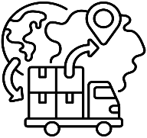 | Enquiry question:  How does the UK trade with the world?
Session number |  | Sequenced learning points
1. Why do we trade goods? |  | ● What is trade?  ● What is a good?  ● Exporting goods  ● Importing goods  ● What is meant by economic activity?
2. What goods do we import to meet demand? |  | ● Why do we trade goods?  ○ Import(ing) & export(ing)  ● How do we meet demand for a good?  ● Where are high demand goods imported from?  ○ How has demand changed over time?
3. What goods do we export to meet supply? |  | ● Why do we trade goods?  ○ Import(ing) & export(ing)  ● Why does the UK sell goods?  ● Where do we export goods to?  ○ How has supply changed over time?
4. Who does the UK trade with? |  | ● UK trade  ● A car is a high demand good  ● Why does the UK export cars?  ● Why does the UK import cars?  ● Consider what data to collect  ● Prepare your risk assessment
5. Collect data through fieldwork |  | ● Engage in fieldwork adhering to risk assessment  ● Collect data  ○ Observe and record car manufacturers in two locations  ○ Record through tally marks and count the total
6. What does our data tell us about the UK’s trade links? |  | ● Present data in a bar chart  ● Present data in a world map  ● Analyse what the data tells us about the UK’s trade links

Subject Knowledge
1. Why do we trade goods? | ● What is trade? | ● Trade is the buying and selling of goods and resources.  ● Trade is an important way for countries to make money.
1. Why do we trade goods? | ● What is a good? | ● A good is a physical object that can be touched. Goods can also be called products or resources.  ● Goods are made by companies in a country.
1. Why do we trade goods? | ● Exporting goods | ● If a country has goods that are in high demand (the number of people wanting to buy a good) them then it can become wealthier by selling them.  ● The UK sells goods that other countries want. This might be because they can’t make them themselves or because they are cheaper or better quality.  ● Selling goods to other countries is called export.
1. Why do we trade goods? | ● Importing goods | ● There are also goods, such as bananas or oranges, that are hard to grow in the UK and there are other goods that cannot be made in the UK.  ● We buy these goods from abroad.  ● Buying goods from other countries is called import.
1. Why do we trade goods? | ● What is meant by economic activity? | ● Economic activity describes the amount of goods or resources a country makes, purchases or sells.  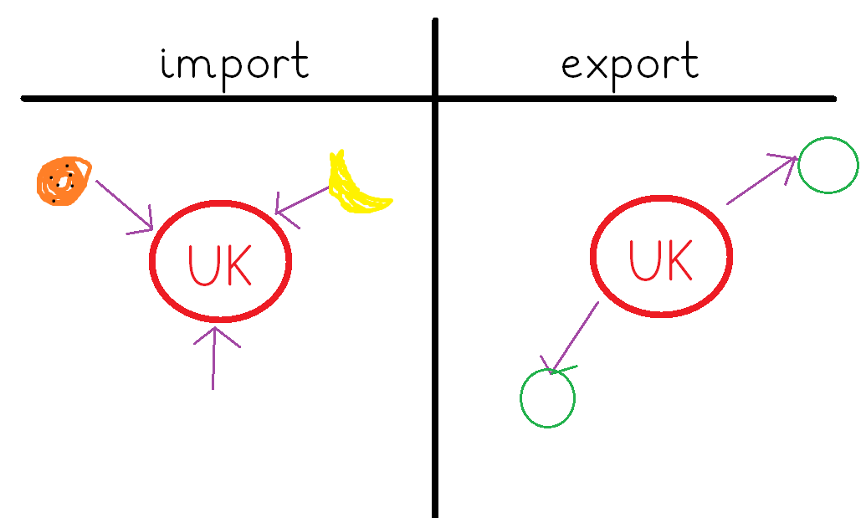
2. What goods do we import to meet demand? | ● Why do we trade goods?  ○ Import(ing) & export(ing) | ● Trade is the buying and selling of goods and resources.  ● Import – a good that is brought into a country from abroad for a price. The UK imports goods they cannot make or grow.  ● Export – a good that is sold to people outside of the country in which it was made. The UK exports goods to make money.  ● Trading allows us to get the things we want and make money at the same time.
2. What goods do we import to meet demand? | ● How do we meet demand for a good? | ● The number of people wanting to buy a good is known as demand. Demand changes over time.  ● If a country cannot meet demand for a good, it will import the good.  ● The higher the demand for a good, the more of that good will be imported.  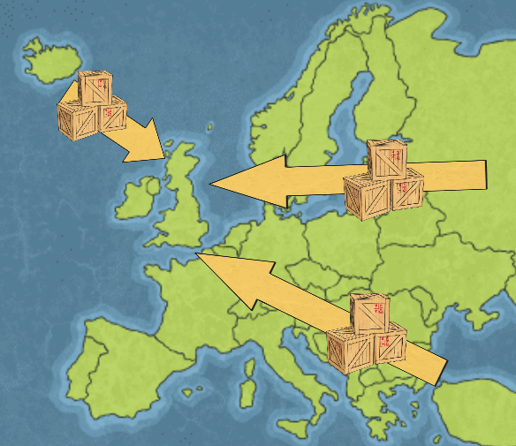
2. What goods do we import to meet demand? | ● Where are high demand goods imported from? | ● Goods are imported from all over the world.  ● Check labels/boxes for information about where the good was made, and consequently imported from.  ●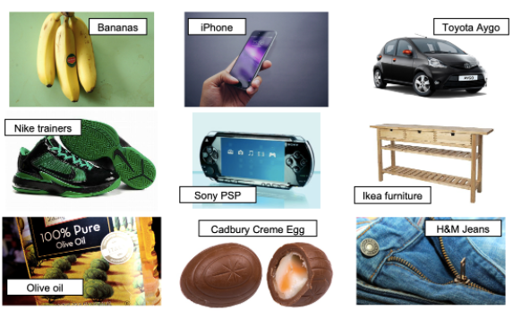 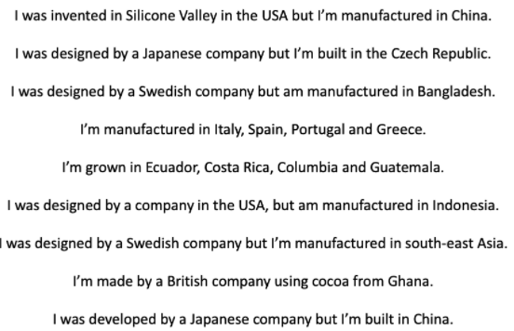
2. What goods do we import to meet demand? | ○ How has demand changed over time? | ● A country’s supply and demand changes over time.  ● Supply and demand can also be impacted by the season. What do we need more of in winter? What do we need more of in summer?  ● Were iPhones in high demand 40 years ago? What might have been in demand instead? A telephone.
3. What goods do we export to meet supply? | ● Why do we trade goods?  ○ Import(ing) & export(ing) | ● Trade is the buying (importing) and selling (exporting) of goods and resources. Trading allows us to get the things we want and make money at the same time.
3. What goods do we export to meet supply? | ● Why does the UK sell goods? | ● The UK makes and grows goods. The amount of goods available to sell is known as supply.  ● The UK exports goods to other countries for a price. This helps the UK economy to grow – the country becomes wealthier.  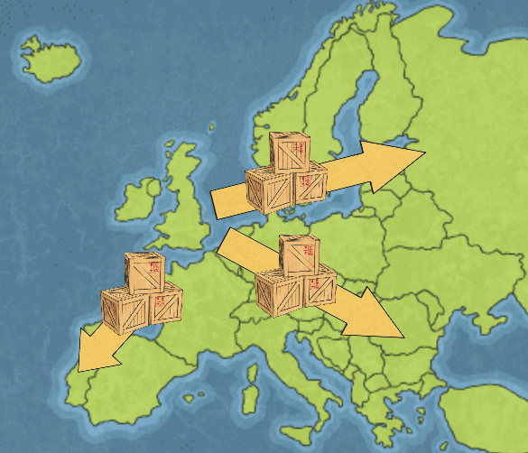
3. What goods do we export to meet supply? | ● Where do we export goods to? | ● The UK exports worldwide.
3. What goods do we export to meet supply? | ○ How has supply changed over time? | ● The UK’s supply and demand has changed over time.  ● What did the UK make and sell in the 80s? Is this the same as today?  ● Oil found in the North Sea was exported in the 1980s – we had enough to cover UK demand, so sold extra abroad for a high price.
4. Who does the UK trade with?  Fill out pages 1, 2 and 3 in fieldwork booklet | ● UK trade | ** USE LOCAL FIELDWORK BOOKLET** 1 booklet per child  ● Trade is the buying (importing) and selling (exporting) of goods and resources.
 | ● A car is a high demand good | ● Most households own at least 1 car.  ● Cars are a high demand good – a lot of people want to buy this good.  ● We use cars to travel around our town, area and country.
 | ● Why does the UK export cars? | ● The UK makes cars – eg companies such as Land Rover, Jaguar, etc.  ● In 2021 cars were the biggest export from the UK, sold for over $38 billion US dollars!  ● Cars are exported to make money.
 | ● Why does the UK import cars? | ● People demand different types of cars – not just cars that are made in the UK. Cars are imported to allow greater choice when choosing a car.
 | ● Consider what data to collect | ● Who does the UK trade cars with?  ● What data (information) do we need to collect to prove or disprove the question? We need to find out where people’s cars were made – where did we buy them from?  ● Survey – go to a car park and find out where each car comes from. Record this in a table (children can see this later in the booklet).
 | ● Prepare your risk assessment | ● How can we be safe on our fieldtrip, visiting a car park.
5. Collect data through fieldwork  Fill out pages 4, 5, 8, and 9 in fieldwork booklet | ● Engage in fieldwork adhering to risk assessment | ● Take booklets on fieldtrip, visiting 2 car parks.
 | ● Collect data  ○ Observe and record car manufacturers in two locations  ○ Record through tally marks and count the total | ● Visit Swallowdale Car Park, record in table where each car is from.  ● Walk to Leisure Centre Car Park, record in table where some cars are from. (could go to Burton Street Car Park instead).
6. What does our data tell us about the UK’s trade links?  Fill out pages 5, 6, 10 and 11 in fieldwork booklet | ● Present data in a bar chart | ● Present data for each car park  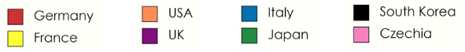  ● Colour key to match world map data presentation
 | ● Present data in a world map | ● Present data by colouring in each country that the UK has imported cars from.  ● Colour key to match bar chart data presentation
 | ● Analyse what the data tells us about the UK’s trade links | ● Answer the enquiry question ‘how does the UK trade with the world.’  ● The UK trades with the world by importing and exporting goods. The UK exports… The UK imports… Evidence of importing – car fieldtrip.

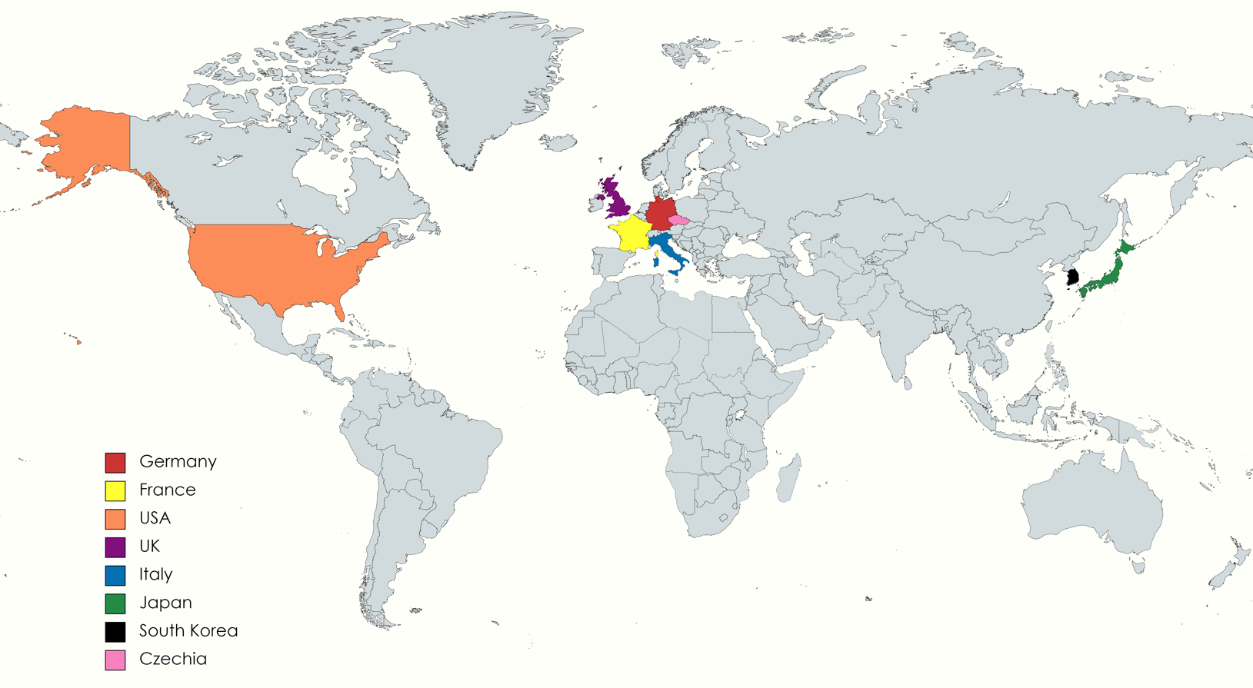

**Put on board to help children locate countries from Fieldtrip

