How does the UK trade with the world?

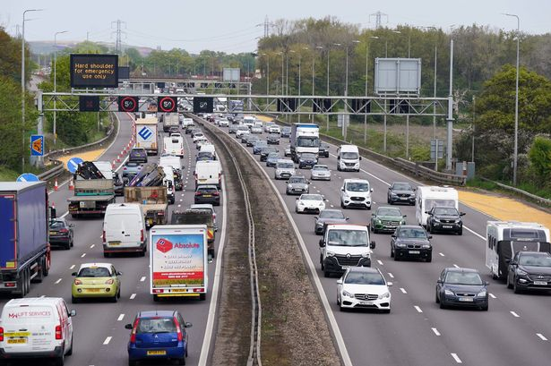

Risk Assessment:
1.

2.

3.

4.

Date of Fieldtrip:

Time of Fieldtrip:
1. What is trade?

__________________________________________________

__________________________________________________

__________________________________________________

2. Show what is mean by:
a) import b) export
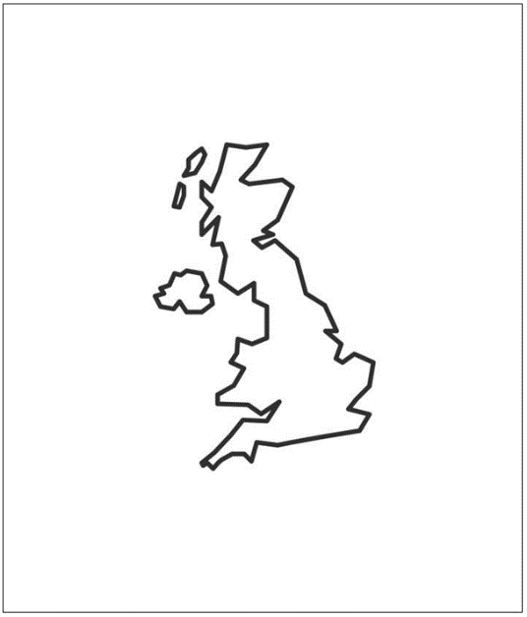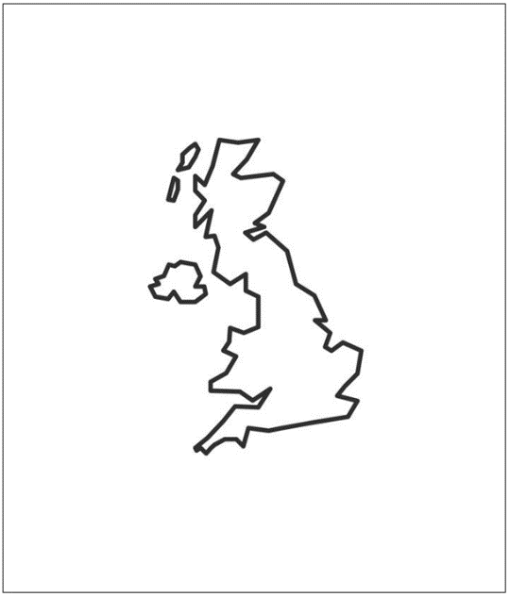

Enquiry Question
How does the UK trade with the world?
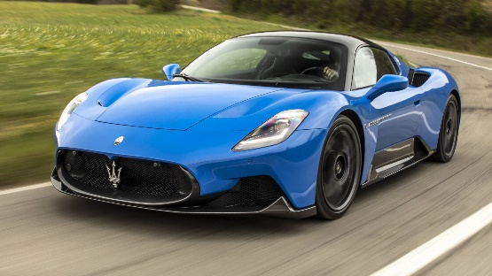
Let’s explore this question by looking at cars – we need to consider who the UK trades cars with.

4. Enquiry prediction:

_________________________________________________________________________________________

_________________________________________________________________________________________

_________________________________________________________________________________________

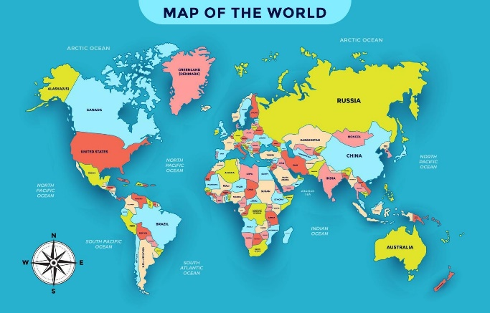
Location 1: Swallowdale Car Park
1. Car count
County of car | Company and Logo | Tally of cars | Total
Germany | Audi 
Germany | BMW 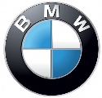
Germany | Mercedes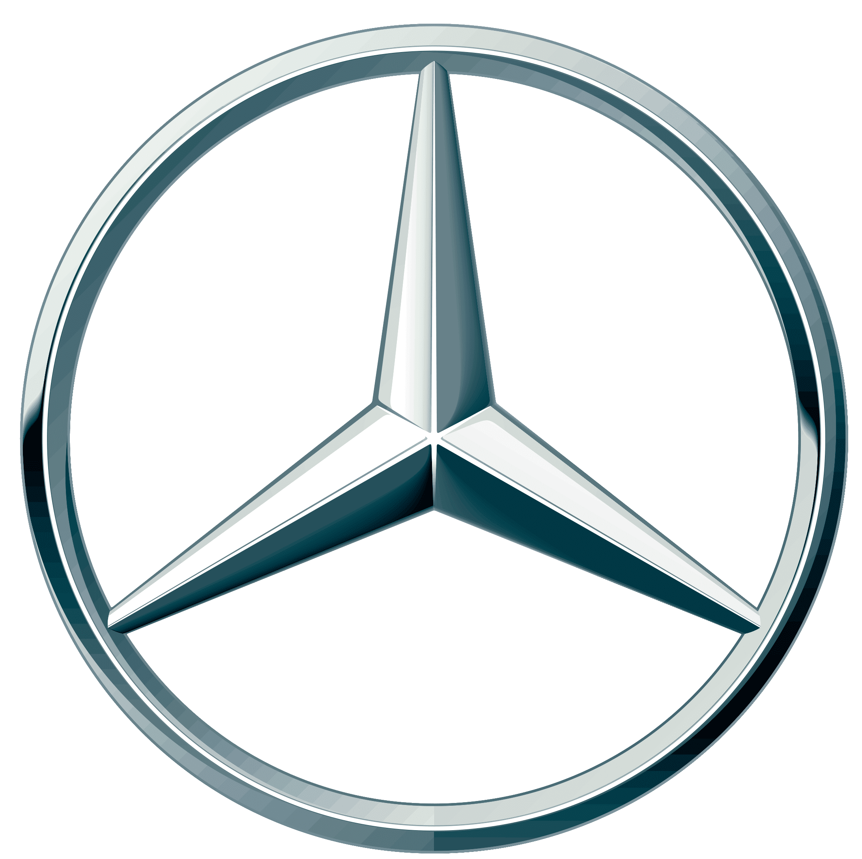
Germany | VW 
France | Citroen 
France | Peugeot 
France | Renault 
USA | Ford 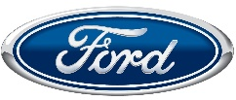
USA | Tesla 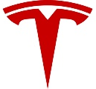
UK | Land Rover 
UK | Jaguar 
UK | Rover 
UK | Vauxhall 
UK | Mini 
Italy | Alfa Romeo 
Italy | Fiat 
Japan | Honda 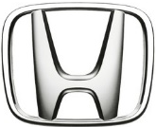
Japan | Lexus 
Japan | Mazda 
Japan | Nissan 
Japan | Subaru 
Japan | Suzuki 
Japan | Toyota 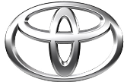
South Korea | Hyundai 
Czechia | Skoda 
Other

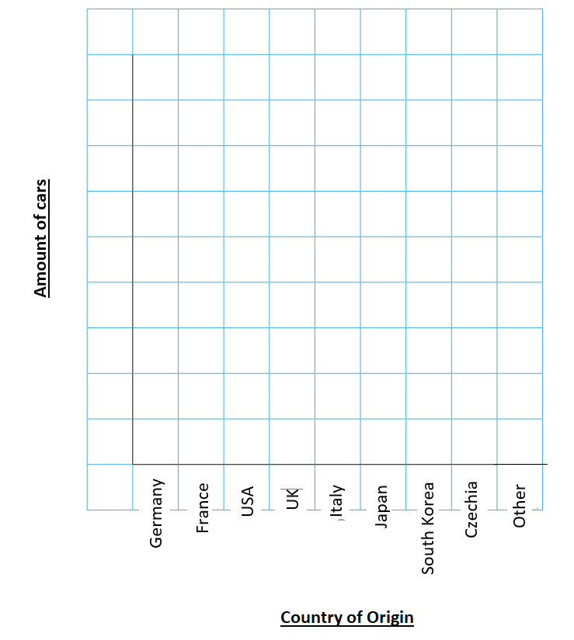
2. Data presentation – bar chart
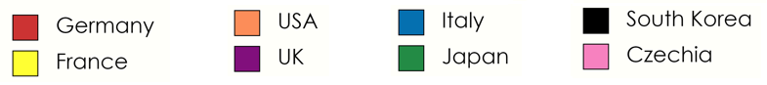
3. Data presentation – on a world map
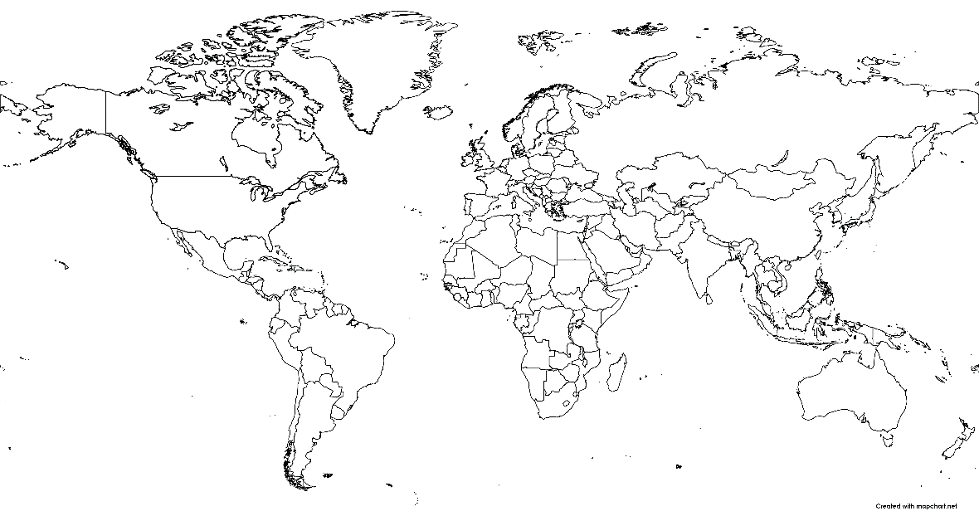
Location 1: Waterfield Leisure Centre Car Park
1. Car count
Key:

County of car | Company and Logo | Tally of cars | Total
Germany | Audi
Germany | BMW
Germany | Mercedes
Germany | VW
France | Citroen
France | Peugeot
France | Renault
USA | Ford
USA | Tesla
UK | Land Rover
UK | Jaguar
UK | Rover
UK | Vauxhall
UK | Mini
Italy | Alfa Romeo
Italy | Fiat
Japan | Honda
Japan | Lexus
Japan | Mazda
Japan | Nissan
Japan | Subaru
Japan | Suzuki
Japan | Toyota
South Korea | Hyundai
Czechia | Skoda
Other

2. Data presentation – bar chart
3. Data presentation – on a world map
Key:

