Why are some areas of Melton Mowbray busier than others?

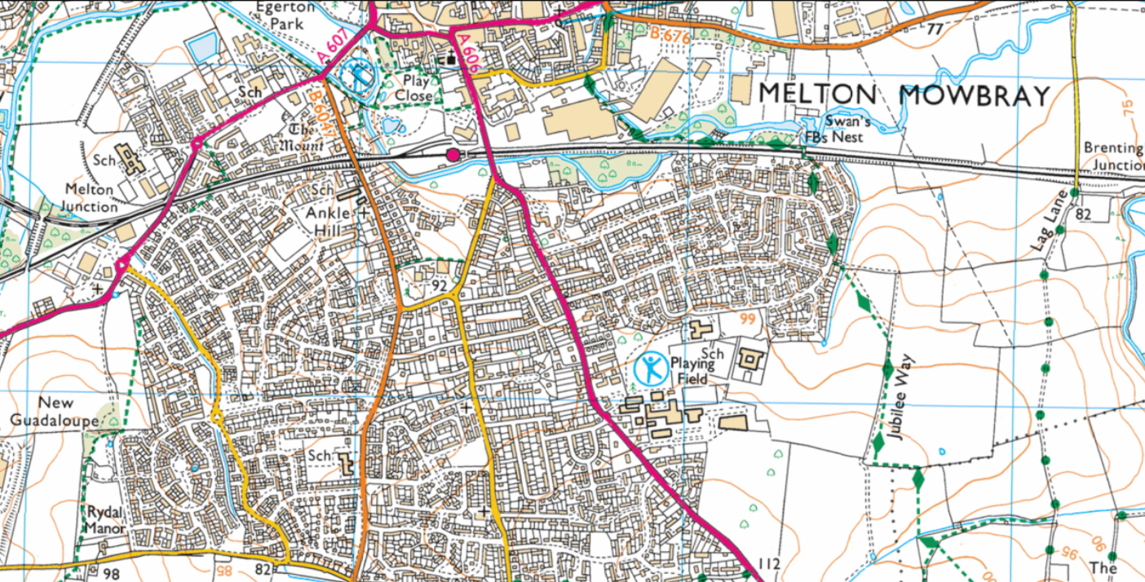

Risk Assessment:
1.

2.

3.

4.

5.

Date:

Time:

Weather:

Location 1:
- Traffic count – 5 minutes
 | tally |  | tally
cars |  | buses
motorbikes |  | vans
lorries |  | other

- Pedestrian count – 3 minutes
tally
Number of pedestrians walking past

- Environmental survey
 | 1 | 2 | 3 | 4 | 5
Dirty |  |  |  |  |  | Clean
Lots of traffic |  |  |  |  |  | No traffic
Noisy |  |  |  |  |  | Quiet
Litter |  |  |  |  |  | No litter
Graffiti |  |  |  |  |  | No graffiti
Crowded |  |  |  |  |  | Spaced out
Neglected |  |  |  |  |  | Well maintained
Very few shops |  |  |  |  |  | Wide variety shops
Total score /40
- Labelled field sketch

- Facilities survey
Shop / Business / Facility | Service/Selling… | Score out of 5  5 = good quality

- Perception – describe the area using 2 words e.g. beautiful, interesting, greenery, housing

Location 2:
- Traffic count – 5 minutes
 | tally |  | tally
cars |  | buses
motorbikes |  | vans
lorries |  | other

- Pedestrian count – 3 minutes
tally
Number of pedestrians walking past

- Environmental survey
 | 1 | 2 | 3 | 4 | 5
Dirty |  |  |  |  |  | Clean
Lots of traffic |  |  |  |  |  | No traffic
Noisy |  |  |  |  |  | Quiet
Litter |  |  |  |  |  | No litter
Graffiti |  |  |  |  |  | No graffiti
Crowded |  |  |  |  |  | Spaced out
Neglected |  |  |  |  |  | Well maintained
Very few shops |  |  |  |  |  | Wide variety shops
Total score /40
- Labelled field sketch

- Facilities survey
Shop / Business / Facility | Service/Selling… | Score out of 5  5 = good quality

- Perception – describe the area using 2 words e.g. beautiful, interesting, greenery, housing

