
Subject Unit Plan
Locational Knowledge
Place Knowledge
Human and Physical Geography
Geographical Skills and Fieldwork
Climate Education
Subject: Geography
Year Group: Year 6
Unit: Earthquakes and Volcanoes
Enquiry Question: Why are some places more vulnerable to tectonic hazards?
National Curriculum Link
• describe and understand key aspects of volcanoes, earthquakes and mountains
• use maps, atlases, globes and digital/computer mapping to locate countries and describe features studied
• use six figure grid references

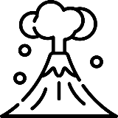 | Enquiry question:  Why are some places more vulnerable to tectonic hazards?
Session number |  | Sequenced learning points
1. What is happening under our feet? |  | ● What is a hazard?  ● The Earth is made up of several layers.  ● The crust is broken into tectonic plates.  ● What is a tectonic hazard?
2. What are the tectonic plates doing? |  | ● The crust is broken in tectonic plates.  ● Tectonic plates are always moving.  ● Where 2 tectonic plates meet is called a plate boundary.  ○ There are 3 types of plate boundary.
3. How are mountains formed? |  | ● What is a mountain?  ○ What is a mountain range?  ● Where do mountains form?  ○ Locate a convergent plate boundary on a map and mark with a symbol.
4. Why do earthquakes happen? |  | ● What is an earthquake?  ● What causes an earthquake?  ○ How do we measure earthquakes?  ● Where do earthquakes happen?  ○ Use maps to identify where earthquakes occur.  ○ Does the UK experience earthquakes?
5. How are volcanoes formed? |  | ● What is a volcano?  ○ There are 3 types of volcanoes.  ● Where do volcanoes form?  ○ Use maps to identify where volcanoes form.  ○ Does the UK have any active volcanoes?  ● What happens during an eruption?
6. Why are some areas more vulnerable to tectonic hazards than others. |  | ● Earthquakes and volcanoes are both tectonic hazards.  ○ Are tectonic hazards linked to climate change?  ● Why are some areas more vulnerable to tectonic hazards.  ● Locate tectonic hazards using 6 figure grid references.

Subject Knowledge
1. What is happening under our feet? | ● What is a hazard? | ● A hazard is a natural event that threatens people or has the potential to cause damage, destruction and death.  ● Some hazards originate under our feet.
1. What is happening under our feet? | ● The Earth is made up of several layers. | ● The Earth is made up of different layers:  1. the core at the centre, a huge hot metal ball  2. the mantle is made up of molten rock called magma  3. the crust, which is the part we can see. It is a thick layer of rock broken into large pieces  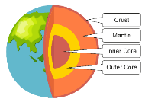  ● A good way for children to visualise this is using apples. Give each child half an apple. Then ask then to draw on the core (inner and outer) in the middle. The rest of the apple is the mantle and the apple skin is the crust.  ● 3D model showing the Earth’s layers https://sketchfab.com/3d-models/earth-core-44c547c28fbf46f4ab430bf1398f5fdb
1. What is happening under our feet? | ● The crust is broken into tectonic plates. | • The crust is broken into different pieces. They are called tectonic plates.  • These plates fit together like a jigsaw and are moving at a rate of a few centimetres a year, in different directions and at different speeds.  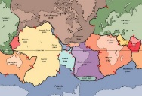  • Use a sharp object (pin) to cut the apple crust into tectonic plates.  ● 3D model of tectonic plates https://sketchfab.com/3d-models/tectonic-plates-mapped-onto-the-earths-surface-9c9581fc2cc041cc9e34c120665b2c75
1. What is happening under our feet? | ● What is a tectonic hazard? | ● A tectonic hazard are events caused by the movement of tectonic plates.
2. What are the tectonic plates doing? | ● The crust is broken into tectonic plates. | ● The Earth is made up of different layers: the core, the mantle and the crust.  ● The crust is broken into different pieces. They are called tectonic plates.
2. What are the tectonic plates doing? | ● Tectonic plates are always moving. | ● These plates are moving at a rate of a few centimetres a year, in different directions and at different speeds.  • Some plates slide past each other, others move away from each other and some bump into each other.  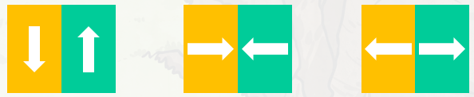
2. What are the tectonic plates doing? | ● Where 2 tectonic plates meet is called a plate boundary.  ○ There are 3 types of plate boundary. | • Where 2 plates meet is called a plate boundary.  • There are 3 types of plate boundaries.  1. Transform boundary: plates rubbing side by side  2. Convergent boundary: both plates moving towards each other  3. Divergent boundary: both plates moving away from each other
3. How are mountains formed? | ● What is a mountain?  ○ What is a mountain range? | ● A mountain is a large elevation of the Earth’s surface  ● A mountain range is a series of mountains that are connected together generally to form a long line of mountains. For example, the Himalayas in Asia.
3. How are mountains formed? | ● Where do mountains form? | ● Mountains (and mountain ranges) are formed at convergent plate boundaries.  ● The two tectonic plates push towards each other and force the ground up where they meet. Therefore, mountains are a tectonic feature, but not necessarily a tectonic hazard.
3. How are mountains formed? | ○ Locate a convergent plate boundary on a map and mark with a symbol. | ● Map with plate directions (arrows) labelled.  ● Where could a mountain (mountain range) form? Look for two plates pushing towards each other – convergent plate boundary.  ● South America & Nazca plate – Andes, Indian & Eurasian plate – Himalayas, Australian & Pacific plate – Southern Alps.  ● Mark potential mountain location using X symbol on map.
4. Why do earthquakes happen? | ● What is an earthquake? | ● An earthquake is a release of friction which produces a violent jolt that shakes the land.
4. Why do earthquakes happen? | ● What causes an earthquake? | ● As the tectonic plates move friction causes energy to build up.  ● Sometimes plates can get stuck which causes more energy to build up, as the magma in the mantle is trying to move the plate.  ● Eventually the energy is released in seismic waves – this is an earthquake.  ● Seismic waves are responsible for shaking the ground.  ● Earthquakes are caused by tectonic plates moving, therefore it is a tectonic hazard.
4. Why do earthquakes happen? | ○ How do we measure earthquakes? | ● The size of an Earthquake is measured using the Richter magnitude scale.  ● Scale from 0-10. The higher the number the more violet the earthquake.  ● The largest recorded earthquake in the world was a magnitude 9.5 in Chile on May 22, 1960.
4. Why do earthquakes happen? | ● Where do earthquakes happen? | ● Earthquakes can occur at any plate boundary  ● Almost 80% of all the planet's earthquakes occur along the rim of the Pacific Ocean, called the "Ring of Fire"; a region that encircles the Pacific Ocean.  ● Website updated showing latest earthquake and where in the world and along which plate boundaries it occurs https://earthquake.usgs.gov/earthquakes/map/?extent=18.14585,-137.19727&extent=54.21386,-52.82227
4. Why do earthquakes happen? | ○ Use maps to identify where earthquakes occur. | ● Map with plate directions (arrows) labelled.  ● Where could an earthquake happen?  ● Mark potential earthquake locations using O symbol on map.
4. Why do earthquakes happen? | ○ Does the UK experience earthquakes? | ● Although the UK does not lie on a plate boundary it can experiences earthquakes. They are rare and so small most people do not feel them.  ● There are fault lines across tectonic plates (caused by friction and energy build up over many years). Release of energy can travel along these lines and cause earthquakes in the middle of tectonic plates.
5. How are volcanoes formed? | ● What is a volcano?  ○ There are 3 types of volcanoes. | ● Volcanoes look like mountains or small hills.  ● A volcano is an opening in the Earth’ crust that allows magma (from the mantle) and gases to escape.  ● There are 3 types of volcanoes.  1. Active volcano; a volcano that has erupted recently, and there is a possibility that it may erupt again.  2. Dormant volcano; a volcano that has not erupted for a long time, however, it may still erupt in the future.  3. Extinct volcano; a volcano which hasn’t erupted in thousands of years and probably won’t ever again
5. How are volcanoes formed? | ● Where do volcanoes form? | ● Volcanoes for at convergent and divergent plate boundaries.  ● Volcanoes are caused by tectonic plates moving away from each other and towards each other. This movement creates an opening (hole) in the crust and allows magma to escape from the mantle. Therefore, it is a tectonic hazard.  ● Website https://www.volcanoesandearthquakes.com/ Using tools at top of webpage you can edit what you want visible on the map. Make a map with plate boundaries and unrest/minor activity/eruption volcanoes visible – hide earthquakes.
5. How are volcanoes formed? | ○ Use maps to identify where volcanoes form.  ○ Does the UK have any active volcanoes? | ● Map with plate directions (arrows) labelled.  ● Where could volcanoes form? At which plate boundary?  ● Mark potential volcanoes location using ∆ symbol on map.  ● Does the UK have any active volcanoes? Why not?
5. How are volcanoes formed? | ● What happens during an eruption? | ● Magma builds up in the volcanoes magma chamber. When enough magma builds up, this pressure is released during an eruption.  ● Magma travels from the chamber, up the vent and spills over the crater – it is now known as lava.  ● Gas and ash is also released during an eruption.  ● Volcanic eruptions can be very dangerous.
6. Why are some areas more vulnerable to tectonic hazards than others. | ● Earthquakes and volcanoes are both tectonic hazards. | ● What is a tectonic hazard?  ● Why is an earthquake a tectonic hazard? What causes it and where does it happen.  ● Why is a volcano a tectonic hazard? Where do they form and why does it erupt?  ● Both tectonic events have the potential to cause damage, destruction and death.
 | ○ Are tectonic hazards linked to climate change? | ● Scientists believe that the frequency and intensity of tectonic hazards are not linked to climate change.  ● Climate change = a change in usual temperatures and weather patterns due to human activity.
 | ● Why are some areas more vulnerable to tectonic hazards? | ● Look at an area – eg USA. Look on map with tectonic plates.  ● Why is the USA vulnerable to tectonic hazards?  ● Is the UK vulnerable to tectonic hazards? Why not?
 | ● Locate tectonic hazards using 6 figure grid references. | ● We can locate tectonic hazards using a 6 figure grid map.  ● 6 figure grid map of New Zealand. (add 6 figure grid lines and numbers to map).  ● This is New Zealand. What plates / plate boundary does New Zealand lie on?  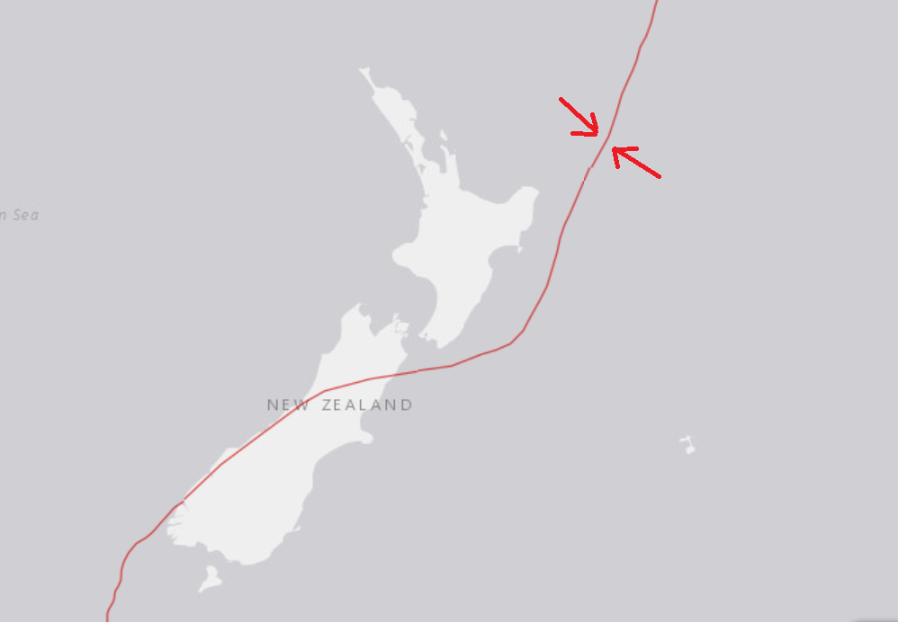  ● New Zealand has mountains ranges, experiences earthquake and has active volcanoes.  ● Give children a 6 figure grid references and what type of tectonic hazard it is. Children to use grid reference to locate this feature and mark it on the map using symbol (X = mountain range, O = earthquake, ∆ = volcano).  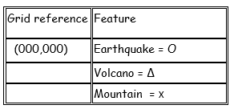  ● “Along the corridor, up the stairs”

