
Subject Unit Plan
Subject: French
Unit: Core Unit 2 Year Group: 3
Overview of Unit:
- Recognise the days of the week when spoken in order.
- Understand most of the colours.
- Understand numbers up to 20.
- Give answers to questions about what I like and do not like with one or two words.
- Show awareness of word classes – nouns, adjectives, verbs and connectives and be aware of similarities in English;
Key phrases and grammar:
- J’aime
- Je n’aime pas
- C’est- it is singular
- et- and
- un/une noun + adjective

Session number | Sequenced learning points | Activities
1 | - revisit nouns and use of le/le and un and une | - Review nouns with articles using https://www.bbc.co.uk/bitesize/topics/z6d98xs/articles/zxnn7yc but stop before the plural section  - Model using a French dictionary to show how to find out https://www.collinsdictionary.com/dictionary/english-french/grass as an example and use online for other searches to check. Children can record in books
2 | - Introduce colours | - U2 L2 Present vocab and Beat the bee game  Share the key text- https://www.youtube.com/watch?v=lurSPEmNKRE  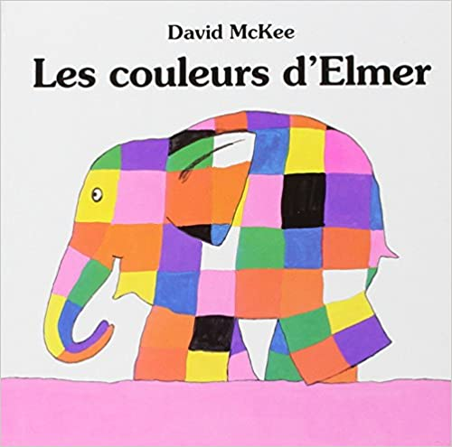
3 | - Colours part 2- become familiar with them and apply to nouns 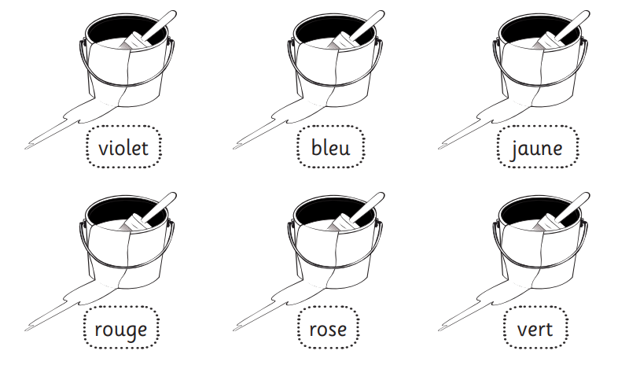 | - U2 L2 Review vocab  Review colours introduced last week. Children complete activity to colour in blank objects with the correct colour  Share PowerPoint in folder with children. Focus on the structure of the phrases article + noun + colour  - U2 L2 Question and answer
4 | - Which colour do you like? I like… | - Introduce the phrase J’aime and explain how it is formed (See below)  - Model using the phrase J’aime to say ‘J'aime la couleur bleu.’ (I like the colour blue.)  - Children to practise saying to different children their favourite colours  - Revisit the key text- what can children see now?
5 | - Which colours do you not like? I do not like… | - Introduce the idea of turning a verb into a negative in French is by using ne.. pas e.g. j’aime becomes je n’aime pas (you will need to explain the use of apostophes as 2 vowels don’t norlaly go together so Je aime becomes J’aime and Je ne aime pas becomes Je n’aime pas)  - Children to practise using the phrase Je n’aime pas le coleur…  - Children to record some sentences to show the colours they do and do not like in French.
6 | - Days of the week in order | - Share Power Point in folder to review days of the week  - Use resource in folder for children to play snap matching English word to French word
7 | - Days of the week in order- using c’est to say it is xxx | - Revisit days of the week PowerPoint from last week  - https://www.youtube.com/watch?v=zyi5wBCs56M  - Introduce C’est as a way to say It is. Revisit idea of 2 vowels together so that Ce est becomes C’est. Children practise saying C’est lundi etc
8 | - Apply the names of the week | - U2 L6 Present new vocabulary and revisit  - Read the story and then use the quiz on page 2 of the worksheet for this lesson. Children record in books
9 | - Numbers 1-10 revisit | - Revisit numbers 1 to 10 from previous unit. Use counting stick to practise counting forward and backwards in French. Provide children with sequence of numbers with one missing e.g. un, deux, quatre- what is missing? Children can play the same game in pairs.  - U1 L4 Present vocab, Beat that bee activity
10 | - Numbers 11-20 | - U2 L3 Present new vocab- practise several times with the children Use Hit it and Spelling game to practise the numbers
11 | - Numbers 11-20 | - U2 L3 Noughts and crosses to revisit and then apply to sentences using question and answer and then true or false
12 | - Unit assessment

Subject Knowledge Support
- “C’est” is actually “ce” and “est” joined together with an apostrophe — much the same as “it’s” in English.

- “Combien…?” means “how many…?” or “how much…?” — it’s a key word for asking questions

- “J’aime” is actually “je” and “aime” combined using an apostrophe — you do this to avoid two vowels being next to each other.

- To make a positive sentence into a negative sentence in French you need to sandwich “ne” and “pas” around the verb. Here the verb is “aime”, so you end up with “je n’aime pas”
Evaluation

