
Subject Unit Plan
Subject: Science
Unit: Animals including humans
Year Group: 4
Overview of Unit:
- Describe the simple functions of the basic parts of the digestive system in humans
- Identify the different types of teeth in humans and their simple functions
- Construct and interpret a variety of food chains, identifying producers, predators and prey
Scientific enquiry:

Investigation question:

Session number | Sequenced learning points | Activities
1 | - Know the names of the parts of the digestive system.  - Be able to describe the route of food from the mouth | - https://www.bbc.co.uk/bitesize/topics/z27kng8/articles/z9wk7p3
2 | - Understand the role of protein, fats and carbohydrates in the digestive system.  - Be able to discuss as part of a balanced diet drawing on knowledge from Year 3 | - https://www.youtube.com/watch?v=eSEYPO30AN0
3 | - Parts of the digestive system and know the roles- parts of the mouth | - https://www.bbc.co.uk/bitesize/topics/z27kng8/articles/z9wk7p3  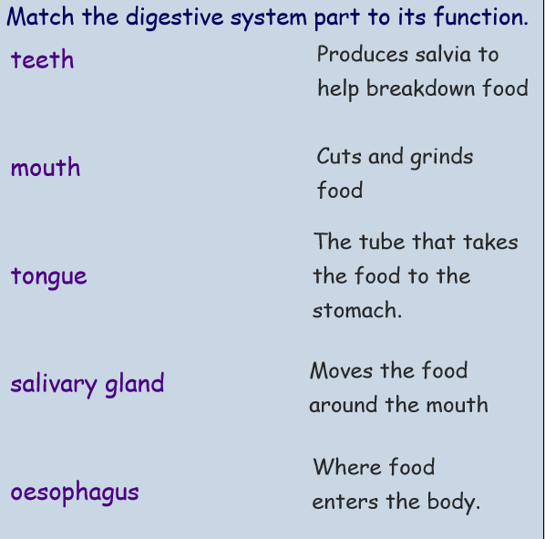
4 | - The stomach and its role in digestion
5 | - The intestines and their role- know the difference between small and large
6 | - Types of teeth and their role- know the different between incisors, molars and canines. | - https://www.bbc.co.uk/bitesize/topics/z27kng8/articles/zsp76yc
7 | - Tooth decay- experiment to show effect of different liquids on teeth | - https://www.bbc.co.uk/bitesize/clips/znrb4wx
8 | - Food chains- know the words consumer, primary consumer and secondary. | - https://www.bbc.co.uk/bitesize/topics/zbnnb9q/articles/zwbtxsg

Subject Knowledge Support
- https://www.sciencefix.co.uk/2020/01/food-and-digestion-subject-knowledge/
- https://www.stem.org.uk/resources/elibrary/resource/36133/digestive-system

Pupils should be introduced to the main body parts associated with the digestive system, for example, mouth, tongue, teeth, oesophagus, stomach and small and large intestine and explore questions that help them to understand their special functions. Pupils might work scientifically by: comparing the teeth of carnivores and herbivores, and suggesting reasons for differences; finding out what damages teeth and how to look after them. They might draw and discuss their ideas about the digestive system and compare them with models or images.

Evaluation

