
Subject Unit Plan
Subject: Science
Unit: Animals, including humans
Year Group: 6
Overview of Unit:
- Identify and name the main parts of the human circulatory system, and describe the functions of the heart, blood vessels and blood
- Recognise the impact of diet, exercise, drugs and lifestyle on the way their bodies function
- Describe the ways in which nutrients and water are transported within animals, including humans

Scientific enquiry:

Investigation question: How does exercise affect your heart rate? Pattern seeking

Investigation question: What is in blood? Research using secondary sources

Investigation question: How are nutrients and water transported in the body? Observing over time

Session number | Sequenced learning points | Activities
1 | - Identify and name the parts of the circulatory system
2 | - Describe the functions of the blood | - Practical: make your own blood
3 | - Describe the functions of the blood vessels
4 + 5 | - The main parts and function of the heart | - https://www.youtube.com/watch?app=desktop&v=_eVG45_iF9U
6 | - Impact of drugs of the body; specific understanding of the difference between legal and illegal | - Link to PSHE  - 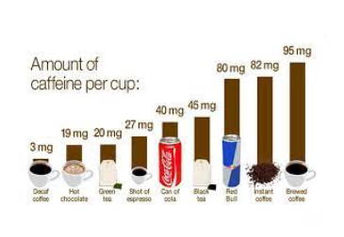
7 | - Impact of diet- specifically looking at sugar levels and diet drinks | - https://www.bbc.co.uk/bitesize/clips/ztr3cdm

Subject Knowledge Support
Link in STEM website for unit
https://www.stem.org.uk/resources/community/collection/13109/year-6-animals-including-humans

Pupils should build on their learning from years 3 and 4 about the main body parts and internal organs (skeletal, muscular and digestive system) to explore and answer questions that help them to understand how the circulatory system enables the body to function.

Pupils should learn how to keep their bodies healthy and how their bodies might be damaged – including how some drugs and other substances can be harmful to the human body.

Pupils might work scientifically by: exploring the work of scientists and scientific research about the relationship between diet, exercise, drugs, lifestyle and health.

Evaluation

