
Subject Unit Plan
Subject: Science
Unit: Living things and their habitats
Year Group: 6
Overview of Unit:
- Describe how living things are classified into broad groups according to common observable characteristics and based on similarities and differences, including micro-organisms, plants and animals
- Give reasons for classifying plants and animals based on specific characteristics
Scientific enquiry:

Investigation question: What conditions are needed for bread to go mouldy? Observing over time

Session number | Sequenced learning points | Activities
1 | - Introduction to classification of animals and the 2 main groups of vertebrates and invertebrates
2 | - Classifying animals into mammals, amphibians, reptile, fish and birds | - https://www.bbc.co.uk/bitesize/topics/zn22pv4/articles/z3nbcwx
3 | - Classifying animals using their characteristics | 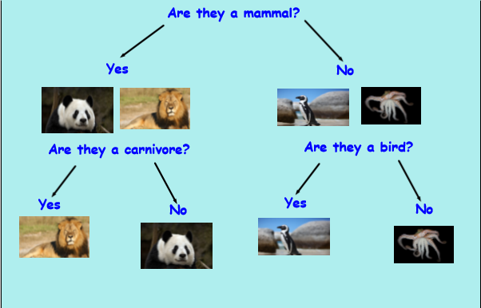
4 | - Micro-organisms with particular focus on fungi, bacteria and virus | - https://www.youtube.com/watch?v=9JW63U2mzqo
5 + 6 | - Micro-organism investigation- mouldy bread investigation | - Focus on investigation skills- prediction and recording results

Subject Knowledge Support
Stem resource:
https://www.stem.org.uk/resources/community/collection/12740/year-6-all-living-things

It is important to group animals and plants so that we can narrow them down into specific groups.
Scientists believe there may be as many as 10 million different species on Earth. When studying their lives and behaviours, it is important to have narrowed them down into different groups so that they can research the appropriate groups.

Pupils should build on their learning about grouping living things in year 4 by looking at the classification system in more detail. They should be introduced to the idea that broad groupings, such as micro-organisms, plants and animals can be subdivided. Through direct observations where possible, they should classify animals into commonly found invertebrates (such as insects, spiders, snails, worms) and vertebrates (fish, amphibians, reptiles, birds and mammals). They should discuss reasons why living things are placed in one group and not another. Pupils might find out about the significance of the work of scientists such as Carl Linnaeus, a pioneer of classification.

Pupils might work scientifically by: using classification systems and keys to identify some animals and plants in the immediate environment. They could research unfamiliar animals and plants from a broad range of other habitats and decide where they belong in the classification system.

Evaluation

